 |  |  |  |  |  |  | E  TG/118/5(proj.2)  ORIGINAL: English  DATE: 2012-04-30
INTERNATIONAL UNION FOR THE PROTECTION OF NEW VARIETIES OF PLANTS
Geneva
 |  |  | DRAFT
 |  | ENDIVE  UPOV Code: CICHO END  Cichorium endivia L. |  |  | *

GUIDELINES

FOR THE CONDUCT OF TESTS

FOR DISTINCTNESS, UNIFORMITY AND STABILITY

prepared by experts from the Netherlands

to be considered by the
Technical Working Party for Vegetables at its forty-sixth session,
to be held near the City of Venlo, Netherlands, from June 11 to 15, 2012

Alternative Names:*

Botanical name | English | French | German | Spanish
Cichorium endivia L. | Endive | Chicorée | Endivie | Escarola

The purpose of these guidelines (“Test Guidelines”) is to elaborate the principles contained in the General Introduction (document TG/1/3), and its associated TGP documents, into detailed practical guidance for the harmonized examination of distinctness, uniformity and stability (DUS) and, in particular, to identify appropriate characteristics for the examination of DUS and production of harmonized variety descriptions.

ASSOCIATED DOCUMENTS
These Test Guidelines should be read in conjunction with the General Introduction and its associated TGP documents.
TABLE OF CONTENTS PAGE

1. Subject of these Test Guidelines 3
2. Material Required 3
3. Method of Examination 3
3.1 Number of Growing Cycles 3
3.2 Testing Place 3
3.3 Conditions for Conducting the Examination 3
3.4 Test Design 3
3.5 Additional Tests 3
4. Assessment of Distinctness, Uniformity and Stability 4
4.1 Distinctness 4
4.2 Uniformity 5
4.3 Stability 5
5. Grouping of Varieties and Organization of the Growing Trial 5
6. Introduction to the Table of Characteristics 5
6.1 Categories of Characteristics 5
6.2 States of Expression and Corresponding Notes 6
6.3 Types of Expression 6
6.4 Example Varieties 6
6.5 Legend 6
7. Table of Characteristics/Tableau des caractères/Merkmalstabelle/Tabla de caracteres 7
8. Explanations on the Table of Characteristics 14
8.1 Explanations covering several characteristics 14
8.2 Explanations for individual characteristics 14
9. Literature 24
10. Technical Questionnaire 25

ANNEX COMMENTS BY THE SUBGROUP

Subject of these Test Guidelines

These Test Guidelines apply to all varieties of Cichorium endivia L., Cichorium endivia L. subsp. endivia; Cichorium endivia var. crispum Lam.; Cichorium endivia var. latifolium Lam..

Material Required

2.1 The competent authorities decide on the quantity and quality of the plant material required for testing the variety and when and where it is to be delivered. Applicants submitting material from a State other than that in which the testing takes place must ensure that all customs formalities and phytosanitary requirements are complied with.

2.2 The material is to be supplied in the form of seed.

2.3 The minimum quantity of plant material, to be supplied by the applicant, should be:

20 g or at least 10,000 seeds.

The seed should meet the minimum requirements for germination, species and analytical purity, health and moisture content, specified by the competent authority. In cases where the seed is to be stored, the germination capacity should be as high as possible and should, be stated by the applicant.

2.4 The plant material supplied should be visibly healthy, not lacking in vigor, nor affected by any important pest or disease.

2.5 The plant material should not have undergone any treatment which would affect the expression of the characteristics of the variety, unless the competent authorities allow or request such treatment. If it has been treated, full details of the treatment must be given.

Method of Examination

3.1 Number of Growing Cycles

The minimum duration of tests should normally be two independent growing cycles.

3.2 Testing Place

Tests are normally conducted at one place. In the case of tests conducted at more than one place, guidance is provided in TGP/9 “Examining Distinctness”.

3.3 Conditions for Conducting the Examination

The tests should be carried out under conditions ensuring satisfactory growth for the expression of the relevant characteristics of the variety and for the conduct of the examination.

3.4 Test Design

3.4.1 Each test should be designed to result in a total of at least 60 plants, which should be divided between at least 2 replicates.

3.4.2 The design of the tests should be such that plants or parts of plants may be removed for measurement or counting without prejudice to the observations which must be made up to the end of the growing cycle.

3.5 Additional Tests

Additional tests, for examining relevant characteristics, may be established.

Assessment of Distinctness, Uniformity and Stability

4.1 Distinctness

4.1.1 General Recommendations

It is of particular importance for users of these Test Guidelines to consult the General Introduction prior to making decisions regarding distinctness. However, the following points are provided for elaboration or emphasis in these Test Guidelines.

4.1.2 Consistent Differences

The differences observed between varieties may be so clear that more than one growing cycle is not necessary. In addition, in some circumstances, the influence of the environment is not such that more than a single growing cycle is required to provide assurance that the differences observed between varieties are sufficiently consistent. One means of ensuring that a difference in a characteristic, observed in a growing trial, is sufficiently consistent is to examine the characteristic in at least two independent growing cycles.

4.1.3 Clear Differences

Determining whether a difference between two varieties is clear depends on many factors, and should consider, in particular, the type of expression of the characteristic being examined, i.e. whether it is expressed in a qualitative, quantitative, or pseudo-qualitative manner. Therefore, it is important that users of these Test Guidelines are familiar with the recommendations contained in the General Introduction prior to making decisions regarding distinctness.

4.1.4 Number of Plants / Parts of Plants to be Examined

Unless otherwise indicated, for the purposes of distinctness, all observations on single plants should be made on 20 plants or parts taken from each of 20 plants and any other observations made on all plants in the test, disregarding any off-type plants.

4.1.5 Method of Observation

The recommended method of observing the characteristic for the purposes of distinctness is indicated by the following key in the second column of the Table of Characteristics (see document TGP/9 “Examining Distinctness”, Section 4 “Observation of characteristics”):

MG: single measurement of a group of plants or parts of plants
MS: measurement of a number of individual plants or parts of plants
VG: visual assessment by a single observation of a group of plants or parts of plants
VS: visual assessment by observation of individual plants or parts of plants

Type of observation: visual (V) or measurement (M)

“Visual” observation (V) is an observation made on the basis of the expert’s judgment. For the purposes of this document, “visual” observation refers to the sensory observations of the experts and, therefore, also includes smell, taste and touch. Visual observation includes observations where the expert uses reference points (e.g. diagrams, example varieties, side-by-side comparison) or non-linear charts (e.g. color charts). Measurement (M) is an objective observation against a calibrated, linear scale e.g. using a ruler, weighing scales, colorimeter, dates, counts, etc.

Type of record: for a group of plants (G) or for single, individual plants (S)

For the purposes of distinctness, observations may be recorded as a single record for a group of plants or parts of plants (G), or may be recorded as records for a number of single, individual plants or parts of plants (S). In most cases, “G” provides a single record per variety and it is not possible or necessary to apply statistical methods in a plant-by-plant analysis for the assessment of distinctness.”

In cases where more than one method of observing the characteristic is indicated in the Table of Characteristics (e.g. VG/MG), guidance on selecting an appropriate method is provided in document TGP/9, Section 4.2.

4.2 Uniformity

4.2.1 It is of particular importance for users of these Test Guidelines to consult the General Introduction prior to making decisions regarding uniformity. However, the following points are provided for elaboration or emphasis in these Test Guidelines:

4.2.2 The assessment of uniformity should be according to the recommendations for cross-pollinated varieties in the General Introduction.

4.3 Stability

4.3.1 In practice, it is not usual to perform tests of stability that produce results as certain as those of the testing of distinctness and uniformity. However, experience has demonstrated that, for many types of variety, when a variety has been shown to be uniform, it can also be considered to be stable.

4.3.2 Where appropriate, or in cases of doubt, stability may be further examined by testing a new seed stock to ensure that it exhibits the same characteristics as those shown by the initial material supplied.

Grouping of Varieties and Organization of the Growing Trial

5.1 The selection of varieties of common knowledge to be grown in the trial with the candidate varieties and the way in which these varieties are divided into groups to facilitate the assessment of distinctness are aided by the use of grouping characteristics.

5.2 Grouping characteristics are those in which the documented states of expression, even where produced at different locations, can be used, either individually or in combination with other such characteristics: (a) to select varieties of common knowledge that can be excluded from the growing trial used for examination of distinctness; and (b) to organize the growing trial so that similar varieties are grouped together.

5.3 The following have been agreed as useful grouping characteristics:

(a) Plant: botanical type (characteristic 1)
(b) Plain type varieties only: Plant: sub-type (characteristic 2)
(c) Cut type varieties only: Plant: sub-type (characteristic 3)
(d) Leaf: color (characteristic 13)
(e) Flower: color (characteristic 29)
(f) Time of bolting (characteristic 31)

5.4 Guidance for the use of grouping characteristics, in the process of examining distinctness, is provided through the General Introduction and document TGP/9 “Examining Distinctness”.

Introduction to the Table of Characteristics

6.1 Categories of Characteristics

6.1.1 Standard Test Guidelines Characteristics

Standard Test Guidelines characteristics are those which are approved by UPOV for examination of DUS and from which members of the Union can select those suitable for their particular circumstances.

6.1.2 Asterisked Characteristics

Asterisked characteristics (denoted by *) are those included in the Test Guidelines which are important for the international harmonization of variety descriptions and should always be examined for DUS and included in the variety description by all members of the Union, except when the state of expression of a preceding characteristic or regional environmental conditions render this inappropriate.

6.2 States of Expression and Corresponding Notes

6.2.1 States of expression are given for each characteristic to define the characteristic and to harmonize descriptions. Each state of expression is allocated a corresponding numerical note for ease of recording of data and for the production and exchange of the description.

6.2.2 In the case of qualitative and pseudo-qualitative characteristics (see Chapter 6.3), all relevant states of expression are presented in the characteristic. However, in the case of quantitative characteristics with 5 or more states, an abbreviated scale may be used to minimize the size of the Table of Characteristics. For example, in the case of a quantitative characteristic with 9 states, the presentation of states of expression in the Test Guidelines may be abbreviated as follows:

State | Note
small | 3
medium | 5
large | 7

However, it should be noted that all of the following 9 states of expression exist to describe varieties and should be used as appropriate:

State | Note
very small | 1
very small to small | 2
small | 3
small to medium | 4
medium | 5
medium to large | 6
large | 7
large to very large | 8
very large | 9

6.2.3 Further explanation of the presentation of states of expression and notes is provided in document TGP/7 “Development of Test Guidelines”.

6.3 Types of Expression

An explanation of the types of expression of characteristics (qualitative, quantitative and pseudo-qualitative) is provided in the General Introduction.

6.4 Example Varieties

Where appropriate, example varieties are provided to clarify the states of expression of each characteristic.

6.5 Legend

(*) Asterisked characteristic – see Chapter 6.1.2

QL Qualitative characteristic – see Chapter 6.3
QN Quantitative characteristic – see Chapter 6.3
PQ Pseudo-qualitative characteristic – see Chapter 6.3

MG, MS, VG, VS – see Chapter 4.1.5

(a)-(c) See Explanations on the Table of Characteristics in Chapter 8.1.

(+) See Explanations on the Table of Characteristics in Chapter 8.2.

Table of Characteristics/Tableau des caractères/Merkmalstabelle/Tabla de caracteres

 |  | English | français | Deutsch | español | Example Varieties  Exemples  Beispielssorten  Variedades ejemplo | Note/  Nota
1.  (*)  (+) | VG | Plant: botanical type | Plante: type de variété botanique | Pflanze: botanischer Typ | Planta: tipo botánico
QL |  | plain type | scarole | ganzblättrig | de hojas anchas | Cichorium endivia var. latifolia | 1
 |  | cut type | frisée | krausblättrig | de hojas rizadas | Cichorium endivia var. crispa | 2
2.  (*)  (+) | VG | Plain type varieties only: Plant: sub-type | Variétés de type scarole seulement: Plante: sous-type | Nur ganzblättrige Sorten: Pflanze: Untergruppe | Sólo variedades de hojas anchas: Planta: subtipo
QL |  | Grosse bouclée 2 | Grosse bouclée 2 | Grosse bouclée 2 | Grosse bouclée 2 |  | 1
 |  | Breedblad Volhart Winter | Breedblad Volhart Winter | Breedblad Volhart Winter | Breedblad Volhart Winter |  | 2
 |  | Géante maraîchère | Géante maraîchère | Géante maraîchère | Géante maraîchère |  | 3
 |  | Cornet | Cornet | Cornet | Cornet |  | 4
 |  | Ambio | Ambio | Ambio | Ambio |  | 5
3.  (*)  (+) | VG | Cut type varieties only: Plant: sub-type | Variétés frisée: Plante: sous-type | Nur krausblättrige Sorten: Pflanze: Untergruppe | Excluyendo escarola de hojas rizadas: Planta: subtipo
QL |  | Wallonne | Wallonne | Wallonne | Wallonne |  | 1
 |  | De Louviers | Louviers | Louviers | De Louviers |  | 2
 |  | D’été à cœur jaune | D’été à cœur jaune | D’été à cœur jaune | D’été à cœur jaune |  | 3
 |  | Other types | Autres | Andere Typen | Otros tipos |  | 4
4. | VG | Plant: diameter | Plante: diamètre | Pflanze: Durchmesser | Planta: diámetro
QN | (a) | very small | très petit | sehr klein | muy pequeño | Belusa | 1
 |  | small | petit | klein | pequeño | De Louviers | 3
 |  | medium | moyen | mittel | medio | Blonde à cœur plein,  D’été à cœur jaune, Golda | 5
 |  | large | grand | groß | grande | Grosse Pancalière | 7
 |  | very large | très grand | sehr groß | muy grande | Superfiorentina, Wallonne | 9
5.  (+) | VG | Plant: growth habit | Plante : port | Pflanze: Wuchsform | Planta: porte
QN | (a) | erect | dressé | aufrecht | vertical | Gloire de l’Exposition | 1
 |  | semi-erect | demi-dressé | halbaufrecht | semivertical | Blonde à cœur plein,  D’été à cœur jaune | 2
 |  | horizontal | horizontal | waagerecht | horizontal | Argentée Mirabel, De Ruffec | 3
6.  (old 5.1)  (*)  (+) | VG | Plant: shape in longitudinal section | Plante : | Pflanze: | Planta:
QN | (a) | dome |  |  |  | Aery, Gloire de l’Exposition | 1
 |  | flattened |  |  |  | Ameris, Dafne,  Grosse Bouclée 2 | 2
 |  | pyramidal |  |  |  | Cornet | 3
 |  | conical |  |  |  |  | 4
7.  (old 7.1)  (+) | VG | Heart: tendency to bleach on the surface
QN |  | absent or very weak |  |  |  | Géante maraîchère | 1
 |  | moderate |  |  |  | Amos, D’été à cœur jaune | 2
 |  | strong |  |  |  | Starly | 3
8.  (old 9)  (+) | VG | Leaf: attitude of upper part | Feuille: port | Blatt: Haltung | Hoja: porte
QN | (b) | erect | dressé | aufrecht | erecta | Cornet de la Loire | 1
 |  | semi-erect | demi dressé | halbaufrecht | semierecta |  | 3
 |  | horizontal | horizontal | waagerecht | horizontal | D’hiver de Provence | 5
9.  (old 11) | VG | Leaf: length | Feuille: longueur | Blatt: Länge | Hoja: longitud
QN | (b) | very short | très courte | sehr kurz | muy corta | Nairobi | 1
 |  | short | courte | kurz | corta | Gloire de l’Exposition | 3
 |  | medium | moyenne | mittel | media | D’hiver de Provence,  Grosse Bouclée 2 | 5
 |  | long | longue | lang | larga | D’été à cœur jaune, Tebas | 7
 |  | very long | trés longue | sehr lang | muy larga | Atleta | 9
10.  (old 12.1)  (+) | VG | Plain type varieties only: Leaf: maximum width | Feuille: largeur maximale | Blatt: maximale Breite | Hoja: anchura máxima
QN | (b) | narrow | étroite | schmal | delgada | Pacos | 3
 |  | medium | moyenne | mittel | media | Grosse Bouclée 2 | 5
 |  | broad | large | breit | ancha | Géante maraîchère | 7
11.  (old 12.2)  (+) | VG | Cut type varieties only: Leaf: maximum width | Feuille: largeur maximale | Blatt: maximale Breite | Hoja: anchura máxima
QN | (b) | narrow | étroite | schmal | delgada |  | 3
 |  | medium | moyenne | mittel | media |  | 5
 |  | broad | large | breit | ancha |  | 7
12.  (old 13)  (+) | VG | Plain type varieties only: Leaf: shape | Variétés de type scarole seulement: Feuille: forme | Nur ganzblättrige Sorten: Blatt: Form | Sólo variedades de hojas anchas: Hoja: forma
QN | (b) | narrow obovate | obovale étroite | schmal verkehrt eiförmig | oboval estrecha | Escariol grüner, Pacos | 1
 |  | obovate | obovale | verkehrt eiförmig | oboval | Andes | 3
 |  | broad obovate | obovale large | breit verkehrt eiförmig | oboval ancha | Diva, Géante maraîchère, Kalinka | 5
13.  (old 14)  (*) | VG | Leaf: color | Feuille: couleur | Blatt: Farbe | Hoja: color
PQ | (b) | yellowish green | vert jaunâtre | gelblichgrün | verde amarillento | Belusa,  Blonde à cœur plein | 1
 |  | green | vert | grün | verde | Grosse Bouclée 2, Novema | 2
 |  | greyish green | vert gris | gräulichgrün | verde grisáceo | De Louviers, Nairobi | 3
14.  (old 15) | VG | Leaf: intensity of color | Feuille: intensité de la couleur | Blatt: Intensität der Färbung | Hoja: intensidad del color
QN | (b) | light | claire | hell | claro |  | 3
 |  | medium | moyenne | mittel | medio |  | 5
 |  | dark | foncée | dunkel | oscuro |  | 7
15.  (old 16.1)  (+) | VG | Plain type varieties only: Leaf: depth of lobing
QN | (b) | absent or very shallow |  |  |  | Géante Mâraichère | 1
 |  | shallow |  |  |  | Blonde à Coeur plein, Grosse Bouclée 2 | 3
 |  | medium |  |  |  | Maruschka | 5
 |  | deep |  |  |  | Ambio | 7
 |  | very deep |  |  |  | Friscaro | 9
16.  (old 16.2)  (+) | VG | Cut type varieties only: Leaf: venation
QN | (b) | not flabellate |  |  |  | Wallonne | 1
 |  | semi flabellate |  |  |  | D’été à coeur jaune | 2
 |  | flabellate |  |  |  | De Louviers,  Gloire de l’exposition | 3
17.  (old 16.4)  (+) | VG | Cut type varieties only: Leaf: length of lobes
QN | (b) | short |  |  |  | Wallonne | 3
 |  | medium |  |  |  | D’été à Coeur jaune | 5
 |  | long |  |  |  | Trés fine Mâraichére | 7
 |  | very long |  |  |  |  | 9
18.  (old 16.6)  (+) | VG | Plain type varieties only: Leaf: dentation of margin
QN | (b) | absent or weak |  |  |  | Grosse Bouclée 2 | 1
 |  | medium |  |  |  | Géante Mâraichère | 2
 |  | strong |  |  |  | Cornet | 3
19.  (old 16.7)  (+) | VG | Cut type varieties only: Leaf: length of dentation of margin
QN | (b) | short |  |  |  | Atleta | 3
 |  | medium |  |  |  | Trés fine Mâraichére | 5
 |  | long |  |  |  | Ruffec | 7
20.  (old 18) | VG | Plain type varieties only: Leaf: undulation of margin | Feuille: ondulation du bord | Blatt: Randwellung | Hoja: ondulación del borde
QN | (b) | weak | faible | gering | débil |  | 3
 |  | medium | moyenne | mittel | media |  | 5
 |  | strong | forte | stark | fuerte |  | 7
21.  (old 19) | VG | Plain type varieties only: Leaf: creasing | Feuille: crispation | Blatt: Faltung | Hoja: crenado
QN | (b) | weak | faible | gering | débil | Géante Mâraichère | 3
 |  | medium | moyenne | mittel | medio | Grosse Bouclée 2 | 5
 |  | strong | forte | stark | fuerte | Blonde à cœur plein | 7
22.  (old 21)  (*)  (+) | VG | Cut type varieties only: Leaf: ratio length of midrib without lamina/total length of leaf | Variétés de type frisée seulement: Feuille: rapport longueur de la nervure médiane sans limbe/longueur totale de la feuille | Nur krausblättrige Sorten: Blatt: Verhältnis Länge der Mittelrippe ohne Blattspreite/Gesamt-länge des Blattes | Sólo variedades que no son de hojas anchas: Hoja: proporción entre la longitud del nervio central sin lámina y la longitud total de la hoja
QN | (b) | very small | très petit | sehr klein | muy pequeña | D’Olivet | 1
 |  | small | petit | klein | pequeña | De Louviers | 3
 |  | medium | moyen | mittel | media | Wallonne | 5
 |  | large | grand | groß | grande |  | 7
 |  | very large | très grand | sehr groß | muy grande | Toujours Blanche | 9
23.  (old 22)  (*)  (+) | VG | Leaf: width of midrib at base | Feuille: largeur de la nervure médiane à la base | Blatt: Breite der Mittelrippe an der Basis | Hoja: anchura del nervio central en la base
QN | (b) | very narrow | très étroite | sehr schmal | muy estrecho | Fresseta | 1
 |  | narrow | étroite | schmal | estrecho | Mercedes | 3
 |  | medium | moyenne | mittel | medio | D’été à cœur jaune,  Grosse Bouclée 2 | 5
 |  | broad | large | breit | ancho | Blonde à cœur plein, Wallonne | 7
24.  (old 23)  (*) | (b) | Cut type varieties only: Leaf: color of midrib at base | Variétés de type non scarole seulement: Feuille: couleur de la nervure médiane à la base | Nur krausblättrige Sorten und Zwischentypen: Blatt: Farbe der Mittelrippe an der Basis | Sólo variedades que no son de hojas anchas: Hoja: color del nervio central en la base
 |  | white |  |  |  | D’été à cœur jaune | 1
 |  | pink |  |  |  | De Meaux | 2
25.  (old 24) | VG | Stem: height | Tige: hauteur | Stengel: Höhe | Tallo: altura
QN | (c) | short | courte | niedrig | bajo | De Louviers | 3
 |  | medium | moyenne | mittel | medio | D’été à cœur jaune | 5
 |  | tall | haute | hoch | alto | Cornet de la Loire,  D’Hiver de Provence | 7
26.  (old 25) | VG | Stem: fasciation | Tige: fasciation | Stengel: Verbänderung | Tallo: fasciación
QL | (c) | absent | absente | fehlend | ausente | Cornet d’Anjou,  D’Hiver de Provence,  De Ruffec | 1
 |  | present | présente | vorhanden | presente | Golda, Grosse Bouclée 2 | 9
27.  (old 26) | VG | Stem: attitude of branches | Tige: port des ramifications | Stengel: Stellung der Seitentriebe | Tallo: porte de las ramificaciones
QN | (c) | erect | dressé | aufrecht | erecto | Grosse Bouclée 2 | 1
 |  | semi-erect | demi dressé | halbaufrecht | semierecto |  | 3
 |  | horizontal | horizontal | waagerecht | horizontal | Ariga | 5
28.  (old 27) | VG | Plain type varieties only: Stem: shape of stipules | Variétés de type scarole seulement: Tige: forme des stipules | Nur ganzblättrige Sorten: Stengel: Form der Nebenblätter | Sólo variedades de hojas anchas: Tallo: forma de las estípulas
QN | (c) | elliptic | elliptiques | elliptisch | elíptica |  | 1
 |  | broad elliptic | elliptiques larges | breit elliptisch | elíptica ancha | Blonde à cœur plein | 2
 |  | circular | arrondis | rund | circular | Solera | 3
29.  (old 28)  (*)  (+) | VG | Flower: color | Fleur: couleur | Blüte: Farbe | Flor: color
PQ |  | white | blanche | weiß | blanco | De Louviers,  Grosse pommant seule | 1
 |  | light pink | rose | rosa | rosa | Lisuna | 2
 |  | dark pink |  |  |  | Ascari | 3
 |  | blue | bleue | blau | azul | Grosse Bouclée 2 | 4
 |  | violet blue | bleu violacé | violettblau | azul violeta | Alaska, Ariga, Sally, Wallonne | 5
30.  (old 29) | MS | Time of harvest maturity | Époque de maturité de récolte | Zeitpunkt der Erntereife | Época de madurez para cosecha
QN |  | early | précoce | früh | temprana | Sally | 3
 |  | medium | moyenne | mittel | media |  | 5
 |  | late | tardive | spät | tardía | Wallonne | 7
 |  | very late | très tardive | sehr spät | muy tardía | Cornet d’Anjou | 9
31.  (old 30)  (*) | MS | Time of bolting | Époque de montaison | Zeitpunkt des Schossens | Época de subida a flor
QN |  | very early | très précoce | sehr früh | muy temprana | Noveli | 1
 |  | early | précoce | früh | temprana | De Meaux,  Grosse pommant seule | 3
 |  | medium | moyenne | mittel | media | Sally | 5
 |  | late | tardive | spät | tardía | Blonde à cœur plein | 7
 |  | very late | très tardive | sehr spät | muy tardía | Excel | 9

Explanations on the Table of Characteristics

8.1 Explanations covering several characteristics

Characteristics should be observed under natural conditions without forcing measures.

Characteristics containing the following key in the second column of the Table of Characteristics should be examined as indicated below:

(a) Plant: All observations on the plant should be made just before harvest maturity.

(b) Leaf: All observations on the leaf should be made just before harvest maturity on leaves excluding the outer and center leaves.

(c) Stem: All observations on the stem should be made on a flowering stem.

(d) Flower: The color should be observed on just opened flowers, because the color of the flowers changes with ageing.

8.2 Explanations for individual characteristics

Ads. 1, 2, 3: Plant: botanical type and sub-types

Endive varieties can be divided into “Plain Type” and “Cut Type”:

(A) Plain type (C. endivia var. latifolia): Endives of the plain type are characterized by their full foliage with serrated margins. They differ from those of the cut type in that their leaves are broader, undulating or curled-up with marginal dentation and incurved towards the heart of the plant.

Plain type includes the following sub-types :

- Grosse bouclée 2 (Nummer Vijf 2): Short, broad foliage; large, full heart, with white, tightly-curled heart leaves. The leaves are slightly lobed.

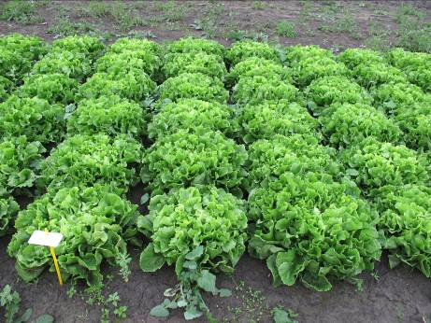

- Breedblad Volhart Winter (A cœur plein): Somewhat flattened shape because the partly incurved inner leaves tend to cover the heart, thus forming quite a noticeable ball low down; the ball is broad, with crinkly leaves. The leaves are slightly lobed.

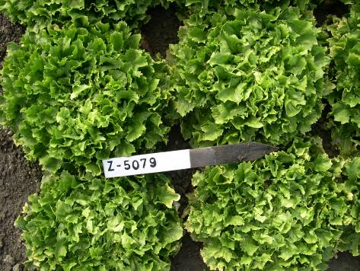

- Géante maraichère: Very voluminous variety of erect growth habit, abundant blond-green foliage and a tightly-closed heart. The leaves are not lobed.

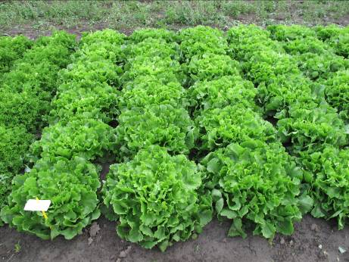

- Cornet: Compared with the other plain-type endives this one has fewer but much more ample leaves, almost as broad as they are long, the margins broken up into numerous elongated serrations. The leaf, initially folded in the centre of the plant, spreads outwards as it grows, like the bell of a trumpet, often forming a sort of cap that continues for some time to envelop the younger, inner leaves, so forming a true heart.

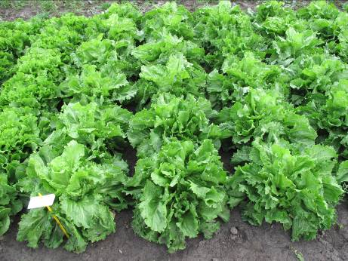

(5) Ambio: The plant has the appearance of a plain type endive, the leaves have the structure of a plain type endive, however the leaves are deeply lobed to parted.

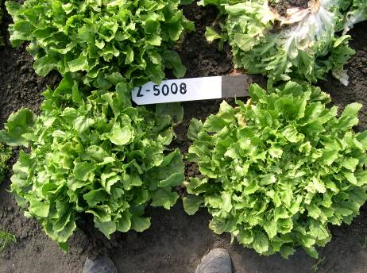
(B) Cut type (C. endivia var.crispa): Endives of the cut type are characterized by their numerous leaves disposed in a rosette shape, deeply indented and creased, smooth and more or less serrated.

Cut type includes the following sub-types:

(1) Wallonne: This type is characterized by its long, broad leaves cut into symmetrical lobes, with finely indented, curly margins and relatively narrow ribs.
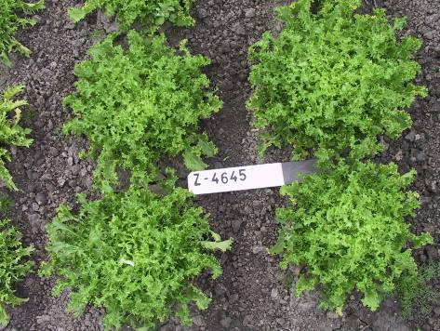

(2) De Louviers: This type is characterized by very fine ribs, very finely and deeply indented, not very curly foliage and a tight heart.

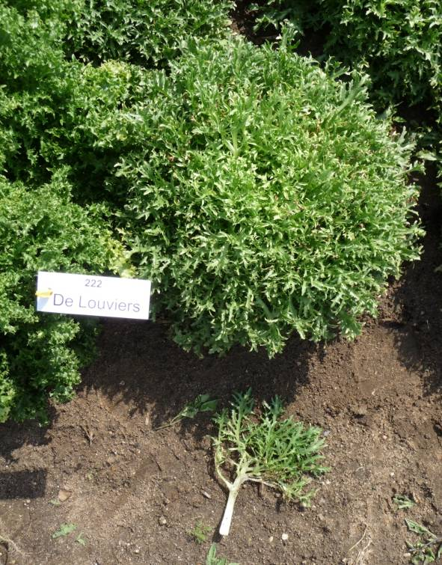

(3) D’été à cœur jaune: This type is characterized by its broad white and fleshy ribs and semi-fine, spreading cut foliage, medium-indented, and quite a tight yellow heart.

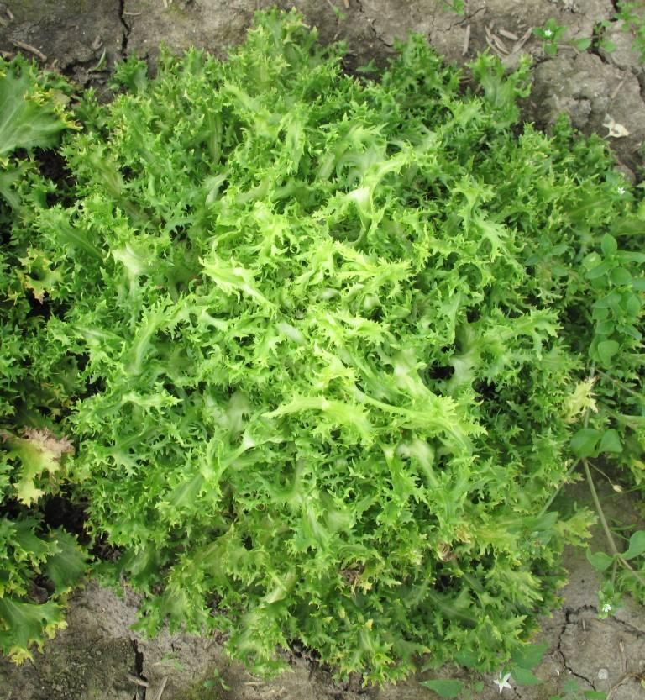

Ad. 6: Plant: shape in longitudinal section

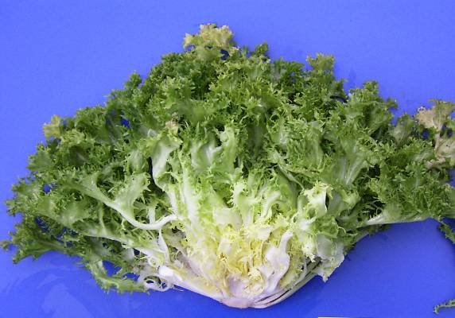 | 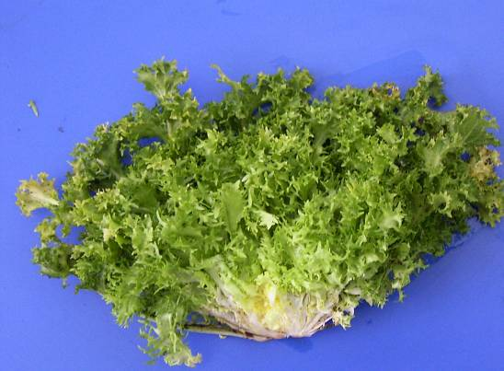
1 | 2
dome | flattened

3 | 4
pyramidal | conical

Ad. 7: Heart: tendency to bleach on the surface

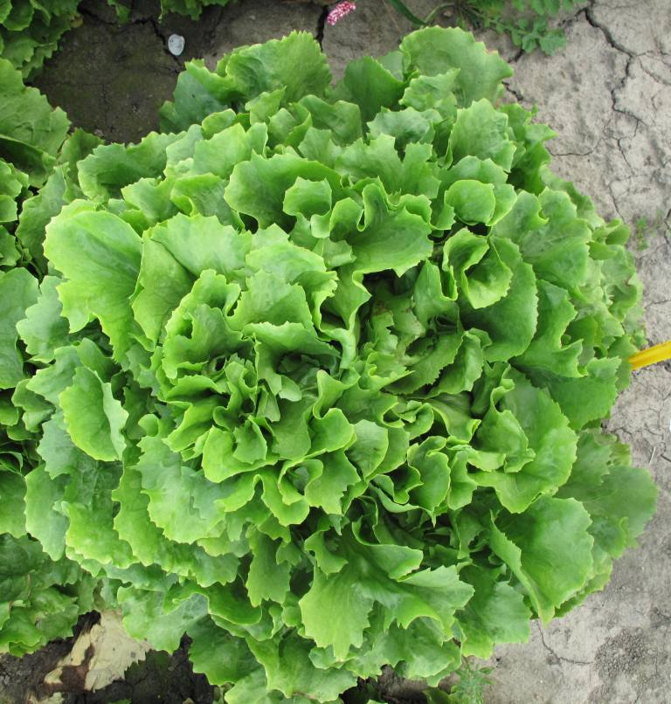 |  | 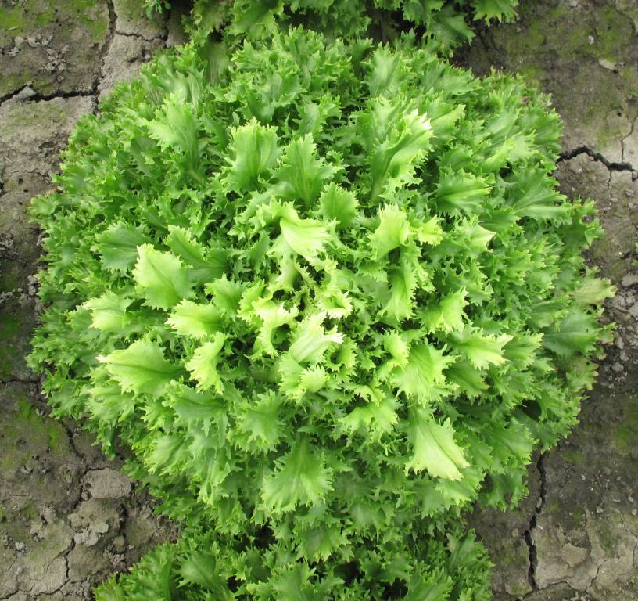
1 | 2 | 3
absent or very weak | moderate | strong

Ad. 10: Plain type varieties only: Leaf: maximum width

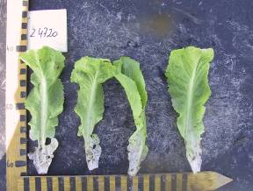 | 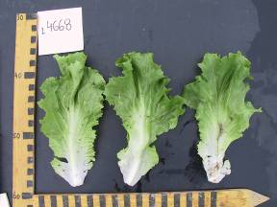 | 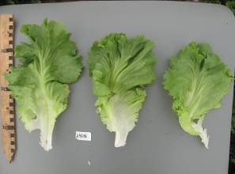
3 | 5 | 7
narrow | medium | broad

Ad. 11: Cut type varieties only: Leaf: maximum width

3 | 5 | 7
narrow | medium | broad

Ad. 12: Plain type varieties only: Leaf: shape

 | 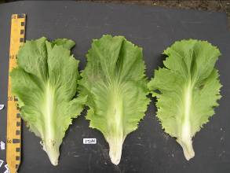
1 | 3 | 5
narrow obovate | obovate | broad obovate

Ad. 15: Plain type varieties only: Leaf: depth of lobing

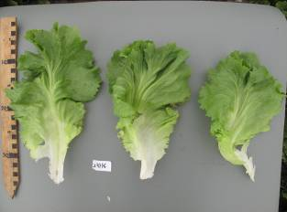 | 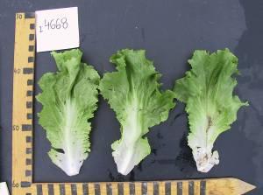 | 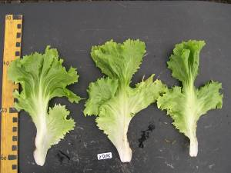 | 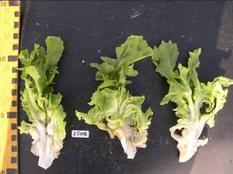
1 | 3 | 5 | 7
absent or very shallow | shallow | medium | deep

Ad. 16: Cut type varieties only: Leaf: venation

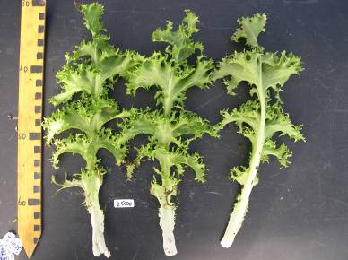 | 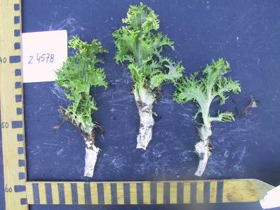 | 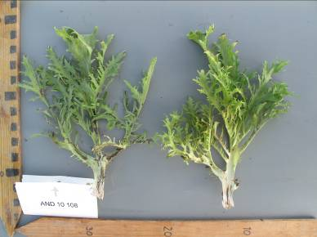
1 | 2 | 3
not flabellate | semi flabellate | flabellate

Ad. 17: Cut type varieties only: Leaf: length of lobes

 |  | 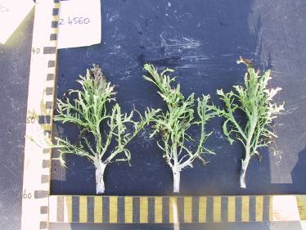
3 | 5 | 7
short | medium | long

 | 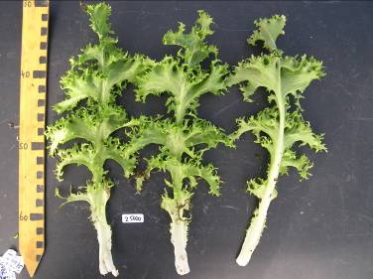
7 | 9
broad | very broad

Ad. 18: Plain type varieties only: Leaf: dentation of margin

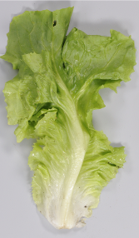 | 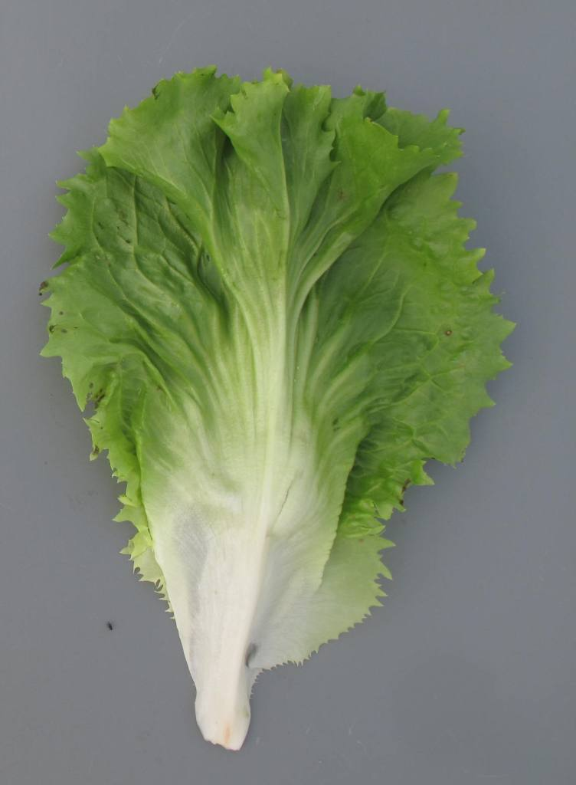 | 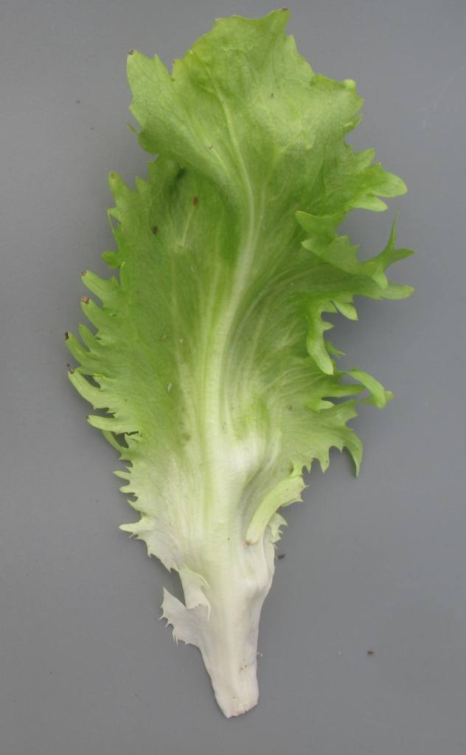
1 | 2 | 3
absent or weak | medium | strong

Ad. 19: Cut type varieties only: Leaf: length of dentation of margin

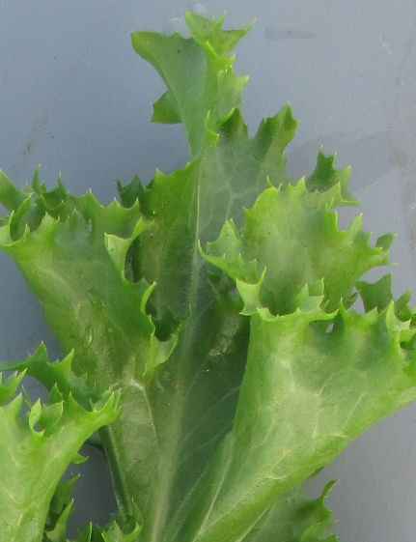 | 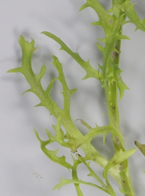 | 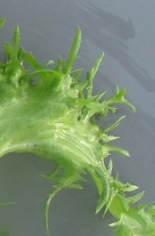
3 | 5 | 7
short | medium | long

Ad. 22: Cut type varieties only: Leaf: ratio length of midrib without lamina/total length of leaf
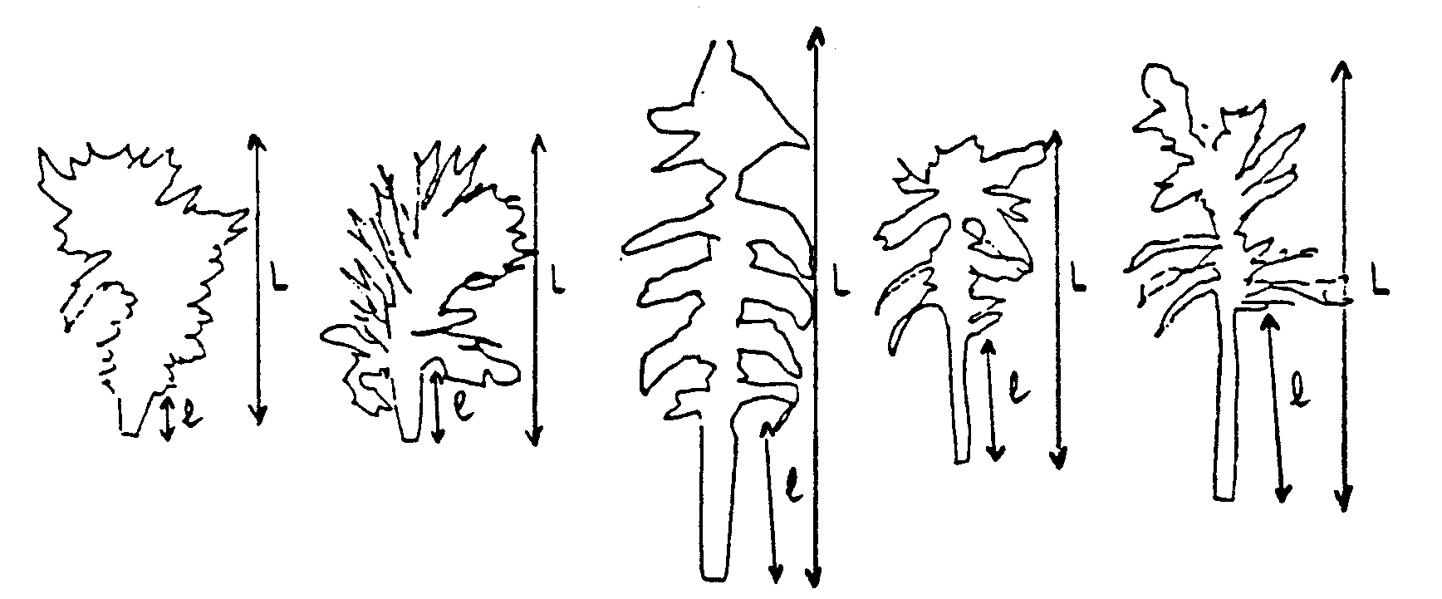
L = total length of leaf
l = length of midrib without lamina

1 | 3 | 5 | 7 | 9
very small | small | medium | large | very large

Ad. 23: Leaf: width of midrib at base

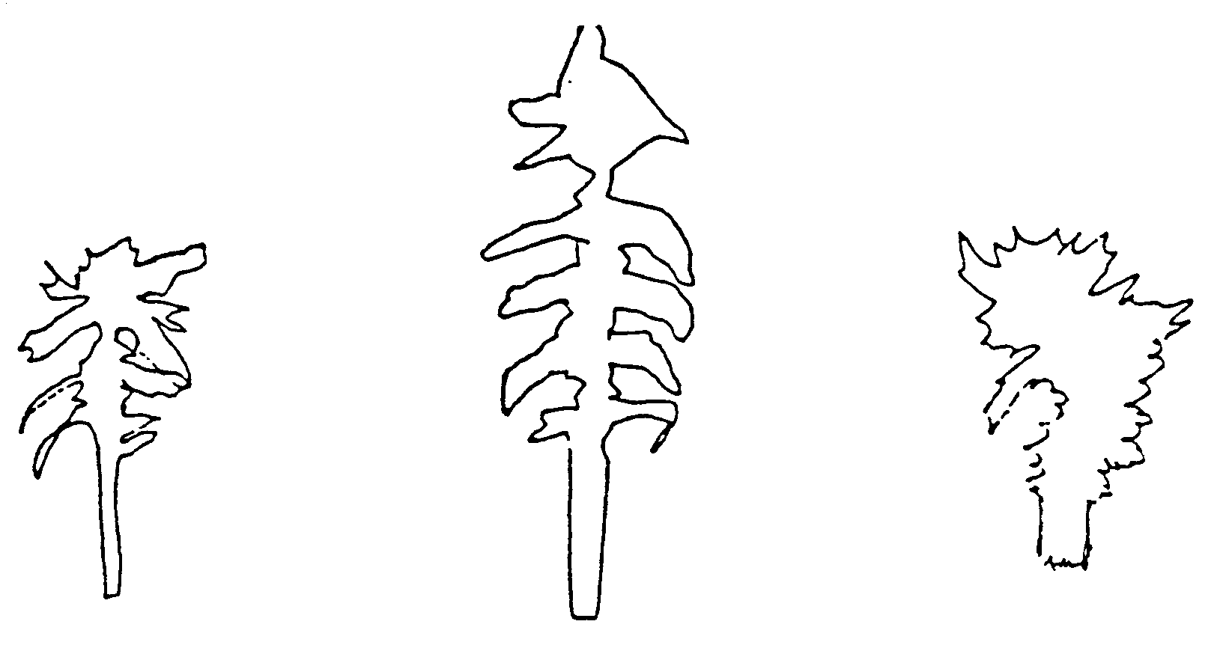
3 | 5 | 7
narrow | medium | broad

Ad. 29: Flower: color

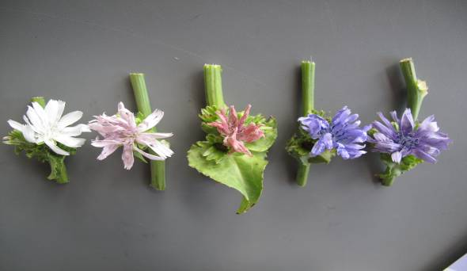
1 | 2 | 3 | 4 | 5
white | light pink | dark pink | blue | violet blue
 | RHS 75D | RHS 70D | RHS 97A | RHS 92B

Literature

No specific literature.

Technical Questionnaire

TECHNICAL QUESTIONNAIRE |  |  |  | Page {x} of {y} |  | Reference Number:
 |  |  |  |  |  | Application date:
 |  |  |  |  |  | (not to be filled in by the applicant)
TECHNICAL QUESTIONNAIRE
to be completed in connection with an application for plant breeders’ rights

1. Subject of the Technical Questionnaire
1.1 Botanical name |  |  | Cichorium endivia L.
1.2 Common name |  |  | Endive
2. Applicant
Name
Address
Telephone No.
Fax No.
E-mail address
Breeder (if different from applicant)
3. Proposed denomination and breeder’s reference
Proposed denomination
(if available)

Breeder’s reference
#4. Information on the breeding scheme and propagation of the variety

4.1 Method of propagating the variety

(a) Cross-pollination
(b) Other [ ]
(please provide details)

5. Characteristics of the variety to be indicated (the number in brackets refers to the corresponding characteristic in Test Guidelines; please mark the note which best corresponds).

 | Characteristics |  |  |  |  |  | Example Varieties |  |  | Note
5.1  (1) | Plant: botanical type
 | plain type |  |  |  |  |  | Cichorium endivia var. latifolia |  |  | 1[ ]
 | cut type |  |  |  |  |  | Cichorium endivia var. crispa |  |  | 2[ ]
5.2  (2) | Plain type varieties only: Plant: sub-type
 | Grosse bouclée |  |  |  |  |  |  |  |  | 1[ ]
 | Breedblad Volhart Winter |  |  |  |  |  |  |  |  | 2[ ]
 | Géante maraîchère |  |  |  |  |  |  |  |  | 3[ ]
 | Cornet |  |  |  |  |  |  |  |  | 4[ ]
 | Ambio |  |  |  |  |  |  |  |  | 5[ ]
5.3  (3) | Cut type varieties only: Plant: sub-type
 | Wallonne |  |  |  |  |  |  |  |  | 1[ ]
 | Louviers |  |  |  |  |  |  |  |  | 2[ ]
 | D’été à cœur jaune |  |  |  |  |  |  |  |  | 3[ ]
 | Other types |  |  |  |  |  |  |  |  | 4[ ]
5.4  (4) | Plant: diameter
 | very small |  |  |  |  |  | Belusa |  |  | 1[ ]
 | very small to small |  |  |  |  |  |  |  |  | 2[ ]
 | small |  |  |  |  |  | De Louviers |  |  | 3[ ]
 | small to medium |  |  |  |  |  |  |  |  | 4[ ]
 | medium |  |  |  |  |  | Blonde à cœur plein,  D’été à cœur jaune, Golda |  |  | 5[ ]
 | medium to large |  |  |  |  |  |  |  |  | 6[ ]
 | large |  |  |  |  |  | Grosse Pancalière |  |  | 7[ ]
 | large to very large |  |  |  |  |  |  |  |  | 8[ ]
 | very large |  |  |  |  |  | Superfiorentina, Wallonne |  |  | 9[ ]
 | Characteristics |  |  |  |  |  | Example Varieties |  |  | Note
5.5  (13) | Leaf: color
 | yellowish green |  |  |  |  |  | Belusa,  Blonde à cœur plein |  |  | 1[ ]
 | green |  |  |  |  |  | Grosse Bouclée 2, Novema |  |  | 2[ ]
 | greyish green |  |  |  |  |  | De Louviers, Nairobi |  |  | 3[ ]
5.6  (14) | Leaf: intensity of color
 | very light |  |  |  |  |  |  |  |  | 1[ ]
 | very light to light |  |  |  |  |  |  |  |  | 2[ ]
 | light |  |  |  |  |  |  |  |  | 3[ ]
 | light to medium |  |  |  |  |  |  |  |  | 4[ ]
 | medium |  |  |  |  |  |  |  |  | 5[ ]
 | medium to dark |  |  |  |  |  |  |  |  | 6[ ]
 | dark |  |  |  |  |  |  |  |  | 7[ ]
 | dark to very dark |  |  |  |  |  |  |  |  | 8[ ]
 | very dark |  |  |  |  |  |  |  |  | 9[ ]
5.7  (29) | Flower: color
 | white |  |  |  |  |  | De Louviers, Grosse pommant seule |  |  | 1[ ]
 | light pink |  |  |  |  |  | Lisuna |  |  | 2[ ]
 | dark pink |  |  |  |  |  | Ascari |  |  | 3[ ]
 | blue |  |  |  |  |  | Grosse Bouclée 2 |  |  | 4[ ]
 | violet blue |  |  |  |  |  | Alaska, Ariga, Sally, Wallonne |  |  | 5[ ]
 | Characteristics |  |  |  |  |  | Example Varieties |  |  | Note
5.8  (31) | Time of bolting
 | very early |  |  |  |  |  | Noveli |  |  | 1[ ]
 | very early to early |  |  |  |  |  |  |  |  | 2[ ]
 | early |  |  |  |  |  | De Meaux, Grosse pommant seule |  |  | 3[ ]
 | early to medium |  |  |  |  |  |  |  |  | 4[ ]
 | medium |  |  |  |  |  | Sally |  |  | 5[ ]
 | medium to late |  |  |  |  |  |  |  |  | 6[ ]
 | late |  |  |  |  |  | Blonde à cœur plein |  |  | 7[ ]
 | late to very late |  |  |  |  |  |  |  |  | 8[ ]
 | very late |  |  |  |  |  | Excel |  |  | 9[ ]
6. Similar varieties and differences from these varieties

Please use the following table and box for comments to provide information on how your candidate variety differs from the variety (or varieties) which, to the best of your knowledge, is (or are) most similar. This information may help the examination authority to conduct its examination of distinctness in a more efficient way.

Denomination(s) of variety(ies) similar to your candidate variety |  | Characteristic(s) in which your candidate variety differs from the similar variety(ies) |  |  | Describe the expression of the characteristic(s) for the similar variety(ies) |  |  | Describe the expression of the characteristic(s) for your candidate variety
Example |  | Leaf: color |  |  | yellowish green |  |  | green
Comments:

#7. Additional information which may help in the examination of the variety

7.1 In addition to the information provided in sections 5 and 6, are there any additional characteristics which may help to distinguish the variety?

Yes [ ] No [ ]

(If yes, please provide details)

7.2 Are there any special conditions for growing the variety or conducting the examination?

Yes [ ] No [ ]

(If yes, please provide details)

7.3 Other information

A representative color image of the variety should accompany the Technical Questionnaire.

8. Authorization for release

(a) Does the variety require prior authorization for release under legislation concerning the protection of the environment, human and animal health?

Yes [ ] No [ ]

(b) Has such authorization been obtained?

Yes [ ] No [ ]

If the answer to (b) is yes, please attach a copy of the authorization.

9. Information on plant material to be examined or submitted for examination.

9.1 The expression of a characteristic or several characteristics of a variety may be affected by factors, such as pests and disease, chemical treatment (e.g. growth retardants or pesticides), effects of tissue culture, different rootstocks, scions taken from different growth phases of a tree, etc.

9.2 The plant material should not have undergone any treatment which would affect the expression of the characteristics of the variety, unless the competent authorities allow or request such treatment. If the plant material has undergone such treatment, full details of the treatment must be given. In this respect, please indicate below, to the best of your knowledge, if the plant material to be examined has been subjected to:

(a) Microorganisms (e.g. virus, bacteria, phytoplasma) Yes [ ] No [ ]

(b) Chemical treatment (e.g. growth retardant, pesticide) Yes [ ] No [ ]

(c) Tissue culture Yes [ ] No [ ]

(d) Other factors Yes [ ] No [ ]

Please provide details for where you have indicated “yes”.

……………………………………………………………

10. I hereby declare that, to the best of my knowledge, the information provided in this form is correct:

Applicant’s name

Signature Date

[Annex follows]
Comments by the Subgroup

Char 5: FR to provide illustrations
Char 6: FR to provide illustrations for state 3 and 4 and an example variety for state 4
Char 8: Fr to provide an explanation and to check whether example varieties of deleted 10 can be used for 9
Char 11: Fr to provide example varieties and an explanation
Char 20: Fr to provide example varieties and illustrations
Char 31.: Fr to provide new example varieties

[End of Annex and of document]

* These names were correct at the time of the introduction of these Test Guidelines but may be revised or updated. [Readers are advised to consult the UPOV Code, which can be found on the UPOV Website (www.upov.int), for the latest information.]
# Authorities may allow certain of this information to be provided in a confidential section of the Technical Questionnaire.
# Authorities may allow certain of this information to be provided in a confidential section of the Technical Questionnaire.

