 |  | E
 |  | TG/71/4(proj.6)  ORIGINAL: English  DATE: 2025-05-09
INTERNATIONAL UNION FOR THE PROTECTION OF NEW VARIETIES OF PLANTS
 | Geneva
 | DRAFT
 | HAZELNUT  UPOV Code(s): CRYLS_AVE; CRYLS_COL; CRYLS_AME  Corylus avellana L.;  Corylus colurna L.;  Corylus americana Marshall | *
GUIDELINES
FOR THE CONDUCT OF TESTS
FOR DISTINCTNESS, UNIFORMITY AND STABILITY

prepared by experts from Italy
to be considered by the
Technical Working Party for Fruit Crops

at its fifty-sixth session, to be held in in Bursa, Türkiye,
from 2025-06-23 to 2025-06-26

Disclaimer: this document does not represent UPOV policies or guidance
Alternative names:*

Botanical name | English | French | German | Spanish
Corylus avellana L., Corylus maxima Mill., Corylus pontica K. Koch | Hazelnut | Noisetier | Haselnuss | Avellano
Corylus colurna L., Corylus iberica Wittm. ex Bobrov | Turkish Hazel | Noisetier de Byzance, Noisetier de Turquie | Baumhasel, Türkische Baumhasel | Avellano de Turquía
Corylus americana Marshall | American filbert, American hazel, Hazelnut |  | Amerikanische Hasel

The purpose of these guidelines (“Test Guidelines”) is to elaborate the principles contained in the General Introduction (document TG/1/3), and its associated TGP documents, into detailed practical guidance for the harmonized examination of distinctness, uniformity and stability (DUS) and, in particular, to identify appropriate characteristics for the examination of DUS and production of harmonized variety descriptions.
ASSOCIATED DOCUMENTS
These Test Guidelines should be read in conjunction with the General Introduction and its associated TGP documents.

TABLE OF CONTENTS | PAGE
1. | SUBJECT OF THESE TEST GUIDELINES.......................................................................................................... | 4
2. | MATERIAL REQUIRED......................................................................................................................................... | 4
3. | METHOD OF EXAMINATION................................................................................................................................ | 4
3.1 | Number of Growing Cycles........................................................................................................................ | 4
3.2 | Testing Place............................................................................................................................................. | 4
3.3 | Conditions for Conducting the Examination............................................................................................... | 4
3.4 | Test Design................................................................................................................................................ | 6
3.5 | Additional Tests......................................................................................................................................... | 6

4. | ASSESSMENT OF DISTINCTNESS, UNIFORMITY AND STABILITY................................................................. | 6
4.1 | Distinctness............................................................................................................................................... | 6
4.2 | Uniformity.................................................................................................................................................. | 7
4.3 | Stability...................................................................................................................................................... | 7

5. | GROUPING OF VARIETIES AND ORGANIZATION OF THE GROWING TRIAL................................................ | 8
6. | INTRODUCTION TO THE TABLE OF CHARACTERISTICS................................................................................ | 8
6.1 | Categories of Characteristics..................................................................................................................... | 8
6.2 | States of Expression and Corresponding Notes........................................................................................ | 9
6.3 | Types of Expression.................................................................................................................................. | 9
6.4 | Example Varieties...................................................................................................................................... | 9
6.5 | Legend....................................................................................................................................................... | 10

7. | TABLE OF CHARACTERISTICS/TABLEAU DES CARACTÈRES/MERKMALSTABELLE/TABLA DE CARACTERES...................................................................................................................................................... | 11
8. | EXPLANATIONS ON THE TABLE OF CHARACTERISTICS............................................................................... | 25
8.1 | Explanations covering several characteristics........................................................................................... | 25
8.2 | Explanations for individual characteristics................................................................................................. | 26

9. | LITERATURE......................................................................................................................................................... | 39
10. | TECHNICAL QUESTIONNAIRE............................................................................................................................ | 40

1. | Subject of these Test Guidelines
 | These Test Guidelines apply to all varieties of Corylus avellana L., Corylus colurna L. and Corylus americana Marshall for fruit production.

2. | Material Required
2.1 | The competent authorities decide on the quantity and quality of the plant material required for testing the variety and when and where it is to be delivered. Applicants submitting material from a State other than that in which the testing takes place must ensure that all customs formalities and phytosanitary requirements are complied with.
2.2 | The material is to be supplied in the form of ownrooted young plants.
2.3 | The minimum quantity of plant material, to be supplied by the applicant, should be:
 | 5 plants.
2.4 | The plant material supplied should be visibly healthy, not lacking in vigor, nor affected by any important pest or disease.
2.5 | The plant material should not have undergone any treatment which would affect the expression of the characteristics of the variety, unless the competent authorities allow or request such treatment. If it has been treated, full details of the treatment must be given.

3. | Method of Examination
3.1 | Number of Growing Cycles
3.1.1 | The minimum duration of tests should normally be two independent growing cycles.
3.1.2 | The two independent growing cycles may be observed from a single planting, examined in two separate growing cycles.
3.1.3 | In particular, it is essential that the plants produce a satisfactory crop of fruit in each of the two growing cycles.
3.1.4 | The growing cycle is considered to be the duration of a single growing season, beginning with the dormancy period, followed by bud burst (flowering and/or vegetative), flowering and fruit harvest and concluding when the following dormant period starts.
3.1.5 | The testing of a variety may be concluded when the competent authority can determine with certainty the outcome of the test.
3.2 | Testing Place
 | Tests are normally conducted at one place. In the case of tests conducted at more than one place, guidance is provided in TGP/9 “Examining Distinctness”.

3.3 | Conditions for Conducting the Examination
3.3.1 | The tests should be carried out under conditions ensuring satisfactory growth for the expression of the relevant characteristics of the variety and for the conduct of the examination.
3.3.2 | The optimum stage of development for the assessment of each characteristic is indicated by a number in the Table of Characteristics. The stages of development denoted by each number are described in Chapter 8.

3.4 | Test Design
 | Each test should be designed to result in a total of at least 5 plants.
3.5 | Additional Tests
 | Additional tests, for examining relevant characteristics, may be established.

4. | Assessment of Distinctness, Uniformity and Stability
4.1 | Distinctness
4.1.1 | General Recommendations
 | It is of particular importance for users of these Test Guidelines to consult the General Introduction prior to making decisions regarding distinctness. However, the following points are provided for elaboration or emphasis in these Test Guidelines.
4.1.2 | Consistent Differences
 | The differences observed between varieties may be so clear that more than one growing cycle is not necessary. In addition, in some circumstances, the influence of the environment is not such that more than a single growing cycle is required to provide assurance that the differences observed between varieties are sufficiently consistent. One means of ensuring that a difference in a characteristic, observed in a growing trial, is sufficiently consistent is to examine the characteristic in at least two independent growing cycles.
4.1.3 | Clear Differences
 | Determining whether a difference between two varieties is clear depends on many factors, and should consider, in particular, the type of expression of the characteristic being examined, i.e. whether it is expressed in a qualitative, quantitative, or pseudo-qualitative manner. Therefore, it is important that users of these Test Guidelines are familiar with the recommendations contained in the General Introduction prior to making decisions regarding distinctness.
4.1.4 | Number of Plants or Parts of Plants to be Examined
 | Unless otherwise indicated, for the purposes of distinctness, all observations on single plants should be made on 3 plants or parts of plants taken from each of 3 plants and any other observations made on all plants in the test, disregarding any off-type plants.
 | In the case of observations of parts taken from single plants, the number of parts to be taken from each of the plants should be 5.
4.1.5 | Method of Observation
 | The recommended method of observing the characteristic for the purposes of distinctness is indicated by the following key in the Table of Characteristics (see document TGP/9 “Examining Distinctness”, Section 4 “Observation of characteristics”):
MG: single measurement of a group of plants or parts of plants
MS: measurement of a number of individual plants or parts of plants
VG: visual assessment by a single observation of a group of plants or parts of plants
VS: visual assessment by observation of individual plants or parts of plants

 | Type of observation: visual (V) or measurement (M)

 | “Visual” observation (V) is an observation made on the basis of the expert’s judgment. For the purposes of this document, “visual” observation refers to the sensory observations of the experts and, therefore, also includes smell, taste and touch. Visual observation includes observations where the expert uses reference points (e.g. diagrams, example varieties, side-by-side comparison) or non-linear charts (e.g. color charts). Measurement (M) is an objective observation against a calibrated, linear scale e.g. using a ruler, weighing scales, colorimeter, dates, counts, etc.
 | Type of record: for a group of plants (G) or for single, individual plants (S)
 | For the purposes of distinctness, observations may be recorded as a single record for a group of plants or parts of plants (G), or may be recorded as records for a number of single, individual plants or parts of plants (S). In most cases, “G” provides a single record per variety and it is not possible or necessary to apply statistical methods in a plant-by-plant analysis for the assessment of distinctness.
 | In cases where more than one method of observing the characteristic is indicated in the Table of Characteristics (e.g. VG/MG), guidance on selecting an appropriate method is provided in document TGP/9, Section 4.2.
4.2 | Uniformity
4.2.1 | It is of particular importance for users of these Test Guidelines to consult the General Introduction prior to making decisions regarding uniformity. However, the following points are provided for elaboration or emphasis in these Test Guidelines:
4.2.2 | These Test Guidelines have been developed for the examination of vegetatively propagated varieties. For varieties with other types of propagation, the recommendations in the General Introduction and document TGP/13 "Guidance for new types and species" Section 4.5 "Testing Uniformity" should be followed.
4.2.3 | For the assessment of uniformity, a population standard of 1% and an acceptance probability of at least 95% should be applied. In the case of a sample size of 5 plants, no off-types are allowed.
4.3 | Stability
4.3.1 | In practice, it is not usual to perform tests of stability that produce results as certain as those of the testing of distinctness and uniformity. However, experience has demonstrated that, for many types of variety, when a variety has been shown to be uniform, it can also be considered to be stable.
4.3.2 | Where appropriate, or in cases of doubt, stability may be further examined by testing a new plant stock to ensure that it exhibits the same characteristics as those shown by the initial material supplied.

5. | Grouping of Varieties and Organization of the Growing Trial
5.1 | The selection of varieties of common knowledge to be grown in the trial with the candidate varieties and the way in which these varieties are divided into groups to facilitate the assessment of distinctness are aided by the use of grouping characteristics.
5.2 | Grouping characteristics are those in which the documented states of expression, even where produced at different locations, can be used, either individually or in combination with other such characteristics: (a) to select varieties of common knowledge that can be excluded from the growing trial used for examination of distinctness; and (b) to organize the growing trial so that similar varieties are grouped together.
5.3 | The following have been agreed as useful grouping characteristics:
(a) |  | Leaf blade: shape (characteristic 12)
(b) |  | Involucre: length in relation to length of nut (characteristic 17)
(c) |  | Involucre: depth of indentations (characteristic 18)
(d) |  | Nut: size (characteristic 23)
(e) |  | Nut: shape in lateral view (characteristic 24)
(f) |  | Nut: shape in cross-section (characteristic 25)
(g) |  | Nut: percentage of kernel (characteristic 43)
(h) |  | Time of female flowering (characteristic 44)
(i) |  | Time of male flowering (characteristic 45)
(j) |  | Time of harvest maturity (characteristic 48)

5.4 | Guidance for the use of grouping characteristics, in the process of examining distinctness, is provided through the General Introduction and document TGP/9 “Examining Distinctness”.

6. | Introduction to the Table of Characteristics
6.1 | Categories of Characteristics
6.1.1 | Standard Test Guidelines Characteristics
 | Standard Test Guidelines characteristics are those which are approved by UPOV for examination of DUS and from which members of the Union can select those suitable for their particular circumstances.

6.1.2 | Asterisked Characteristics
 | Asterisked characteristics (denoted by *) are those included in the Test Guidelines which are important for the international harmonization of variety descriptions and should always be examined for DUS and included in the variety description by all members of the Union, except when the state of expression of a preceding characteristic or regional environmental conditions render this inappropriate.
6.2 | States of Expression and Corresponding Notes
6.2.1 | States of expression are given for each characteristic to define the characteristic and to harmonize descriptions. Each state of expression is allocated a corresponding numerical note for ease of recording of data and for the production and exchange of the description.
6.2.2 | All relevant states of expression are presented in the characteristic.
6.2.3 | Further explanation of the presentation of states of expression and notes is provided in document TGP/7 “Development of Test Guidelines”.
6.3 | Types of Expression
 | An explanation of the types of expression of characteristics (qualitative, quantitative and pseudo-qualitative) is provided in the General Introduction.
6.4 | Example Varieties
 | Where appropriate, example varieties are provided to clarify the states of expression of each characteristic.

6.5 | Legend
 |  | English |  | français |  | deutsch | español | Example Varieties  Exemples  Beispielssorten  Variedades ejemplo | Note/  Nota
1 | 2 | 3 | 4 | 5 | 6 | 7
 |  | Name of characteristics in English |  | Nom du caractère en français |  | Name des Merkmals auf Deutsch | Nombre del carácter en español
 |  | states of expression |  | types d’expression |  | Ausprägungsstufen | tipos de expresión

1 | Characteristic number
2 | (*) | Asterisked characteristic | – see Chapter 6.1.2
3 | Type of expression
 | QL | Qualitative characteristic | – see Chapter 6.3
 | QN | Quantitative characteristic | – see Chapter 6.3
 | PQ | Pseudo-qualitative characteristic | – see Chapter 6.3
4 | Method of observation (and type of plot, if applicable)
 | MG, MS, VG, VS |  | – see Chapter 4.1.5
5 | (+) | See Explanations on the Table of Characteristics in Chapter 8.2
6 | (a)-(f) | See Explanations on the Table of Characteristics in Chapter 8.1
7 | Growth stage key See Explanations on the Table of Characteristics in Chapter 8.3

7. | Table of Characteristics/Tableau des caractères/Merkmalstabelle/Tabla de caracteres

 |  | English |  | français |  | deutsch | español | Example Varieties  Exemples  Beispielssorten  Variedades ejemplo | Note/  Nota
1. |  | QN | VG | (+) | (a)
 |  | Plant: vigor
 |  | weak |  |  |  |  |  | Kargalak, Tombul | 1
 |  | weak to medium |  |  |  |  |  | Merveille de Bollwiller | 2
 |  | medium |  |  |  |  |  | Tonda Gentile delle Langhe | 3
 |  | medium to strong |  |  |  |  |  | Daviana | 4
 |  | strong |  |  |  |  |  | Fertile de Coutard | 5
2. | (*) | QN | VG |  | (a)
 |  | Plant: growth habit
 |  | fastigiate |  |  |  |  |  | Daviana | 1
 |  | upright |  |  |  |  |  | Butler, San Giovanni, Segorbe | 2
 |  | semi-upright |  |  |  |  |  | Fertile de Coutard, Negret, Tonda Gentile delle Langhe, Tonda Romana | 3
 |  | spreading |  |  |  |  |  | Morell, Tombul | 4
 |  | drooping |  |  |  |  |  | Kargalak, Palaz | 5
3. |  | QN | VG | (+)
 |  | Plant: suckers
 |  | absent or very few |  |  |  |  |  | Balàzs, Tonda Bianca | 1
 |  | few |  |  |  |  |  | Cosford, Daviana | 2
 |  | medium |  |  |  |  |  | Segorbe | 3
 |  | many |  |  |  |  |  | Fertile de Coutard | 4
 |  | very many |  |  |  |  |  | Kargalak | 5
4. |  | QN | VG | (+) | (a), (b)
 |  | One-year-old shoot: density of lenticels
 |  | absent or sparse |  |  |  |  |  | Segorbe | 1
 |  | medium |  |  |  |  |  | Mortarella | 2
 |  | dense |  |  |  |  |  | Tonda Gentile delle Langhe | 3
5. |  | QN | VG | (+) | (a), (b)
 |  | One-year-old-shoot: density of hairs
 |  | absent or sparse |  |  |  |  |  | Mortarella, Segorbe | 1
 |  | medium |  |  |  |  |  | Fertile de Coutard, Tonda Gentile delle Langhe | 2
 |  | dense |  |  |  |  |  | Kargalak, Tonda di Giffoni | 3
6. |  | PQ | VG | (+) | (a), (b)
 |  | Bud: shape
 |  | conical |  |  |  |  |  | Cosford, Merveille de Bollwiller | 1
 |  | ovoid |  |  |  |  |  | Fertile de Coutard, Negret | 2
 |  | globose |  |  |  |  |  | Lambert's Filbert | 3
7. | (*) | PQ | VG |  | (a), (b)
 |  | Bud: color
 |  | green |  |  |  |  |  | Lambert's Filbert, Riccia di Talanico, Segorbe | 1
 |  | reddish green |  |  |  |  |  | Bergeri, Kargalak, Negret | 2
 |  | red |  |  |  |  |  | Fructo rubro, Merveille de Bollwiller | 3
8. |  | QN | VG |  | (b), (c)
 |  | Male inflorescence: length
 |  | very short |  |  |  |  |  | Morell | 1
 |  | short |  |  |  |  |  | Negret, Vermellet | 2
 |  | medium |  |  |  |  |  | Fertile de Coutard, Tonda Gentile delle Langhe | 3
 |  | long |  |  |  |  |  | Segorbe | 4
 |  | very long |  |  |  |  |  | Racinante, San Giovanni | 5
9. |  | QN | VG |  | (b), (c)
 |  | Male inflorescence number of catkins per cluster
 |  | one to two |  |  |  |  |  |  | 1
 |  | three to four |  |  |  |  |  |  | 2
 |  | more than five |  |  |  |  |  |  | 3
10. | (*) | PQ | VG |  | (b), (c)
 |  | Male inflorescence: color
 |  | green |  |  |  |  |  | Fertile de Coutard, Segorbe, Tonda Gentile delle Langhe | 1
 |  | pink brown |  |  |  |  |  | Bergeri, Cosford, Merveille de Bollwiller | 2
 |  | red |  |  |  |  |  | Rote Zellernuss | 3
11. | (*) | PQ | VG |  | (b), (c)
 |  | Stigma: color
 |  | light yellow |  |  |  |  |  | Daviana | 1
 |  | pink |  |  |  |  |  | San Giovanni | 2
 |  | red |  |  |  |  |  | Fertile de Coutard | 3
 |  | purple red |  |  |  |  |  | Merveille de Bollwiller | 4
12. | (*) | PQ | VG | (+) | (b), (d)
 |  | Leaf blade: shape
 |  | elliptic |  |  |  |  |  | Merveille de Bollwiller | 1
 |  | ovate |  |  |  |  |  | Lambert's Filbert | 2
 |  | obovate |  |  |  |  |  | Tonda di Giffoni | 3
 |  | circular |  |  |  |  |  | Segorbe | 4
13. | (*) | QN | MG/VG |  | (b), (d)
 |  | Leaf blade: size
 |  | very small |  |  |  |  |  |  | 1
 |  | small |  |  |  |  |  | Cosford, Imperatrice Eugenie, Merveille de Bollwiller | 2
 |  | medium |  |  |  |  |  | Fertile de Coutard | 3
 |  | large |  |  |  |  |  | Segorbe, Tonda di Giffoni | 4
 |  | very large |  |  |  |  |  | Tonda Gentile delle Langhe | 5
14. |  | QN | MG/VG |  | (b), (d)
 |  | Petiole: length
 |  | short |  |  |  |  |  | Tonda di Giffoni | 1
 |  | medium |  |  |  |  |  | Segorbe | 2
 |  | long |  |  |  |  |  | Cosford, Fertile de Coutard, Tonda Gentile delle Langhe | 3
15. |  | QN | VG |  | (b), (d)
 |  | Petiole: density of hairs
 |  | sparse |  |  |  |  |  | Segorbe | 1
 |  | medium |  |  |  |  |  | Merveille de Bollwiller | 2
 |  | dense |  |  |  |  |  | Fertile de Coutard, Tonda di Giffoni | 3
16. | (*) | QL | VG | (+) | (e)
 |  | Involucre: constriction
 |  | absent |  |  |  |  |  | Fertile de Coutard, Tonda Gentile delle Langhe | 1
 |  | present |  |  |  |  |  | Kargalak | 9
17. | (*) | QN | MG/VG | (+) | (e)
 |  | Involucre: length in relation to length of nut
 |  | shorter |  |  |  |  |  | Tonda Bianca | 1
 |  | same length |  |  |  |  |  | Cosford, Fertile de Coutard, Merveille de Bollwiller | 2
 |  | longer |  |  |  |  |  | Kargalak, Lambert's Filbert, Segorbe, Tombul, Tonda Gentile delle Langhe | 3
18. | (*) | QN | VG | (+) | (e)
 |  | Involucre: depth of indentations
 |  | shallow |  |  |  |  |  | Lambert's Filbert, Tombul | 1
 |  | medium |  |  |  |  |  | Fertile de Coutard, Tonda Gentile delle Langhe | 2
 |  | deep |  |  |  |  |  | Gunslebert | 3
19. | (*) | QN | VG | (+) | (e)
 |  | Involucre: serration on the fruit
 |  | weak |  |  |  |  |  | Lambert's Filbert, Segorbe, Tombul, Tonda Bianca | 1
 |  | medium |  |  |  |  |  | Fertile de Coutard, Tonda Gentile delle Langhe | 2
 |  | strong |  |  |  |  |  | Gunslebert, Morell, Negret | 3
20. |  | QN | VG | (+) | (e)
 |  | Involucre: size of basal support
 |  | small |  |  |  |  |  | Cosford | 1
 |  | medium |  |  |  |  |  | Merveille de Bollwiller, Segorbe | 2
 |  | large |  |  |  |  |  | Fertile de Coutard, Tonda di Giffoni | 3
21. |  | QN | VG | (+) | (e)
 |  | Involucre: jointing of bracts
 |  | absent |  |  |  |  |  | Corabel, Ferwiller, Gunslebert | 1
 |  | on one side only |  |  |  |  |  | Fertile de Coutard, Negret, Tonda di Giffoni, Tonda Gentile delle Langhe | 2
 |  | on both sides |  |  |  |  |  | Tombul | 3
22. |  | QN | MG/VG |  | (e)
 |  | Infructescence: number of nuts per cluster
 |  | only one |  |  |  |  |  | Daviana, Tonda Bianca | 1
 |  | one or two |  |  |  |  |  | Cosford, Merveille de Bollwiller | 2
 |  | two or three |  |  |  |  |  | Fertile de Coutard, Negret, Tonda di Giffoni | 3
 |  | three or four |  |  |  |  |  | Segorbe | 4
 |  | more than four |  |  |  |  |  | Tombul | 5
23. | (*) | QN | MG/VG |  | (f)
 |  | Nut: size
 |  | very small |  |  |  |  |  | Sivri | 1
 |  | small |  |  |  |  |  | Negret, Tombul, Tonda Gentile delle Langhe | 2
 |  | medium |  |  |  |  |  | Morell, Segorbe, Tonda di Giffoni | 3
 |  | large |  |  |  |  |  | Fertile de Coutard, Merveille de Bollwiller | 4
 |  | very large |  |  |  |  |  | Apoldaer Zellernuss, Bergeri, Ennis | 5
24. | (*) | PQ | VG | (+) | (f)
 |  | Nut: shape in lateral view
 |  | circular |  |  |  |  |  | Clark, Fertile de Coutard, Tonda Gentile delle Langhe | 1
 |  | conical |  |  |  |  |  | Ennis , Jean's, Merveille de Bollwiller | 2
 |  | ovate |  |  |  |  |  | Imperatrice Eugenie, Negret | 3
 |  | oblate |  |  |  |  |  | Kargalak | 4
 |  | obovate |  |  |  |  |  | Butler | 5
 |  | oblong |  |  |  |  |  | Cosford, Lambert's Filbert | 6
25. | (*) | PQ | VG | (+) | (f)
 |  | Nut: shape in cross-section
 |  | elliptic |  |  |  |  |  | Lambert's Filbert, Negret | 1
 |  | circular |  |  |  |  |  | Merveille de Bollwiller, Tonda Romana | 2
 |  | angular |  |  |  |  |  | Tonda Gentile delle Langhe | 3
 |  | transverse oblong |  |  |  |  |  | Gunslebert | 4
26. |  | PQ | VG |  | (f)
 |  | Nut: color
 |  | greenish yellow |  |  |  |  |  | Tonda Bianca | 1
 |  | light brown |  |  |  |  |  | Cosford, Daviana, Morell, Tonda Gentile delle Langhe | 2
 |  | dark brown |  |  |  |  |  | Ennis, Fertile de Coutard, Negret, Tonda Romana | 3
27. |  | QN | VG |  | (f)
 |  | Nut: presence of stripes on shell
 |  | absent or weak |  |  |  |  |  | Kargalak, Segorbe | 1
 |  | medium |  |  |  |  |  | Cosford, Daviana | 2
 |  | strong |  |  |  |  |  | Camponica | 3
28. | (*) | PQ | VG | (+) | (f)
 |  | Nut: shape of apex
 |  | narrow acute |  |  |  |  |  | Imperatrice Eugenie, Jean's | 1
 |  | broad acute |  |  |  |  |  | Merveille de Bollwiller, Negret | 2
 |  | obtuse |  |  |  |  |  | Fertile de Coutard, Tonda Gentile delle Langhe | 3
 |  | truncate |  |  |  |  |  | Kargalak | 4
29. | (*) | QN | VG | (+) | (f)
 |  | Nut: prominence of mucron
 |  | weak |  |  |  |  |  | Cosford, Fertile de Coutard, Tonda di Giffoni | 1
 |  | medium |  |  |  |  |  | Lambert's Filbert | 2
 |  | strong |  |  |  |  |  | Tonda Romana | 3
30. | (*) | QN | VG | (+) | (f)
 |  | Nut: size of pistil scar
 |  | small |  |  |  |  |  | Negret, Tonda Gentile delle Langhe | 1
 |  | medium |  |  |  |  |  | Sivri , Tonda di Giffoni | 2
 |  | large |  |  |  |  |  | Feriale, Tombul | 3
31. | (*) | QN | VG |  | (f)
 |  | Nut density of hairiness at apex
 |  | absent or sparse |  |  |  |  |  | Cosford, Kargalak | 1
 |  | medium |  |  |  |  |  | Fertile de Coutard | 2
 |  | dense |  |  |  |  |  | Apoldaer Zellernuss, Lambert's Filbert | 3
32. | (*) | QN | VG | (+) | (f)
 |  | Nut size of basal scar in relation to size of nut
 |  | small |  |  |  |  |  | Tonda Gentile delle Langhe | 1
 |  | medium |  |  |  |  |  | Fertile de Coutard | 2
 |  | large |  |  |  |  |  | Cosford, Kargalak, Merveille de Bollwiller | 3
33. | (*) | QN | VG | (+) | (f)
 |  | Nut: curvature of basal scar
 |  | concave |  |  |  |  |  | Feriale | 1
 |  | flat |  |  |  |  |  | Kargalak, Merveille de Bollwiller | 2
 |  | convex |  |  |  |  |  | Cosford, Lambert's Filbert, Negret | 3
34. | (*) | QN | MG/VG |  | (f)
 |  | Kernel: size
 |  | very small |  |  |  |  |  | Sivri , Tombul | 1
 |  | small |  |  |  |  |  | Negret, Tonda Gentile delle Langhe | 2
 |  | medium |  |  |  |  |  | Segorbe, Tonda di Giffoni, Tonda Romana | 3
 |  | large |  |  |  |  |  | Daviana, Fertile de Coutard, Merveille de Bollwiller | 4
 |  | very large |  |  |  |  |  | Pallagrossa | 5
35. | (*) | PQ | VG | (+) | (f)
 |  | Kernel: shape in lateral view
 |  | circular |  |  |  |  |  | Segorbe, Tonda di Giffoni, Tonda Gentile delle Langhe, Tonda Romana | 1
 |  | angular |  |  |  |  |  | Kargalak | 2
 |  | ovate |  |  |  |  |  | Imperatrice Eugenie, Merveille de Bollwiller | 3
 |  | obovate |  |  |  |  |  | Daviana, San Giovanni | 4
 |  | oblong |  |  |  |  |  | Cosford, Gunslebert | 5
36. |  | PQ | VG | (+) | (f)
 |  | Kernel: shape of apex
 |  | pointed |  |  |  |  |  | Fertile de Coutard, Negret | 1
 |  | rounded |  |  |  |  |  | Gunslebert, San Giovanni, Tonda Romana | 2
 |  | truncate |  |  |  |  |  | Kargalak | 3
37. |  | PQ | VG | (+) | (f)
 |  | Kernel: shape in cross-section
 |  | oblong |  |  |  |  |  | Lambert's Filbert | 1
 |  | circular |  |  |  |  |  | Kargalak, Tonda Romana | 2
 |  | obovate |  |  |  |  |  | Tonda Gentile delle Langhe | 3
38. |  | PQ | VG | (+) | (f)
 |  | Kernel: shape of base
 |  | pointed |  |  |  |  |  | Tombul | 1
 |  | rounded |  |  |  |  |  | Fertile de Coutard, Merveille de Bollwiller, Negret | 2
 |  | truncate |  |  |  |  |  | Kargalak, Tonda Gentile delle Langhe, Tonda Romana | 3
39. |  | PQ | VG |  | (f)
 |  | Kernel color of skin
 |  | yellow brown |  |  |  |  |  | Ennis | 1
 |  | light brown |  |  |  |  |  | Cosford | 2
 |  | dark brown |  |  |  |  |  | Lambert's Filbert, Merveille de Bollwiller | 3
40. | (*) | QL | VG | (+) | (f)
 |  | Kernel: lateral groove
 |  | absent |  |  |  |  |  | Fertile de Coutard, Merveille de Bollwiller | 1
 |  | present |  |  |  |  |  | Imperatrice Eugenie, Lambert's Filbert, Tonda di Giffoni | 9
41. | (*) | QN | VG | (+) | (f)
 |  | Kernel: presence of fiber
 |  | absent or weak |  |  |  |  |  | Daviana, Kargalak, Lambert's Filbert | 1
 |  | medium |  |  |  |  |  | Fertile de Coutard, Negret, Segorbe | 3
 |  | strong |  |  |  |  |  | Cosford | 5
42. |  | QN | VG |  | (f)
 |  | Kernel: inner cavity
 |  | absent or small |  |  |  |  |  | Mortarella | 1
 |  | medium |  |  |  |  |  | Cosford, Negret, Tonda Gentile delle Langhe, Tonda Romana | 2
 |  | large |  |  |  |  |  | Fertile de Coutard, Segorbe, Tonda di Giffoni | 3
43. | (*) | QN | MG/VG |  | (f)
 |  | Nut: percentage of kernel
 |  | very low |  |  |  |  |  | Merveille de Bollwiller | 1
 |  | low |  |  |  |  |  | Fertile de Coutard, Segorbe | 2
 |  | medium |  |  |  |  |  | Negret, Tonda Gentile delle Langhe | 3
 |  | high |  |  |  |  |  | Daviana, Imperatrice Eugenie | 4
 |  | very high |  |  |  |  |  | Cosford, Tombul | 5
44. | (*) | QN | MG |  | (c)
 |  | Time of female flowering
 |  | very early |  |  |  |  |  | San Giovanni | 1
 |  | early |  |  |  |  |  | Comen, Fertile de Coutard, Tonda di Giffoni | 2
 |  | medium |  |  |  |  |  | Tonda Bianca, Tonda Gentile delle Langhe | 3
 |  | late |  |  |  |  |  | Daviana, Lambert's Filbert, Morell, Segorbe | 4
 |  | very late |  |  |  |  |  | Bergeri, Gunslebert, Merveille de Bollwiller | 5
45. | (*) | QN | MG |  | (c)
 |  | Time of male flowering
 |  | very early |  |  |  |  |  | Tonda Gentile delle Langhe | 1
 |  | early |  |  |  |  |  | Palaz | 2
 |  | medium |  |  |  |  |  | Negret | 3
 |  | late |  |  |  |  |  | Lambert's Filbert | 4
 |  | very late |  |  |  |  |  | Morell | 5
46. | (*) | QN | MG |  | (c)
 |  | Time of female flowering compared to time of male flowering
 |  | earlier |  |  |  |  |  | Negret, San Giovanni, Tonda Romana | 1
 |  | same time |  |  |  |  |  | Merveille de Bollwiller, Morell | 2
 |  | later |  |  |  |  |  | Bergeri, Cosford, Tonda Gentile delle Langhe | 3
47. | (*) | QN | MG |  | (b)
 |  | Time of beginning of leaf budburst
 |  | very early |  |  |  |  |  | San Giovanni | 1
 |  | early |  |  |  |  |  | Tonda di Giffoni, Tonda Gentile delle Langhe | 2
 |  | medium |  |  |  |  |  | Negret, Tonda Romana | 3
 |  | late |  |  |  |  |  | Bergeri, Cosford, Lambert's Filbert | 4
 |  | very late |  |  |  |  |  | Merveille de Bollwiller | 5
48. | (*) | QN | MG | (+) | (f)
 |  | Time of harvest maturity
 |  | very early |  |  |  |  |  | San Pere | 1
 |  | early |  |  |  |  |  | Tonda Gentile delle Langhe | 2
 |  | medium |  |  |  |  |  | Daviana, Morell, Tonda Romana | 3
 |  | late |  |  |  |  |  | Merveille de Bollwiller, Negret | 4
 |  | very late |  |  |  |  |  | Bergeri | 5

8. | Explanations on the Table of Characteristics
8.1 | Explanations covering several characteristics
 | Characteristics containing the following key in the Table of Characteristics should be examined as indicated below:
(a) | Observation should be made in dormant period.
(b) | Observation should be made in the central third of the branches.
(c) | Observation should be made when 50%of the respective inflorescence are in full flowering (pollen dehiscence or fully developed stigmas).
(d) | Observation should be made on fully developed leaves
(e) | Observation should be made before drying off, on normal developed fruits.
(f) | Observations on the fruit and kernel should be made on at least 50 fruits with a humidity content of less than 8% (the samples in paper bags shall be stored in dry conditions for about one month after harvesting).

8.2 | Explanations for individual characteristics
Ad. 1: Plant: vigor

The vigor of the tree should be considered as the overall abundance of vegetative growth, after at least
one satisfactory crop of fruit. It can either be assessed at the peak of vegetative growth in late summer, or during the dormant season considering shoot length and thickness.

Ad. 3: Plant: suckers

Observations on the emission of suckers should be made in early summer.

Ad. 4: One-year-old shoot: density of lenticels

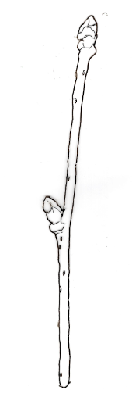 | 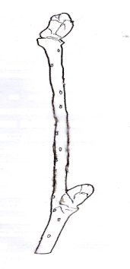 | 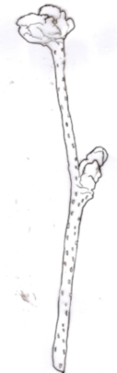
1 | 2 | 3
sparse | medium | dense

Ad. 5: One-year-old-shoot: density of hairs

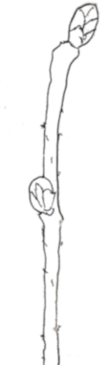 | 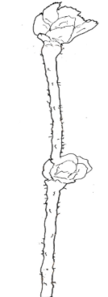 | 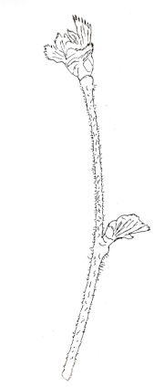
1 | 2 | 3
sparse | medium | dense

Ad. 6: Bud: shape

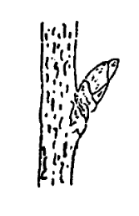 | 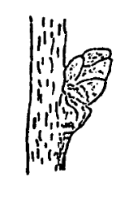 | 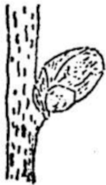
1 | 2 | 3
conical | ovoid | globose

Ad. 12: Leaf blade: shape

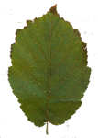 | 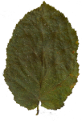 | 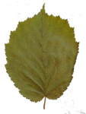 | 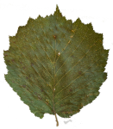
1 | 2 | 3 | 4
elliptic | ovate | obovate | circular

Ad. 16: Involucre: constriction

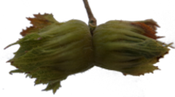 | 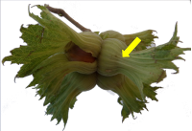
1 | 9
absent | present

Ad. 17: Involucre: length in relation to length of nut

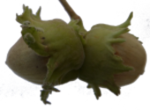 | 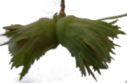 | 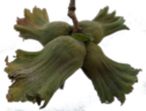
1 | 2 | 3
shorter | equal | longer

Ad. 18: Involucre: depth of indentations

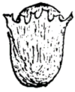 | 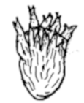 | 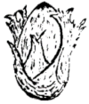
1 | 2 | 3
shallow | medium | deep

Ad. 19: Involucre: serration on the fruit

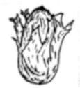 | 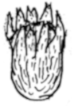 | 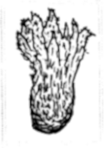
1 | 2 | 3
weak | medium | strong

Ad. 20: Involucre: size of basal support

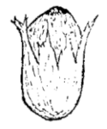 | 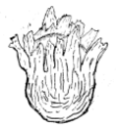 | 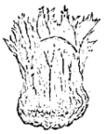
1 | 2 | 3
small | medium | large

Ad. 21: Involucre: jointing of bracts

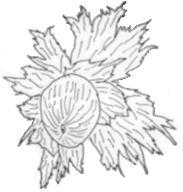 | 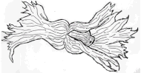 | 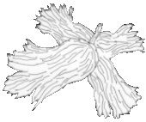
1 | 2 | 3
absent | on one side | on both sides

Ad. 24: Nut: shape in lateral view

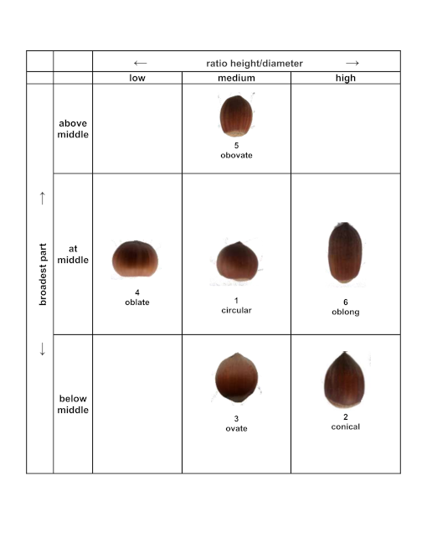

Ad. 25: Nut: shape in cross-section

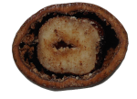 | 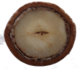 | 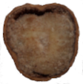 | 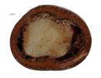
1 | 2 | 3 | 4
elliptic | circular | angular | transverse oblong

Ad. 28: Nut: shape of apex

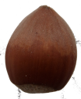 | 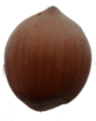 | 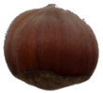 | 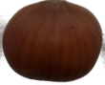
1 | 2 | 3 | 4
narrow acute | broad acute | obtuse | truncate

Ad. 29: Nut: prominence of mucron

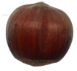 | 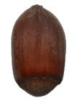 | 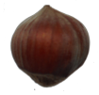
1 | 2 | 3
weak | medium | strong

Ad. 30: Nut: size of pistil scar

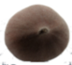 | 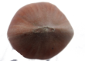 | 
1 | 2 | 3
small | medium | large

Ad. 32: Nut size of basal scar in relation to size of nut

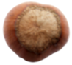 | 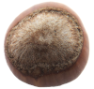 | 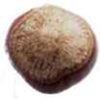
1 | 2 | 3
small | medium | large

Ad. 33: Nut: curvature of basal scar

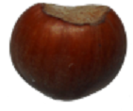 | 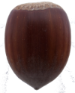 | 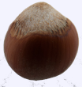
1 | 2 | 3
concave | flat | convex

Ad. 35: Kernel: shape in lateral view

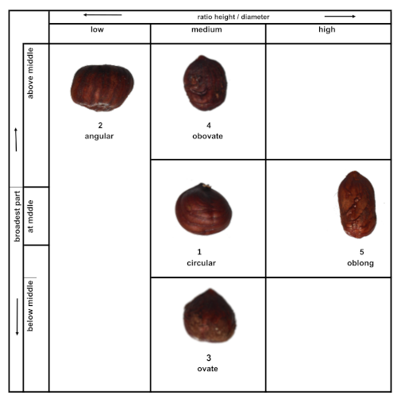

Ad. 36: Kernel: shape of apex

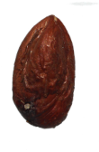 | 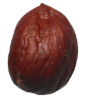 | 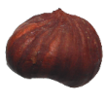
1 | 2 | 3
pointed | rounded | truncate

Ad. 37: Kernel: shape in cross-section

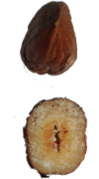 | 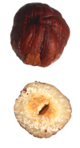 | 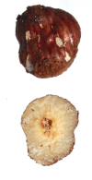
1 | 2 | 3
oblong | circular | obovate

Ad. 38: Kernel: shape of base

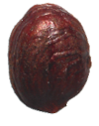 | 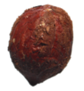 | 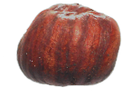
1 | 2 | 3
pointed | rounded | truncate

Ad. 40: Kernel: lateral groove

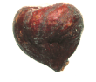 | 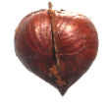
1 | 9
absent | present

Ad. 41: Kernel: presence of fiber

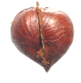 | 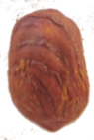 | 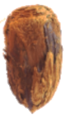
1 | 3 | 5
absent or weak | medium | strong

Ad. 48: Time of harvest maturity

Time of harvest maturity is reached when 50% of the fruits have fallen off.

8.3 Synonyms of example varieties

Example variety | Synonym(s)
Apoldaer Zellernuss  Bergeri  Camponica  Fertile de Coutard | Apolda  Bergère, Bergers Zellernuss, La Berger, Louis Berge.  Campanica, Tonda Napoletana, Tonda Tempestiva, Camponeca.  Barcelona, Castanyera, Grada di Viseu, Grande.
Gunslebert | Grosse Gunslebener Zellernuss, Gunslebener Riesennuss, Gunslebert Zellernuss,Gunslebener Zellernuss.
Kargalak | Imperiale de Trapezunt, Inperiale de Trèbizonde, Trapezunski, Trapezunter Kaiserhasel, Karidaty. Karidati
Lambert's Filbert | Longa de Spagna, Du Chilly, Filbert Cop, Kentish Cob, Korthaset Zellernuss, Lambert Filbert, Grosse Longue.
Merveille de Bollwiller  Morell  Negret  Palaz  Tombul | Bollwiller, Wissmanns Zellernuss, Wunder aus Bollwiller, Hallesche Riesennus, Zàzrak z Bollwilleru, Gèante du Halle.  Flocal, Falsetana.  Negreta  Pallaz  Mehmet Arif, Yaglii Findik, Giresum Yaglisi.

9. | Literature

Bignami, C., De Salvador, R.F., Strabbioli, G., 1999: "Aspetti agronomici e prospettive di valorizzazione della corilicoltura nel Lazio", Frutticoltura, n.11. 16-27, Rome, IT

Bioversity, FAO and CIHEAM. 2008. Descriptors for hazelnut (Corylus avellana L.). Bioversity International, Rome, Italy; Food and Agriculture Organization of the United Nations, Rome, Italy; International Centre for Advanced Mediterranean Agronomic Studies, Zaragoza, ES.

Cristoferi,V., Rouphael, Y., de Gyves, E.M., Bignami, C., 2007. "A simple model for estimating leaf area of hazelnut from linearmeasurements. Scientia Horticulturae 113 (2007) 221-225

Cristoferi, V., Pica, A.L., Silestri C., Bizzarri, S., 2018: "Phenology and yield evaluatation of hazelnut cultivars in Latium Region",Acta Hortic. 1226 pp 20-130, Viterbo, IT.

De Salvador, F.R., Giorgioni, M., Massari, D., Bizzarri, S., Onorati, P., Kaswalder, F., 2002: "La collezione di Vico Matrino (VT) per il rinnovo varietale ed il miglioramento qualitativo del nocciolo", 2° Convegno Nazionale sul nocciolo, Giffoni V.P., 171-177, Rome, IT.

De Salvador, F.R., Bignami, C., Bizzarri, S., Cristoferi, V., 2005: "Monografia di cultivar di nocciolo", Regione Lazio - Area D20 Servizi di sviluppo Agricolo e Informazione Socio-economica. Stampato da Tipolitografia C.S.R. - Centro Stampa e Riproduzione, Rome, IT.

Koksal, A.I. 2002 Turkish hazelnut cultivars Hazelnut Promotion Group ISBN: 975-92886-1-3
https://www.nadirkitap.com/turkish-hazelnut-cultivars-prof-dr-a-ilhami-koksal-kitap28602263.html

​​​Manzo, P., Tamponi,G., 1982: "Monografia di cultivar di nocciuolo", Istituto Sperimentale per la Frutticoltura, Rome, IT.

Mehlenbacher, S.A., 1994: "Genetic improvement of the hazelnut. Acta Horticulturae 351, 23-38, Corvallis, Oregon, US.

Pacchiarelli, A.; Lupo, M.;Ferrucci, A.; Giovanelli, F.; Priori, S.;Pica, A.L.; Silvestri, C.; Cristofori, V.2024. Phenology, Yield and Nut Traits Evaluation of Twelve European Hazelnut Cultivars Grown in Central Italy. Forests 2024, 15, 833. https://
doi.org/10.3390/f15050833.Viterbo IT.

Rovira, M., 1997: "Genetic variability among hazelnut (Corylus avellana L.) cultivars". Acta Horticulturae. 445: 45-50Rheus, ES.

Tombesi, A., Limongelli, F., 2002: "Varietà e miglioramento genetico del nocciolo", 2° Convegno Nazionale sul nocciolo, Giffoni V.P., ottobre 2002, 11:27, Rome, IT

10. | Technical Questionnaire

TECHNICAL QUESTIONNAIRE | Page {x} of {y} | Reference Number:

Application date:
(not to be filled in by the applicant)
TECHNICAL QUESTIONNAIRE
to be completed in connection with an application for plant breeders' rights

1. | Subject of the Technical Questionnaire
 | 1.1.1 | Botanical name | Corylus avellana L. | [ ]
 | 1.1.2 | Common name | Hazelnut
 | 1.2.1 | Botanical name | Corylus colurna L. | [ ]
 | 1.2.2 | Common name | Turkish Hazel
 | 1.3.1 | Botanical name | Corylus americana Marshall | [ ]
 | 1.3.2 | Common name | American filbert, American hazel, Hazelnut

2. | Applicant
 | Name
 | Address
 | Telephone No.
 | Fax No.
 | E-mail address
 | Breeder (if different from
 | applicant)

3. | Proposed denomination and breeder's reference
 | Proposed denomination
 | (if available)
 | Breeder's reference

TECHNICAL QUESTIONNAIRE |  |  | Page {x} of {y} | Reference Number:
#4. | Information on the breeding scheme and propagation of the variety
 | 4.1 | Breeding scheme
 | Variety resulting from:
4.1.1 | Crossing
(a) | controlled cross | [ ]
(please state parent variety)

(…………………..……………..…) x (……………..…………………..…)

female parent male parent

(b) | partially known cross | [ ]
(please state known parent variety(ies))

(…………………..……………..…) x (……………..…………………..…)

female parent male parent

(c) | unknown cross | [ ]
4.1.2 | Mutation  (please state parent variety) | [ ]
4.1.3 | Discovery and development  (please state where and when discovered and how developed) | [ ]
4.1.4 | Other  (Please provide details) | [ ]

TECHNICAL QUESTIONNAIRE | Page {x} of {y} | Reference Number:

 | 4.2 | Method of propagating the variety
4.2.1 | Vegetative propagation
(a) | Stool bed layering | [ ]
(b) | Other (state method) | [ ]
4.2.2 | Other  (Please provide details) | [ ]

TECHNICAL QUESTIONNAIRE | Page {x} of {y} | Reference Number:

5. | Characteristics of the variety to be indicated (the number in brackets refers to the corresponding characteristic in Test Guidelines; please mark the note which best corresponds).

 | Characteristics | Example Varieties | Note
5.1  (12) | Leaf blade: shape
 | elliptic | Merveille de Bollwiller | 1 [ ]
 | ovate | Lambert's Filbert | 2 [ ]
 | obovate | Tonda di Giffoni | 3 [ ]
 | circular | Segorbe | 4 [ ]
5.2  (17) | Involucre: length in relation to length of nut
 | shorter | Tonda Bianca | 1 [ ]
 | same length | Cosford, Fertile de Coutard, Merveille de Bollwiller | 2 [ ]
 | longer | Kargalak, Lambert's Filbert, Segorbe, Tombul, Tonda Gentile delle Langhe | 3 [ ]
5.3  (18) | Involucre: depth of indentations
 | shallow | Lambert's Filbert, Tombul | 1 [ ]
 | medium | Fertile de Coutard, Tonda Gentile delle Langhe | 2 [ ]
 | deep | Gunslebert | 3 [ ]
5.4  (23) | Nut: size
 | very small | Sivri | 1 [ ]
 | small | Negret, Tombul, Tonda Gentile delle Langhe | 2 [ ]
 | medium | Morell, Segorbe, Tonda di Giffoni | 3 [ ]
 | large | Fertile de Coutard, Merveille de Bollwiller | 4 [ ]
 | very large | Apoldaer Zellernuss, Bergeri, Ennis | 5 [ ]
5.5  (24) | Nut: shape in lateral view
 | circular | Clark, Fertile de Coutard, Tonda Gentile delle Langhe | 1 [ ]
 | conical | Ennis, Jean's, Merveille de Bollwiller | 2 [ ]
 | ovate | Imperatrice Eugenie, Negret | 3 [ ]
 | oblate | Kargalak | 4 [ ]
 | obovate | Butler | 5 [ ]
 | oblong | Cosford, Lambert's Filbert | 6 [ ]

 | Characteristics | Example Varieties | Note
5.6  (25) | Nut: shape in cross-section
 | elliptic | Lambert's Filbert, Negret | 1 [ ]
 | circular | Merveille de Bollwiller, Tonda Romana | 2 [ ]
 | angular | Tonda Gentile delle Langhe | 3 [ ]
 | transverse oblong | Gunslebert | 4 [ ]
5.7  (43) | Nut: percentage of kernel
 | very low | Merveille de Bollwiller | 1 [ ]
 | low | Fertile de Coutard, Segorbe | 2 [ ]
 | medium | Negret, Tonda Gentile delle Langhe | 3 [ ]
 | high | Daviana, Imperatrice Eugenie | 4 [ ]
 | very high | Cosford, Tombul | 5 [ ]
5.8  (44) | Time of female flowering
 | very early | San Giovanni | 1 [ ]
 | early | Comen, Fertile de Coutard, Tonda di Giffoni | 2 [ ]
 | medium | Tonda Bianca, Tonda Gentile delle Langhe | 3 [ ]
 | late | Daviana, Lambert's Filbert, Morell, Segorbe | 4 [ ]
 | very late | Bergeri, Gunslebert, Merveille de Bollwiller | 5 [ ]
5.9  (45) | Time of male flowering
 | very early | Tonda Gentile delle Langhe | 1 [ ]
 | early | Palaz | 2 [ ]
 | medium | Negret | 3 [ ]
 | late | Lambert's Filbert | 4 [ ]
 | very late | Morell | 5 [ ]
5.10  (48) | Time of harvest maturity
 | very early | San Pere | 1 [ ]
 | early | Tonda Gentile delle Langhe | 2 [ ]
 | medium | Daviana, Morell, Tonda Romana | 3 [ ]
 | late | Merveille de Bollwiller, Negret | 4 [ ]
 | very late | Bergeri | 5 [ ]

TECHNICAL QUESTIONNAIRE | Page {x} of {y} | Reference Number:

6. | Similar varieties and differences from these varieties
Please use the following table and box for comments to provide information on how your candidate variety differs from the variety (or varieties) which, to the best of your knowledge, is (or are) most similar. This information may help the examination authority to conduct its examination of distinctness in a more efficient way.

Denomination(s) of variety(ies) similar to your candidate variety | Characteristic(s) in which your candidate variety differs from the similar variety(ies) | Describe the expression of the characteristic(s) for the similar variety(ies) | Describe the expression of the characteristic(s) for your candidate variety

Example | Nut size: small | Tonda Gentile delle Langhe | Nut shape in lateral view: circular (Fertile de Coutard)

 | Comments:

TECHNICAL QUESTIONNAIRE | Page {x} of {y} | Reference Number:

#7. | Additional information which may help in the examination of the variety
7.1 | In addition to the information provided in sections 5 and 6, are there any additional characteristics which may help to distinguish the variety?
 | Yes | [ ] | No | [ ]
 | (If yes, please provide details)
7.2 | Are there any special conditions for growing the variety or conducting the examination?
 | Yes | [ ] | No | [ ]
 | (If yes, please provide details)
7.3 | Other information
A representative color photograph of the variety displaying its main distinguishing feature(s), should accompany the Technical Questionnaire. The photograph will provide a visual illustration of the candidate variety which supplements the information provided in the Technical Questionnaire.
The key points to consider when taking a photograph of the candidate variety are:
• Indication of the date and geographic location
• Correct labeling (breeder’s reference)
• Good quality printed photograph (minimum 10 cm x 15 cm) and/or sufficient resolution electronic format version (minimum 960 x 1280 pixels)”
Further guidance on providing photographs with the Technical Questionnaire is available in document TGP/7 "Development of Test Guidelines", Guidance Note 35 (http://www.upov.int/tgp/en/).
[The link provided may be deleted by members of the Union when developing authorities’ own test guidelines.]

TECHNICAL QUESTIONNAIRE | Page {x} of {y} | Reference Number:

8. | Authorization for release
 | (a) | Does the variety require prior authorization for release under legislation concerning the protection of the environment, human and animal health?
 |  | Yes | [ ] | No | [ ]
 | (b) | Has such authorization been obtained?
 |  | Yes | [ ] | No | [ ]
 | If the answer to (b) is yes, please attach a copy of the authorization.

9. Information on plant material to be examined or submitted for examination

9.1 The expression of a characteristic or several characteristics of a variety may be affected by factors, such as pests and disease, chemical treatment (e.g. growth retardants or pesticides), effects of tissue culture, different rootstocks, scions taken from different growth phases of a tree, etc.
9.2 The plant material should not have undergone any treatment which would affect the expression of the characteristics of the variety, unless the competent authorities allow or request such treatment. If the plant material has undergone such treatment, full details of the treatment must be given. In this respect, please indicate below, to the best of your knowledge, if the plant material to be examined has been subjected to:

 | (a) | Microorganisms (e.g. virus, bacteria, phytoplasma) | Yes [ ] | No [ ]
 | (b) | Chemical treatment (e.g. growth retardant, pesticide) | Yes [ ] | No [ ]
 | (c) | Tissue culture | Yes [ ] | No [ ]
 | (d) | Other factors | Yes [ ] | No [ ]
 | Please provide details for where you have indicated “yes”.

10. | I hereby declare that, to the best of my knowledge, the information provided in this form is correct:
 | Applicant’s name
 | Signature |  | Date

[End of document]

