|  |  |  |  |  |  |
| --- | --- | --- | --- | --- | --- |
|  | 75 | | | E  **TG/256/2(proj.3)**  ORIGINAL: English  **DATE**: 2025-05-16 | |
| INTERNATIONAL UNION FOR THE PROTECTION OF NEW VARIETIES OF PLANTS | | | | |
| Geneva | | | | |
| DRAFT |

|  |  |  |
| --- | --- | --- |
|  | GRANADILLA, PASSION FRUIT  UPOV Code(s): PASSI_EDU  *Passifloraedulis* Sims | * |

GUIDELINESFOR THE CONDUCT OF TESTS  
FOR DISTINCTNESS, UNIFORMITY AND STABILITY

prepared by an expert from Australia

to be considered by the

Technical Working Party for Fruit Crops at its fifty-sixth session,

to be held in Bursa, Türkiye, from 2025-06-23 to 2025-06-26

Disclaimer: this document does not represent UPOV policies or guidance

Alternative Names:*

| *Botanical name* | *English* | *French* | *German* | *Spanish* |
| --- | --- | --- | --- | --- |
| *Passifloraedulis* Sims | Granadilla, Passion fruit | Barbadine, Fruit de la passion | Passionsfrucht, Purpurgranadilla | Granadilla, Maracuyá |

The purpose of these guidelines (“Test Guidelines”) is to elaborate the principles contained in the General Introduction (document TG/1/3), and its associated TGP documents, into detailed practical guidance for the harmonized examination of distinctness, uniformity and stability (DUS) and, in particular, to identify appropriate characteristics for the examination of DUS and production of harmonized variety descriptions.

**ASSOCIATED DOCUMENTS**

These Test Guidelines should be read in conjunction with the General Introduction and its associated

TGP documents.

TABLE OF CONTENTS PAGE

1. Subject of these Test Guidelines 3

2. Material Required 3

3. Method of Examination 3

3.1  Number of Growing Cycles 3

3.2  Testing Place 3

3.3  Conditions for Conducting the Examination 3

3.4  Test Design 3

3.5  Additional Tests 4

4. Assessment of Distinctness, Uniformity and Stability 4

4.1  Distinctness 4

4.2  Uniformity 5

4.3  Stability 5

5. Grouping of Varieties and Organization of the Growing Trial 5

6. Introduction to the Table of Characteristics 6

6.1  Categories of Characteristics 6

6.2  States of Expression and Corresponding Notes 6

6.3  Types of Expression 6

6.4  Example Varieties 6

6.5  Legend 7

7. Table of Characteristics/Tableau des caracteres/Merkmalstabelle/Tabla de caracteres 8

8. Explanations on the Table of Characteristics 20

8.1  Explanations covering several characteristics 20

8.2  Explanations for individual characteristics 22

9. Literature 26

10. Technical Questionnaire 27

# Subject of these Test Guidelines

These Test Guidelines apply to all varieties of *Passifloraedulis* Sims.

# Material Required

2.1 The competent authorities decide on the quantity and quality of the plant material required for testing the variety and when and where it is to be delivered. Applicants submitting material from a State other than that in which the testing takes place must ensure that all customs formalities and phytosanitary requirements are complied with.

2.2 The material is to be supplied in the form of rooted cuttings or vegetatively propagated young plants.

2.3 The minimum quantity of plant material, to be supplied by the applicant, should be:

5 rooted cuttings or 5 vegetatively propagated young plants.

2.4 The plant material supplied should be visibly healthy, not lacking in vigor, nor affected by any important pest or disease.

2.5 The plant material should not have undergone any treatment which would affect the expression of the characteristics of the variety, unless the competent authorities allow or request such treatment. If it has been treated, full details of the treatment must be given.

# Method of Examination

## 3.1  Number of Growing Cycles

3.1.1 The minimum duration of tests should normally be two independent growing cycles.

3.1.2 The two independent growing cycles may be observed from a single planting, examined in two separate growing cycles.

3.1.3 The growing cycle is considered to be the period ranging from the beginning of active vegetative growth or flowering, continuing through active vegetative growth or flowering and fruit development and concluding with the harvesting of fruit.

3.1.4 In particular, it is essential that the plants produce a satisfactory crop of fruit in each of the two growing cycles.

3.1.5 To ensure satisfactory crop of good quality fruits, four freshly opened flower from each of the five plants should be hand pollinated and marked. Fruit developed from these flowers should be used for assessing fruit characteristics.

3.1.6 The testing of a variety may be concluded when the competent authority can determine with certainty the outcome of the test.

## 3.2  Testing Place

Tests are normally conducted at one place. In the case of tests conducted at more than one place, guidance is provided in TGP/9 “Examining Distinctness”.

## 3.3  Conditions for Conducting the Examination

The tests should be carried out under conditions ensuring satisfactory growth for the expression of the relevant characteristics of the variety and for the conduct of the examination.

## 3.4  Test Design

3.4.1 Each test should be designed to result in a total of at least 5 plants.

3.4.2 The design of the tests should be such that plants or parts of plants may be removed for measurement or counting without prejudice to the observations which must be made up to the end of the growing cycle.

## 3.5  Additional Tests

Additional tests, for examining relevant characteristics, may be established.

# Assessment of Distinctness, Uniformity and Stability

## 4.1  Distinctness

4.1.1 General Recommendations

It is of particular importance for users of these Test Guidelines to consult the General Introduction prior to making decisions regarding distinctness. However, the following points are provided for elaboration or emphasis in these Test Guidelines.

4.1.2 Consistent Differences

The differences observed between varieties may be so clear that more than one growing cycle is not necessary. In addition, in some circumstances, the influence of the environment is not such that more than a single growing cycle is required to provide assurance that the differences observed between varieties are sufficiently consistent. One means of ensuring that a difference in a characteristic, observed in a growing trial, is sufficiently consistent is to examine the characteristic in at least two independent growing cycles.

4.1.3 Clear Differences

Determining whether a difference between two varieties is clear depends on many factors, and should consider, in particular, the type of expression of the characteristic being examined, i.e. whether it is expressed in a qualitative, quantitative, or pseudo-qualitative manner. Therefore, it is important that users of these Test Guidelines are familiar with the recommendations contained in the General Introduction prior to making decisions regarding distinctness.

4.1.4 Number of Plants or Parts of Plants to be Examined

Unless otherwise indicated, for the purposes of distinctness, all observations on single plants should be made on 5 plants or parts of plants taken from each of 5 plants and any other observations made on all plants in the test, disregarding any off-type plants.

In the case of observations of parts taken from single plants, the number of parts to be taken from each of the plants should be 2.

4.1.5 Method of Observation

The recommended method of observing the characteristic for the purposes of distinctness is indicated by the following key in the Table of Characteristics (see document TGP/9 “Examining Distinctness”, Section 4 “Observation of characteristics”):

MG: single measurement of a group of plants or parts of plants

MS: measurement of a number of individual plants or parts of plants

VG: visual assessment by a single observation of a group of plants or parts of plants

VS: visual assessment by observation of individual plants or parts of plants”):

Type of observation: visual (V) or measurement (M)

“Visual” observation (V) is an observation made on the basis of the expert’s judgment. For the purposes of this document, “visual” observation refers to the sensory observations of the experts and, therefore, also includes smell, taste and touch. Visual observation includes observations where the expert uses reference points (e.g. diagrams, example varieties, side-by-side comparison) or non-linear charts (e.g. color charts). Measurement (M) is an objective observation against a calibrated, linear scale e.g. using a ruler, weighing scales, colorimeter, dates, counts, etc.

Type of record: for a group of plants (G) or for single, individual plants (S)

For the purposes of distinctness, observations may be recorded as a single record for a group of plants or parts of plants (G), or may be recorded as records for a number of single, individual plants or parts of plants (S). In most cases, “G” provides a single record per variety and it is not possible or necessary to apply statistical methods in a plant-by-plant analysis for the assessment of distinctness.

In cases where more than one method of observing the characteristic is indicated in the Table of Characteristics (e.g. VG/MG), guidance on selecting an appropriate method is provided in document TGP/9, Section 4.2.

## 4.2  Uniformity

4.2.1 It is of particular importance for users of these Test Guidelines to consult the General Introduction prior to making decisions regarding uniformity. However, the following points are provided for elaboration or emphasis in these Test Guidelines:

4.2.2 These Test Guidelines have been developed for the examination of vegetatively propagated varieties. For varieties with other types of propagation, the recommendations in the General Introduction and document TGP/13 "Guidance for new types and species" Section 4.5 "Testing Uniformity" should be followed.

4.2.3 For the assessment of uniformity of vegetatively propagated varieties a population standard of 1% and an acceptance probability of at least 95% should be applied. In the case of a sample size of 5 plants, no off-types are allowed.

## 4.3  Stability

4.3.1 In practice, it is not usual to perform tests of stability that produce results as certain as those of the testing of distinctness and uniformity. However, experience has demonstrated that, for many types of variety, when a variety has been shown to be uniform, it can also be considered to be stable.

4.3.2 Where appropriate, or in cases of doubt, stability may be further examined by testing a new seed or plant stock to ensure that it exhibits the same characteristics as those shown by the initial material supplied.

# Grouping of Varieties and Organization of the Growing Trial

5.1 The selection of varieties of common knowledge to be grown in the trial with the candidate varieties and the way in which these varieties are divided into groups to facilitate the assessment of distinctness are aided by the use of grouping characteristics.

5.2 Grouping characteristics are those in which the documented states of expression, even where produced at different locations, can be used, either individually or in combination with other such characteristics: (a) to select varieties of common knowledge that can be excluded from the growing trial used for examination of distinctness; and (b) to organize the growing trial so that similar varieties are grouped together.

5.3 The following have been agreed as useful grouping characteristics:

(a) Flower: anthocyanin spots on style (characteristic 35)

(b) Fruit: height (characteristic 37)

(c) Fruit: color of skin (characteristic 42)

(d) Fruit: weight (characteristic 44)

(e) Fruit: color of pulp (characteristic 45)

(f) Plant: self-incompatibility (characteristic 48)

5.4 Guidance for the use of grouping characteristics, in the process of examining distinctness, is provided through the General Introduction and document TGP/9 “Examining Distinctness”.

# Introduction to the Table of Characteristics

## 6.1  Categories of Characteristics

6.1.1 Standard Test Guidelines Characteristics

Standard Test Guidelines characteristics are those which are approved by UPOV for examination of DUS and from which members of the Union can select those suitable for their particular circumstances.

6.1.2 Asterisked Characteristics

Asterisked characteristics (denoted by *) are those included in the Test Guidelines which are important for the international harmonization of variety descriptions and should always be examined for DUS and included in the variety description by all members of the Union, except when the state of expression of a preceding characteristic or regional environmental conditions render this inappropriate.

## 6.2  States of Expression and Corresponding Notes

6.2.1 States of expression are given for each characteristic to define the characteristic and to harmonize descriptions. Each state of expression is allocated a corresponding numerical note for ease of recording of data and for the production and exchange of the description.

6.2.2 All relevant states of expression are presented in the characteristic.

6.2.3 Further explanation of the presentation of states of expression and notes is provided in document TGP/7 “Development of Test Guidelines”.

## 6.3  Types of Expression

An explanation of the types of expression of characteristics (qualitative, quantitative and pseudo-qualitative) is provided in the General Introduction.

## 6.4  Example Varieties

Where appropriate, example varieties are provided to clarify the states of expression of each characteristic.

## 6.5  Legend

|  |  |  |  |  |  |  |  |  |  |
| --- | --- | --- | --- | --- | --- | --- | --- | --- | --- |
|  | | English | | français | | deutsch | español | Example Varieties  Exemples  Beispielssorten  Variedades ejemplo | Note/  Nota |
| **1** | **2** | **3** | **4** | **5** | **6** | **7** |  |  |  |
|  |  | **Name of characteristics in English** | | **Nom du caractère en français** | | **Name des Merkmals auf Deutsch** | **Nombre del carácter en español** |  |  |
|  | states of expression | | types d’expression | | Ausprägungsstufen | tipos de expresión |  |  |

1 Characteristic number

2 (*) Asterisked characteristic – see Chapter 6.1.2

3 Type of expression

QL Qualitative characteristic – see Chapter 6.3

QN Quantitative characteristic – see Chapter 6.3

PQ Pseudo-qualitative characteristic – see Chapter 6.3

4 Method of observation (and type of plot, if applicable)

MG, MS, VG, VS – see Chapter 4.1.5

5 (+) See Explanations on the Table of Characteristics in Chapter 8.2

6 (a)-(x) See Explanations on the Table of Characteristics in Chapter 8.1

7 Growth stage key (if applicable) See Explanations on the Table of Characteristics in Chapter 8.3

# Table of Characteristics/Tableau des caracteres/Merkmalstabelle/Tabla de caracteres

|  | | English | | français | | deutsch | español | Example Varieties  Exemples  Beispielssorten  Variedades ejemplo | Note/  Nota |
| --- | --- | --- | --- | --- | --- | --- | --- | --- | --- |
| **1.** |  | **QN** | **VG** | **(+)** |  |  |  |  |  |
|  | | **Plant: vigor** | |  | |  |  |  |  |
| very weak | |  | |  |  | Lacey | 1 |
| weak | |  | |  |  | Misty Gem | 2 |
| medium | |  | |  |  | Tango | 3 |
| strong | |  | |  |  | Flamenco | 4 |
| very strong | |  | |  |  | Toms Special | 5 |
| **2.** |  | **PQ** | **VG** | **(+)** |  |  |  |  |  |
|  | | **Shoot: color** | |  | |  |  |  |  |
| light green | |  | |  |  | Nellie Kelly Black, Summer Queen | 1 |
| medium green | |  | |  |  | Misty Gem | 2 |
| dark green | |  | |  |  | Charité, Ester | 3 |
| greenish purple | |  | |  |  |  | 4 |
| purple | |  | |  |  | Panama Gold | 5 |
| **3.** |  | **QN** | **VG** |  | **(a)** |  |  |  |  |
|  | | **Plant: relative number of leaves with three lobes** | |  | |  |  |  |  |
| absent or very few | |  | |  |  | OPA6/19 | 1 |
| few | |  | |  |  |  | 2 |
| medium | |  | |  |  | OPA4/19 | 3 |
| many | |  | |  |  | Misty Gem | 4 |
| very many | |  | |  |  | Flamenco, Toms Special | 5 |
| **4.** |  | **QN** | **VG** |  |  |  |  |  |  |
|  | | **Stipules: anthocyanin coloration** | |  | |  |  |  |  |
| absent or weak | |  | |  |  | Flamenco | 1 |
| medium | |  | |  |  |  | 2 |
| strong | |  | |  |  | Panama Gold | 3 |
| **5.** |  | **QN** | **VG** |  | **(a)** |  |  |  |  |
|  | | **Leaf blade: blistering** | |  | |  |  |  |  |
| absent or weak | |  | |  |  | Panama Gold | 1 |
| medium | |  | |  |  | Panama Red | 2 |
| strong | |  | |  |  | Nellie Kelly Black | 3 |
| **6.** |  | **QN** | **MS/VG** |  | **(a),(d)** |  |  |  |  |
|  | | **Leaf blade: length** | |  | |  |  |  |  |
| very short | |  | |  |  |  | 1 |
| very short to short | |  | |  |  |  | 2 |
| short | |  | |  |  | Lacey | 3 |
| short to medium | |  | |  |  | Sweetheart | 4 |
| medium | |  | |  |  | Flamenco, Misty Gem | 5 |
| medium to long | |  | |  |  | Panama Red | 6 |
| long | |  | |  |  | OPA3/19, OPA4/19 | 7 |
| long to very long | |  | |  |  | OPA12/19 | 8 |
| very long | |  | |  |  | OPA6/19 | 9 |
| **7.** |  | **QN** | **MS/VG** |  | **(a),(d)** |  |  |  |  |
|  | | **Leaf blade: width** | |  | |  |  |  |  |
| very narrow | |  | |  |  |  | 1 |
| very narrow to narrow | |  | |  |  |  | 2 |
| narrow | |  | |  |  | E23 | 3 |
| narrow to medium | |  | |  |  | Lacey | 4 |
| medium | |  | |  |  | Misty Gem, Toms Special | 5 |
| medium to broad | |  | |  |  | Flamenco | 6 |
| broad | |  | |  |  | OPA13/19, Tango | 7 |
| broad to very broad | |  | |  |  | OPA3/19 | 8 |
| very broad | |  | |  |  |  | 9 |
| **8.** |  | **QN** | **MS/VG** |  | **(a),(d)** |  |  |  |  |
|  | | **Only varieties with: Plant: relative number of leaves with three lobes: present: Leaf blade: width of the middle lobe** | |  | |  |  |  |  |
| very narrow | |  | |  |  |  | 1 |
| very narrow to narrow | |  | |  |  |  | 2 |
| narrow | |  | |  |  | Lacey, Sweetheart | 3 |
| narrow to medium | |  | |  |  | E23, Toms Special | 4 |
| medium | |  | |  |  | Misty Gem | 5 |
| medium to broad | |  | |  |  | OPA5/19, OPA7/19 | 6 |
| broad | |  | |  |  | OPA11/19, OPA4/19 | 7 |
| broad to very broad | |  | |  |  | McGuffies Red, OPA3/19 | 8 |
| very broad | |  | |  |  | OPA12/19 | 9 |
| **9.** |  | **QN** | **VG** |  | **(a)** |  |  |  |  |
|  | | **Leaf blade: intensity of green color of upper side** | |  | |  |  |  |  |
| very light | |  | |  |  |  | 1 |
| light | |  | |  |  | Lacey | 2 |
| medium | |  | |  |  | McGuffies Red, Pandora | 3 |
| dark | |  | |  |  | Sweetheart, Tango | 4 |
| very dark | |  | |  |  | OPA6/19 | 5 |
| **10.** |  | **QN** | **VG** |  | **(a)** |  |  |  |  |
|  | | **Leaf blade: glossiness of upper side** | |  | |  |  |  |  |
| weak | |  | |  |  | E23 | 1 |
| medium | |  | |  |  | Flamenco, Tango | 2 |
| strong | |  | |  |  | OPA6/19, Sweetheart | 3 |
| **11.** |  | **PQ** | **VG** | **(+)** | **(a)** |  |  |  |  |
|  | | **Leaf blade: shape of base** | |  | |  |  |  |  |
| acute | |  | |  |  |  | 1 |
| obtuse | |  | |  |  |  | 2 |
| truncate | |  | |  |  |  | 3 |
| weakly cordate | |  | |  |  | OPA4/19 | 4 |
| strongly cordate | |  | |  |  | Flamenco, Misty Gem | 5 |
| **12.** |  | **QN** | **MS/VG** | **(+)** | **(a),(d)** |  |  |  |  |
|  | | **Leaf blade: depth of sinus** | |  | |  |  |  |  |
| absent or very shallow | |  | |  |  | OPA6/19 | 1 |
| shallow | |  | |  |  |  | 2 |
| medium | |  | |  |  | Panama Red | 3 |
| deep | |  | |  |  | Panama Gold | 4 |
| very deep | |  | |  |  |  | 5 |
| **13.** |  | **QN** | **MS/VG** |  | **(a)** |  |  |  |  |
|  | | **Petiole: length** | |  | |  |  |  |  |
| very short | |  | |  |  |  | 1 |
| very short to short | |  | |  |  |  | 2 |
| short | |  | |  |  | Tango, Toms Special | 3 |
| short to medium | |  | |  |  | Misty Gem, OPA13/19 | 4 |
| medium | |  | |  |  | Flamenco, OPA3/19 | 5 |
| medium to long | |  | |  |  | McGuffies Red, OPA4/19 | 6 |
| long | |  | |  |  | OPA11/19, OPA7/19 | 7 |
| long to very long | |  | |  |  | OPA12/19 | 8 |
| very long | |  | |  |  |  | 9 |
| **14.** |  | **QN** | **VG** |  | **(a)** |  |  |  |  |
|  | | **Petiole: anthocyanin coloration** | |  | |  |  |  |  |
| absent or weak | |  | |  |  | Misty Gem, Toms Special | 1 |
| medium | |  | |  |  | Lacey, McGuffies Red | 2 |
| strong | |  | |  |  | Panama Gold | 3 |
| **15.** | **(*)** | **QL** | **VG** | **(+)** | **(a)** |  |  |  |  |
|  | | **Petiole: position of nectaries** | |  | |  |  |  |  |
| adjacent to the base of the leaf blade | |  | |  |  | Flamenco, Lacey | 1 |
| distant from the base of the leaf blade | |  | |  |  | E23, OPA3/19 | 2 |
| **16.** |  | **QN** | **MS/VG** |  | **(b)** |  |  |  |  |
|  | | **Flower: length of pedicel** | |  | |  |  |  |  |
| very short | |  | |  |  |  | 1 |
| short | |  | |  |  | Lacey | 2 |
| medium | |  | |  |  | Misty Gem | 3 |
| long | |  | |  |  | Flamenco, Toms Special | 4 |
| very long | |  | |  |  | OPA11/19, Sweetheart | 5 |
| **17.** |  | **QN** | **MS/VG** |  | **(b),(h)** |  |  |  |  |
|  | | **Flower: length of bract** | |  | |  |  |  |  |
| very short | |  | |  |  |  | 1 |
| short | |  | |  |  | Lacey, Misty Gem | 2 |
| medium | |  | |  |  | OPA3/19, Toms Special | 3 |
| long | |  | |  |  | McGuffies Red, OPA6/19 | 4 |
| very long | |  | |  |  | OPA12/19, Sweetheart | 5 |
| **18.** |  | **QN** | **MS/VG** |  | **(b),(h)** |  |  |  |  |
|  | | **Flower: width of bract** | |  | |  |  |  |  |
| very narrow | |  | |  |  |  | 1 |
| narrow | |  | |  |  | Flamenco, OPA13/19 | 2 |
| medium | |  | |  |  | McGuffies Red, Pandora | 3 |
| broad | |  | |  |  | OPA7/19, Tango | 4 |
| very broad | |  | |  |  | OPA6/19 | 5 |
| **19.** |  | **QL** | **VG** |  | **(b)** |  |  |  |  |
|  | | **Flower: nectaries on bract** | |  | |  |  |  |  |
| absent | |  | |  |  |  | 1 |
| present | |  | |  |  | Misty Gem | 9 |
| **20.** |  | **QL** | **VG** |  | **(b)** |  |  |  |  |
|  | | **Only varieties with Flower: nectaries on bract: present: Flower: color of nectaries on bract** | |  | |  |  |  |  |
| green | |  | |  |  | Lacey | 1 |
| purple | |  | |  |  |  | 2 |
| **21.** |  | **QN** | **MS/VG** |  | **(b),(h)** |  |  |  |  |
|  | | **Flower: length of sepal** | |  | |  |  |  |  |
| very short | |  | |  |  |  | 1 |
| short | |  | |  |  | Lacey | 2 |
| medium | |  | |  |  | Misty Gem, Sweetheart | 3 |
| long | |  | |  |  | OPA11/19 | 4 |
| very long | |  | |  |  |  | 5 |
| **22.** |  | **QN** | **MS/VG** |  | **(b),(h)** |  |  |  |  |
|  | | **Flower: width of sepal** | |  | |  |  |  |  |
| very narrow | |  | |  |  |  | 1 |
| narrow | |  | |  |  | OPA5/19 | 2 |
| medium | |  | |  |  | Lacey, Misty Gem | 3 |
| broad | |  | |  |  | OPA11/19 | 4 |
| very broad | |  | |  |  |  | 5 |
| **23.** |  | **QN** | **MS/VG** |  | **(b),(h)** |  |  |  |  |
|  | | **Flower: length of petal** | |  | |  |  |  |  |
| very short | |  | |  |  |  | 1 |
| short | |  | |  |  | OPA5/19 | 2 |
| medium | |  | |  |  | Flamenco, Sweetheart | 3 |
| long | |  | |  |  | McGuffies Red, Panama Red | 4 |
| very long | |  | |  |  |  | 5 |
| **24.** |  | **QN** | **MS/VG** |  | **(b),(h)** |  |  |  |  |
|  | | **Flower: width of petal** | |  | |  |  |  |  |
| very narrow | |  | |  |  |  | 1 |
| narrow | |  | |  |  | Lacey, OPA3/19 | 2 |
| medium | |  | |  |  | Flamenco, Sweetheart | 3 |
| broad | |  | |  |  | Toms Special | 4 |
| very broad | |  | |  |  |  | 5 |
| **25.** |  | **QN** | **MS/VG** |  | **(b),(g)** |  |  |  |  |
|  | | **Flower: length of androgynophore** | |  | |  |  |  |  |
| very short | |  | |  |  |  | 1 |
| short | |  | |  |  | Lacey, Misty Gem | 2 |
| medium | |  | |  |  | OPA12/19, Toms Special | 3 |
| long | |  | |  |  | Flamenco, OPA3/19 | 4 |
| very long | |  | |  |  |  | 5 |
| **26.** |  | **QN** | **VG** | **(+)** | **(b)** |  |  |  |  |
|  | | **Flower: intensity of color on inner filaments in throat** | |  | |  |  |  |  |
| absent or light | |  | |  |  | Flamenco | 1 |
| medium | |  | |  |  | OPA3/19, Toms Special | 2 |
| dark | |  | |  |  | OPA12/19 | 3 |
| **27.** |  | **QN** | **MS/VG** |  | **(b),(f)** |  |  |  |  |
|  | | **Flower: diameter of corona including filaments** | |  | |  |  |  |  |
| very small | |  | |  |  |  | 1 |
| small | |  | |  |  | Lacey | 2 |
| medium | |  | |  |  | Misty Gem, Sweetheart | 3 |
| large | |  | |  |  | OPA12/19 | 4 |
| very large | |  | |  |  |  | 5 |
| **28.** |  | **QN** | **MS/VG** |  | **(b),(f)** |  |  |  |  |
|  | | **Flower: width of purple rings on corona filaments** | |  | |  |  |  |  |
| absent or very narrow | |  | |  |  |  | 1 |
| narrow | |  | |  |  | OPA7/19 | 2 |
| medium | |  | |  |  | OPA5/19, Sweetheart | 3 |
| broad | |  | |  |  | OPA12/19 | 4 |
| very broad | |  | |  |  |  | 5 |
| **29.** | **(*)** | **QN** | **VG** |  | **(b)** |  |  |  |  |
|  | | **Flower: intensity of color of purple rings on corona filaments** | |  | |  |  |  |  |
| light | |  | |  |  | OPA7/19 | 1 |
| medium | |  | |  |  | Lacey, Misty Gem | 2 |
| dark | |  | |  |  | OPA12/19 | 3 |
| **30.** |  | **QN** | **MS/VG** |  | **(b),(i)** |  |  |  |  |
|  | | **Anther: length** | |  | |  |  |  |  |
| short | |  | |  |  |  | 1 |
| medium | |  | |  |  | Flamenco, Misty Gem | 2 |
| long | |  | |  |  | OPA11/19, OPA12/19 | 3 |
| **31.** |  | **QN** | **MS/VG** |  | **(b),(i)** |  |  |  |  |
|  | | **Anther: width** | |  | |  |  |  |  |
| narrow | |  | |  |  |  | 1 |
| medium | |  | |  |  | Sweetheart, Toms Special | 2 |
| broad | |  | |  |  | OPA13/19, OPA4/19 | 3 |
| **32.** |  | **QN** | **MS/VG** |  | **(b),(g)** |  |  |  |  |
|  | | **Ovary: length** | |  | |  |  |  |  |
| short | |  | |  |  | E23 | 1 |
| medium | |  | |  |  | Flamenco, Sweetheart | 2 |
| long | |  | |  |  | OPA11/19, Toms Special | 3 |
| **33.** |  | **QN** | **MS/VG** |  | **(b),(g)** |  |  |  |  |
|  | | **Ovary: width** | |  | |  |  |  |  |
| narrow | |  | |  |  | E23 | 1 |
| medium | |  | |  |  | Flamenco, Sweetheart | 2 |
| broad | |  | |  |  | OPA11/19, Toms Special | 3 |
| **34.** |  | **QN** | **VG** |  | **(b)** |  |  |  |  |
|  | | **Anther: number of anthocyanin spots on filament** | |  | |  |  |  |  |
| absent or very few | |  | |  |  |  | 1 |
| few | |  | |  |  | Flamenco, Toms Special | 2 |
| medium | |  | |  |  | OPA11/19, Sweetheart | 3 |
| many | |  | |  |  | Lacey, OPA3/19 | 4 |
| very many | |  | |  |  |  | 5 |
| **35.** | **(*)** | **QN** | **VG** | **(+)** | **(b)** |  |  |  |  |
|  | | **Flower: anthocyanin spots on style** | |  | |  |  |  |  |
| absent or few | |  | |  |  | Lacey, OPA11/19 | 1 |
| medium | |  | |  |  | OPA5/19, OPA7/19 | 2 |
| many | |  | |  |  | OPA3/19 | 3 |
| **36.** |  | **QN** | **VG** |  | **(b)** |  |  |  |  |
|  | | **Flower: number of anthocyanin spots on androgynophore** | |  | |  |  |  |  |
| absent or few | |  | |  |  | Lacey, OPA13/19, OPA3/19 | 1 |
| medium | |  | |  |  | OPA4/19, Sweetheart | 2 |
| many | |  | |  |  | Flamenco, Toms Special | 3 |
| **37.** | **(*)** | **QN** | **MS/VG** |  | **(c),(e)** |  |  |  |  |
|  | | **Fruit: height** | |  | |  |  |  |  |
| very short | |  | |  |  |  | 1 |
| very short to short | |  | |  |  |  | 2 |
| short | |  | |  |  | E23, Lacey | 3 |
| short to medium | |  | |  |  |  | 4 |
| medium | |  | |  |  | Flamenco, OPA13/19 | 5 |
| medium to tall | |  | |  |  |  | 6 |
| tall | |  | |  |  | McGuffies Red, OPA11/19 | 7 |
| tall to very tall | |  | |  |  |  | 8 |
| very tall | |  | |  |  | Golden Giant | 9 |
| **38.** |  | **QN** | **MS/VG** |  | **(c),(e)** |  |  |  |  |
|  | | **Fruit: diameter** | |  | |  |  |  |  |
| very small | |  | |  |  |  | 1 |
| very small to small | |  | |  |  |  | 2 |
| small | |  | |  |  | E23, Lacey | 3 |
| small to medium | |  | |  |  |  | 4 |
| medium | |  | |  |  | Flamenco, Pandora | 5 |
| medium to large | |  | |  |  |  | 6 |
| large | |  | |  |  | OPA12/19 | 7 |
| large to very large | |  | |  |  |  | 8 |
| very large | |  | |  |  | Golden Giant | 9 |
| **39.** |  | **QN** | **MS/VG** |  | **(c)** |  |  |  |  |
|  | | **Fruit: ratio height/diameter** | |  | |  |  |  |  |
| very low | |  | |  |  |  | 1 |
| low | |  | |  |  |  | 2 |
| medium | |  | |  |  | Lacey, OPA3/19 | 3 |
| high | |  | |  |  | McGuffies Red | 4 |
| very high | |  | |  |  |  | 5 |
| **40.** |  | **PQ** | **VG** | **(+)** | **(c)** |  |  |  |  |
|  | | **Fruit: shape in longitudinal view** | |  | |  |  |  |  |
| obloid | |  | |  |  | BRS GA1 | 1 |
| globose | |  | |  |  | Lacey, Misty Gem, OPA3/19 | 2 |
| broad ellipsoid | |  | |  |  | McGuffies Red, OPA6/19 | 3 |
| narrow ellipsoid | |  | |  |  |  | 4 |
| ovoid | |  | |  |  | Pandora | 5 |
| obtuse ovoid | |  | |  |  | Panama Red | 6 |
| obovoid | |  | |  |  |  | 7 |
| **41.** |  | **QN** | **VG** |  | **(c)** |  |  |  |  |
|  | | **Fruit: number of lenticels** | |  | |  |  |  |  |
| absent or very low | |  | |  |  |  | 1 |
| low | |  | |  |  | McGuffies Red | 2 |
| medium | |  | |  |  | OPA6/19 | 3 |
| many | |  | |  |  | Pandora | 4 |
| very many | |  | |  |  | Misty Gem, Panama Red | 5 |
| **42.** | **(*)** | **PQ** | **VG** |  | **(c)** |  |  |  |  |
|  | | **Fruit: color of skin** | |  | |  |  |  |  |
| green | |  | |  |  |  | 1 |
| medium yellow | |  | |  |  |  | 2 |
| yellow | |  | |  |  | Brazilian Gold, Inca Gold | 3 |
| dark yellow | |  | |  |  | Panama Gold | 4 |
| reddish orange | |  | |  |  |  | 5 |
| red | |  | |  |  | McGuffies Red | 6 |
| reddish purple | |  | |  |  | Sweetheart, Toms Special | 7 |
| purple | |  | |  |  | Misty Gem, Tango | 8 |
| black purple | |  | |  |  | Nellie Kelly Black | 9 |
| **43.** |  | **QN** | **MS/VG** | **(+)** | **(c)** |  |  |  |  |
|  | | **Fruit: thickness of skin** | |  | |  |  |  |  |
| very thin | |  | |  |  |  | 1 |
| very thin to thin | |  | |  |  |  | 2 |
| thin | |  | |  |  | OPA6/19 | 3 |
| thin to medium | |  | |  |  |  | 4 |
| medium | |  | |  |  | E23, Flamenco, Misty Gem | 5 |
| medium to thick | |  | |  |  |  | 6 |
| thick | |  | |  |  | OPA3/19, Pandora | 7 |
| thick to very thick | |  | |  |  |  | 8 |
| very thick | |  | |  |  | OPA12/19 | 9 |
| **44.** | **(*)** | **QN** | **MG/MS** | **(+)** | **(c)** |  |  |  |  |
|  | | **Fruit: weight** | |  | |  |  |  |  |
| very low | |  | |  |  | E23 | 1 |
| very low to low | |  | |  |  |  | 2 |
| low | |  | |  |  | Lacey, Misty Gem | 3 |
| low to medium | |  | |  |  |  | 4 |
| medium | |  | |  |  | Flamenco, OPA3/19, OPA5/19 | 5 |
| medium to high | |  | |  |  |  | 6 |
| high | |  | |  |  | McGuffies Red, OPA12/19 | 7 |
| high to very high | |  | |  |  |  | 8 |
| very high | |  | |  |  | Golden Giant | 9 |
| **45.** | **(*)** | **PQ** | **VG** |  | **(c)** |  |  |  |  |
|  | | **Fruit: color of pulp** | |  | |  |  |  |  |
| whitish | |  | |  |  |  | 1 |
| greenish yellow | |  | |  |  |  | 2 |
| yellow | |  | |  |  | McGuffies Red, Misty Gem | 3 |
| yellow orange | |  | |  |  | E23, Flamenco | 4 |
| orange | |  | |  |  | OPA3/19 | 5 |
| **46.** | **(*)** | **QN** | **MG/MS** | **(+)** | **(c)** |  |  |  |  |
|  | | **Fruit: weight of pulp including seeds** | |  | |  |  |  |  |
| very low | |  | |  |  | E23 | 1 |
| very low to low | |  | |  |  |  | 2 |
| low | |  | |  |  | Misty Gem | 3 |
| low to medium | |  | |  |  |  | 4 |
| medium | |  | |  |  | Flamenco, McGuffies Red, Pandora | 5 |
| medium to high | |  | |  |  |  | 6 |
| high | |  | |  |  | OPA6/19, OPA7/19 | 7 |
| high to very high | |  | |  |  |  | 8 |
| very high | |  | |  |  |  | 9 |
| **47.** |  | **QN** | **MG** | **(+)** |  |  |  |  |  |
|  | | **Fruit: sweetness of pulp** | |  | |  |  |  |  |
| very low | |  | |  |  |  | 1 |
| very low to low | |  | |  |  |  | 2 |
| low | |  | |  |  | E23 | 3 |
| low to medium | |  | |  |  | Panama Red | 4 |
| medium | |  | |  |  | Flamenco | 5 |
| medium to high | |  | |  |  | Misty Gem | 6 |
| high | |  | |  |  | Pandora, Sweetheart | 7 |
| high to very high | |  | |  |  | McGuffies Red | 8 |
| very high | |  | |  |  | OPA6/19 | 9 |
| **48.** | **(*)** | **QL** | **VG** | **(+)** |  |  |  |  |  |
|  | | **Plant: self-incompatibility** | |  | |  |  |  |  |
| absent | |  | |  |  | Flamenco, Toms Special | 1 |
| present | |  | |  |  | Panama Red | 9 |

# Explanations on the Table of Characteristics

## 8.1  Explanations covering several characteristics

Characteristics containing the following key in the Table of Characteristics should be examined as indicated below:

(a) Leaf blade and petiole: Observations should be made on fully developed leaves from the middle third of vigorous shoots.

(b) Flower:Observations should be made on fully opened flowers.

(c) Fruit developed from hand pollinated flowers should be used for assessing fruit characteristics. Observations should be made on 10 typical fruits at the time when ≥75% of the fruit skin has changed color.

(d)

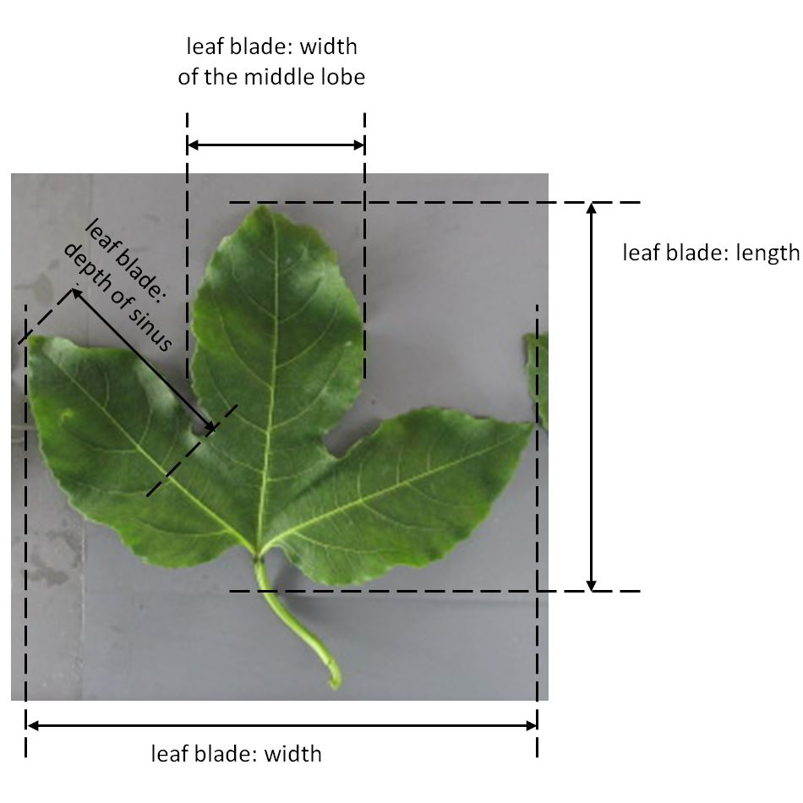

(e)

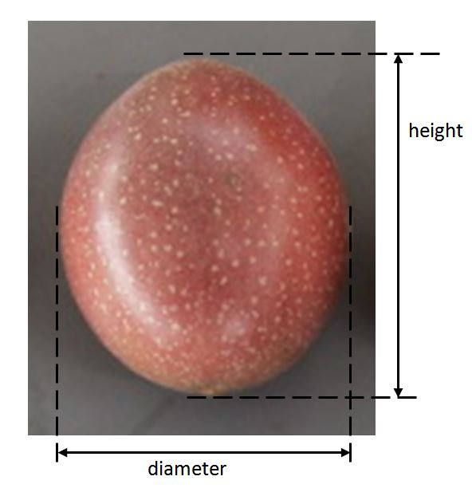

(f)

(g)

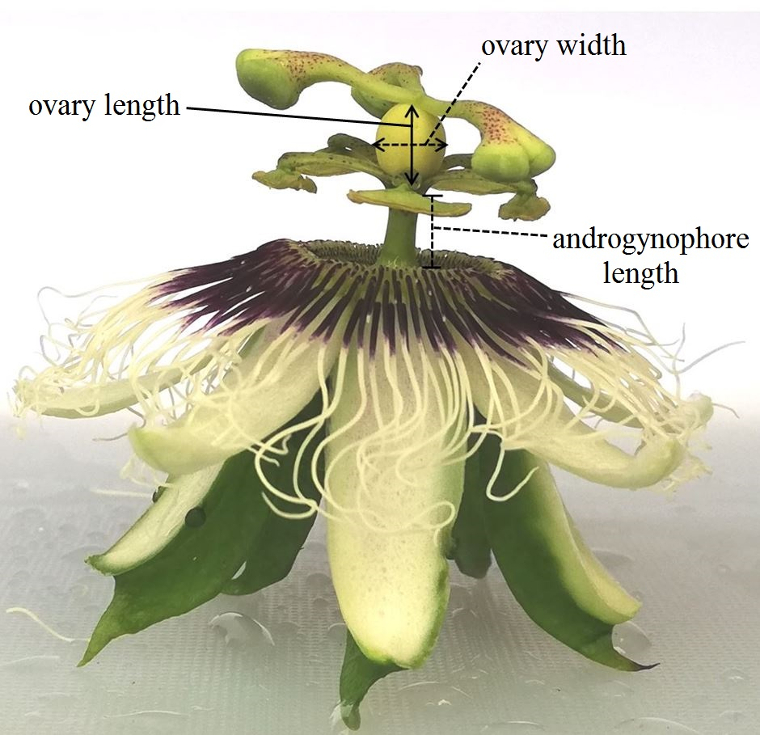

(h)

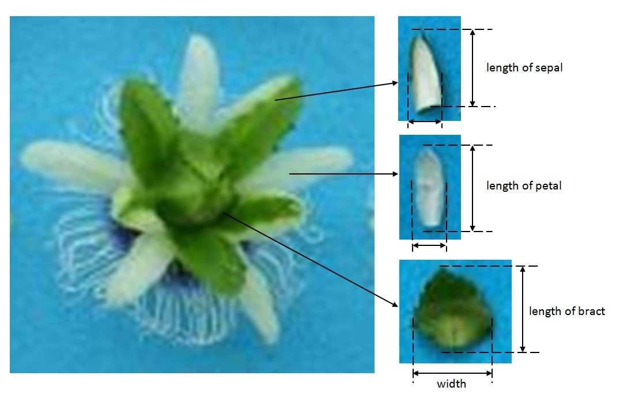

(i)

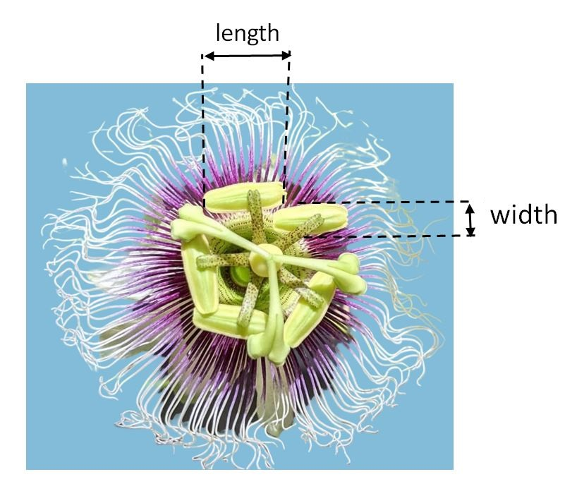

## 8.2  Explanations for individual characteristics

Ad. 1: Plant: vigor

The plant vigor should be considered as the overall abundance of vegetative growth.

Ad. 2: Shoot: color

Observations should be made on vigorous current season’s shoots.

Ad. 11: Leaf blade: shape of base

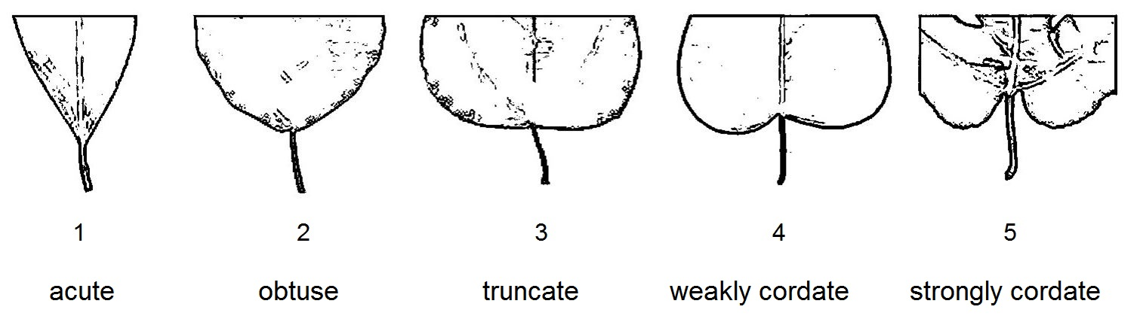

Ad. 12: Leaf blade: depth of sinus

Observations should be made on the deepest sinus.

Ad. 15: Petiole: position of nectaries

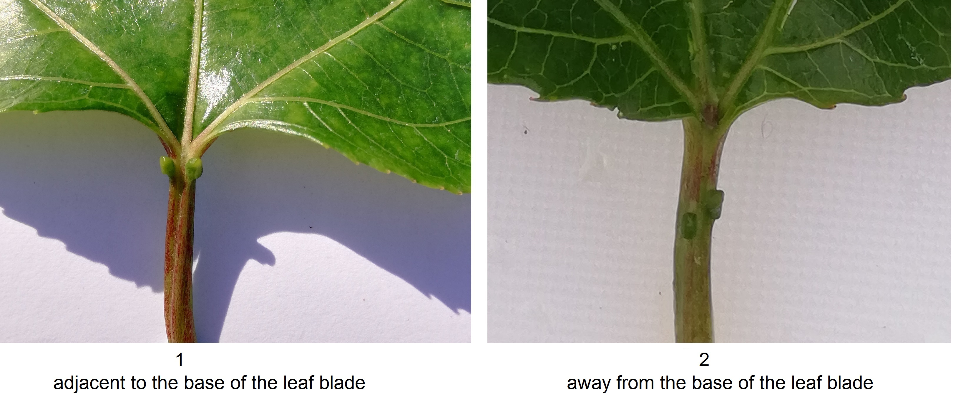

Ad. 26: Flower: intensity of color on inner filaments in throat

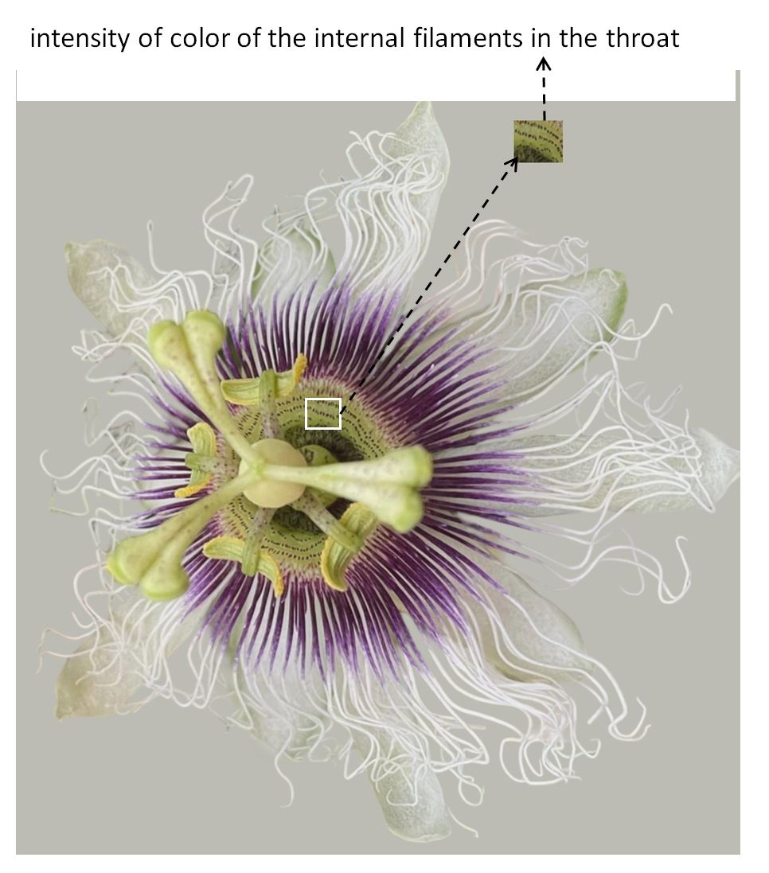

Ad. 35: Flower: anthocyanin spots on style

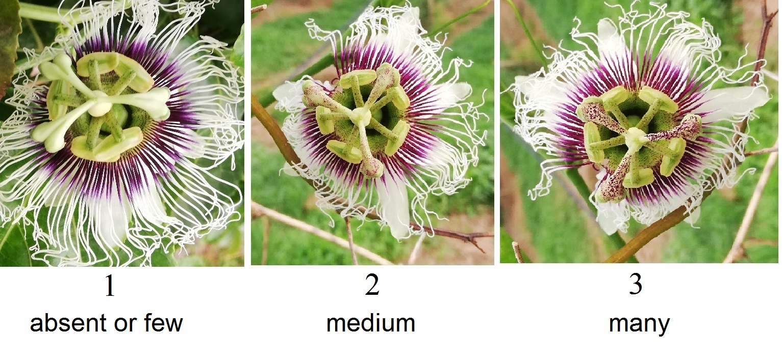

Ad. 40: Fruit: shape in longitudinal view

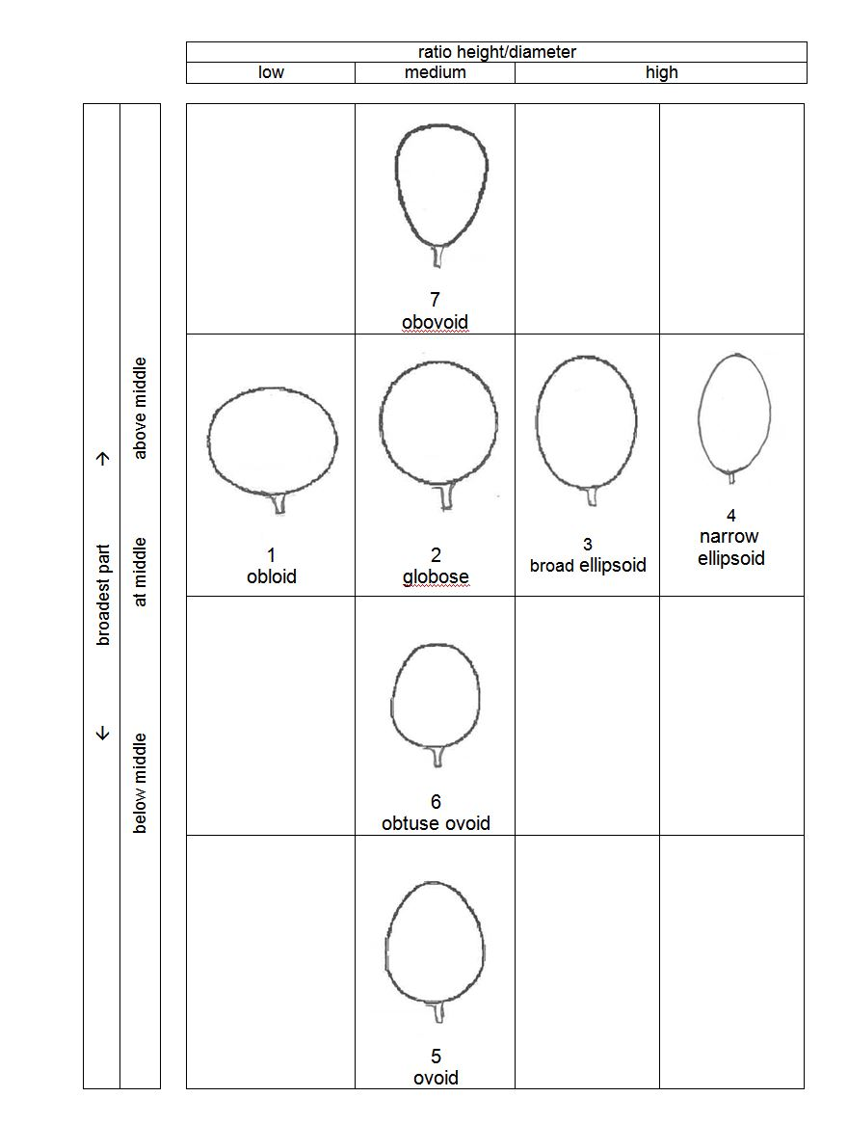

Ad. 43: Fruit: thickness of skin

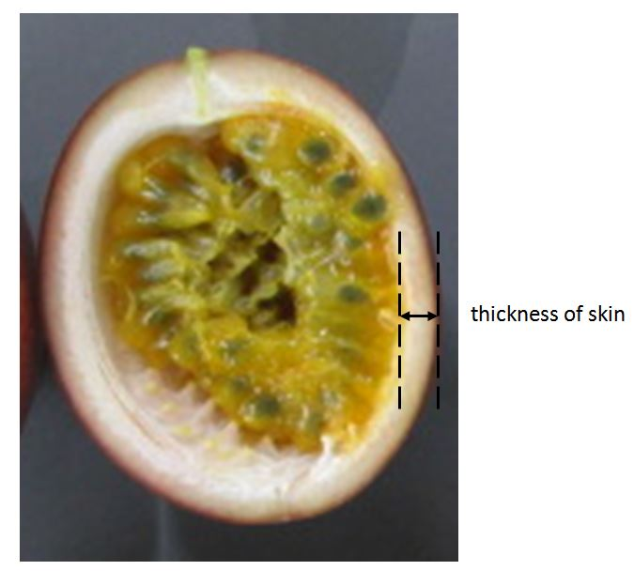

Ad. 44: Fruit: weight

Observations should be made on freshly harvested fruit.

Ad. 46: Fruit: weight of pulp including seeds

This characteristic can be observed by cutting the fruit and scooping out the pulp including seeds and then weighing them on an electronic scale.

Ad. 47: Fruit: sweetness of pulp

The sweetness of pulp should be observed in degrees Brix.

Ad. 48: Plant: self-incompatibility

A variety is self-incompatible when the fertile pollen of its own flower or of other flowers of the same variety is not able to fertilize the ovary.  
To observe self-incompatibility, 5 un-opened flowers should be emasculated and bagged. Once the bagged flowers open, they should be hand pollinated using fresh pollen from the same plant or another plant of the same variety and re-bagged. Self-incompatibility is absent in the variety under observation if the ovary of the pollinated flower is swollen and still attached to the plant 72 hours after pollination.  

# Literature

Jesus, O.N., Oliveira, E.J., Faleiro, F.G., Soares, T.L.S., and Girardi, E.A. (2017). Illustrated Morpho-agronomic Descriptors for *Passiflora*spp. (Embrapa), Brasília, BR

# Technical Questionnaire

|  |  |  |  |
| --- | --- | --- | --- |
| TECHNICAL QUESTIONNAIRE | Page {x} of {y} | Reference Number: | |
|  |  |  | |
|  |  | Application date:  (not to be filled in by the applicant) | |
| TECHNICAL QUESTIONNAIRE  to be completed in connection with an application for plant breeders' rights | | | |
| 1. Subject of the Technical Questionnaire | | | |
| 1.1.1 Botanical name | *Passifloraedulis* Sims | |  |
|  |  | |  |
| 1.1.2 Common name | Granadilla, Passion fruit | |  |
| 2. Applicant | | | |
| Name |  | |  |
|  |  | |  |
| Address |  | |  |
|  |  | |  |
| Telephone No. |  | |  |
|  |  | |  |
| Fax No. |  | |  |
|  |  | |  |
| E-mail address |  | |  |
|  |  | |  |
| Breeder (if different from  applicant) |  | |  |
|  |  | |  |

|  |  |  |  |
| --- | --- | --- | --- |
| TECHNICAL QUESTIONNAIRE | Page {x} of {y} | Reference Number: | |
|  | | | |
| 3. Proposed denomination and breeder's reference | | | |
| Proposed denomination  (if available) |  | |  |
|  |  | |  |
| Breeder's reference |  | |  |

|  |  |  |
| --- | --- | --- |
| TECHNICAL QUESTIONNAIRE | Page {x} of {y} | Reference Number: |

|  |
| --- |
| #4. Information on the breeding scheme and propagation of the variety  4.1 Breeding scheme  Variety resulting from:  4.1.1 Crossing  (a) controlled cross [ ]  (please state parent variety)  (…………………..……………..…) x (……………..…………………..…)  female parent male parent  (b) partially known cross [ ]  (please state parent variety(ies))  (…………………..……………..…) x (……………..…………………..…)  female parent male parent  (c) unknown cross [ ] |
| 4.1.2 Mutation  (please state parent variety) |
| 4.1.3 Discovery and development  (please state where and when discovered and how developed) |
| 4.1.4 Other  (Please provide details) |

|  |  |  |
| --- | --- | --- |
| TECHNICAL QUESTIONNAIRE | Page {x} of {y} | Reference Number: |

|  |
| --- |
| 4.2 Method of propagating the variety  4.2.1 Vegetative propagation  (a) Cuttings [ ]  (b) In vitro propagation [ ]  (c) Budding and grafting (please specify rootstock) [ ]  (d) Other (state method) [ ]  4.2.2 Other  (Please provide details) [ ] |
|  |

|  |  |  |  |  |  |
| --- | --- | --- | --- | --- | --- |
| TECHNICAL QUESTIONNAIRE | | Page {x} of {y} | | Reference Number: | |
|  | | | | | |
| 5. Characteristics of the variety to be indicated (the number in brackets refers to the corresponding characteristic in Test Guidelines; please mark the note which best corresponds). | | | | | |
|  | Characteristics | | Example Varieties | | Note |
| **5.1**  **(35)** | **Flower: anthocyanin spots on style** | |  | |  |
|  | absent or few | | Lacey, OPA11/19 | | 1 [ ] |
|  | medium | | OPA5/19, OPA7/19 | | 2 [ ] |
|  | many | | OPA3/19 | | 3 [ ] |
| **5.2**  **(37)** | **Fruit: height** | |  | |  |
|  | very short | |  | | 1 [ ] |
|  | very short to short | |  | | 2 [ ] |
|  | short | | E23, Lacey | | 3 [ ] |
|  | short to medium | |  | | 4 [ ] |
|  | medium | | Flamenco, OPA13/19 | | 5 [ ] |
|  | medium to tall | |  | | 6 [ ] |
|  | tall | | McGuffies Red, OPA11/19 | | 7 [ ] |
|  | tall to very tall | |  | | 8 [ ] |
|  | very tall | | Golden Giant | | 9 [ ] |
| **5.3**  **(42)** | **Fruit: color of skin** | |  | |  |
|  | green | |  | | 1 [ ] |
|  | medium yellow | |  | | 2 [ ] |
|  | yellow | | Brazilian Gold, Inca Gold | | 3 [ ] |
|  | dark yellow | | Panama Gold | | 4 [ ] |
|  | reddish orange | |  | | 5 [ ] |
|  | red | | McGuffies Red | | 6 [ ] |
|  | reddish purple | | Sweetheart, Toms Special | | 7 [ ] |
|  | purple | | Misty Gem, Tango | | 8 [ ] |
|  | black purple | | Nellie Kelly Black | | 9 [ ] |
|  |  | |  | |  |

|  |  |  |  |  |  |
| --- | --- | --- | --- | --- | --- |
| TECHNICAL QUESTIONNAIRE | | Page {x} of {y} | | Reference Number: | |
|  | |  | |  | |
|  | Characteristics | | Example Varieties | | Note |
| **5.4**  **(44)** | **Fruit: weight** | |  | |  |
|  | very low | | E23 | | 1 [ ] |
|  | very low to low | |  | | 2 [ ] |
|  | low | | Lacey, Misty Gem | | 3 [ ] |
|  | low to medium | |  | | 4 [ ] |
|  | medium | | Flamenco, OPA3/19, OPA5/19 | | 5 [ ] |
|  | medium to high | |  | | 6 [ ] |
|  | high | | McGuffies Red, OPA12/19 | | 7 [ ] |
|  | high to very high | |  | | 8 [ ] |
|  | very high | | Golden Giant | | 9 [ ] |
| **5.5**  **(45)** | **Fruit: color of pulp** | |  | |  |
|  | whitish | |  | | 1 [ ] |
|  | greenish yellow | |  | | 2 [ ] |
|  | yellow | | McGuffies Red, Misty Gem | | 3 [ ] |
|  | yellow orange | | E23, Flamenco | | 4 [ ] |
|  | orange | | OPA3/19 | | 5 [ ] |
| **5.6**  **(48)** | **Plant: self-incompatibility** | |  | |  |
|  | absent | | Flamenco, Toms Special | | 1 [ ] |
|  | present | | Panama Red | | 9 [ ] |

|  |  |  |  |  |  |
| --- | --- | --- | --- | --- | --- |
| TECHNICAL QUESTIONNAIRE | | Page {x} of {y} | | Reference Number: | |
|  | | | | | | |
| 6. Similar varieties and differences from these varieties  *Please use the following table and box for comments to provide information on how your candidate variety differs from the variety (or varieties) which, to the best of your knowledge, is (or are) most similar. This information may help the examination authority to conduct its examination of distinctness in a more efficient way.* | | | | | | |
| Denomination(s) of variety(ies) similar to your candidate variety | Characteristic(s) in which your candidate variety differs from the similar variety(ies) | | Describe the expression of the characteristic(s) for the **similar** variety(ies) | | Describe the expression of the characteristic(s) for **your** candidate variety |
| *Example* | *Fruit: height* | | *short* | | *tall* |
|  | | | | | | |
|  | | | | | | |
|  | | | | | | |
| Comments | | | | | | |

|  |  |  |
| --- | --- | --- |
| TECHNICAL QUESTIONNAIRE | Page {x} of {y} | Reference Number: |
|  | | | |
| #7. Additional information which may help in the examination of the variety  7.1 In addition to the information provided in sections 5 and 6, are there any additional characteristics which may help to distinguish the variety?  Yes [ ] No [ ]  (If yes, please provide details)  7.2 Are there any special conditions for growing the variety or conducting the examination?  Yes [ ] No [ ]  (If yes, please provide details)  7.3 Other information  A representative color photograph of the variety displaying its main distinguishing feature(s), should accompany the Technical Questionnaire. The photograph will provide a visual illustration of the candidate variety which supplements the information provided in the Technical Questionnaire.  The key points to consider when taking a photograph of the candidate variety are:  • Indication of the date and geographic location  • Correct labeling (breeder’s reference)  • Good quality printed photograph (minimum 10 cm x 15 cm) and/or sufficient resolution electronic format version (minimum 960 x 1280 pixels)”  Further guidance on providing photographs with the Technical Questionnaire is available in document TGP/7 "Development of Test Guidelines", Guidance Note 35 (http://www.upov.int/tgp/en/).  [The link provided may be deleted by members of the Union when developing authorities’ own test guidelines.] | | | |

|  |  |  |  |
| --- | --- | --- | --- |
| TECHNICAL QUESTIONNAIRE | Page {x} of {y} | Reference Number: | |
|  | | | |
| 8. Authorization for release  (a) Does the variety require prior authorization for release under legislation concerning the protection of the environment, human and animal health?  Yes [ ] No [ ]  (b) Has such authorization been obtained?  Yes [ ] No [ ]  If the answer to (b) is yes, please attach a copy of the authorization. | | | |
| 9. Information on plant material to be examined or submitted for examination  9.1 The expression of a characteristic or several characteristics of a variety may be affected by factors, such as pests and disease, chemical treatment (e.g. growth retardants or pesticides), effects of tissue culture, different rootstocks, scions taken from different growth phases of a tree, etc.  9.2 The plant material should not have undergone any treatment which would affect the expression of the characteristics of the variety, unless the competent authorities allow or request such treatment. If the plant material has undergone such treatment, full details of the treatment must be given. In this respect, please indicate below, to the best of your knowledge, if the plant material to be examined has been subjected to:  (a) Microorganisms (e.g. virus, bacteria, phytoplasma) Yes [ ] No [ ]  (b) Chemical treatment (e.g. growth retardant, pesticide) Yes [ ] No [ ]  (c) Tissue culture Yes [ ] No [ ]  (d) Other factors Yes [ ] No [ ]  Please provide details for where you have indicated “yes”.  ____________________________________________________________  9.3 Has the plant material to be examined been tested for the presence of virus or other pathogens?  Yes [ ]  (please provide details as specified by the Authority)  No [ ] | | | |
| 10. I hereby declare that, to the best of my knowledge, the information provided in this form is correct: | | | |
| Applicant’s name |  | | |
| Signature |  | Date |  |
|  | [End of document] | | |