 |  | E
TG/13/11 Rev. 4(proj.1)
ORIGINAL: English
DATE: 2024-11-19

INTERNATIONAL UNION FOR THE PROTECTION OF NEW VARIETIES OF PLANTS
 | Geneva
 | DRAFT
 | LETTUCE  UPOV Code(s): LACTU_SAT  Lactuca sativa L. | ∗
GUIDELINES
FOR THE CONDUCT OF TESTS
FOR DISTINCTNESS, UNIFORMITY AND STABILITY

prepared by an expert from France
to be considered by
the Enlarged Editorial Committee at its meeting
to be held in Geneva, on January 13 and 15, 2025

Disclaimer: this document does not represent UPOV policies or guidance

This document contains the following changes proposed by the Technical Working Party for Vegetables (TWV), at its fifty-eighth session, presented in grey highlight and deletions in strikethrough:
- Revision of the grouping characteristics in chapter 5.3
- Deletion of characteristics 38 to 47 “Resistance to Bremia lactucae (Bl) Isolates Bl: 16EU to Bl: 27EU”
- Revision of characteristic and explanation Ad. 55 “Resistance to Fusarium oxysporum f.sp. lactucae (Fol) Race 1”
- Addition of new characteristic “Resistance to Fusarium oxysporum f.sp. lactucae (Fol) Race 4” at the end of the table of characteristics
- Changes to the Technical Questionnaire

Alternative names:*

Botanical name | English | French | German | Spanish
Lactuca sativa L. | Lettuce | Laitue | Salat | Lechuga

The purpose of these guidelines (“Test Guidelines”) is to elaborate the principles contained in the General Introduction (document TG/1/3), and its associated TGP documents, into detailed practical guidance for the harmonized examination of distinctness, uniformity and stability (DUS) and, in particular, to identify appropriate characteristics for the examination of DUS and production of harmonized variety descriptions.

ASSOCIATED DOCUMENTS
These Test Guidelines should be read in conjunction with the General Introduction and its associated TGP documents.

TABLE OF CONTENTS | PAGE
1. | SUBJECT OF THESE TEST GUIDELINES.......................................................................................................... | 3
2. | MATERIAL REQUIRED......................................................................................................................................... | 3
3. | METHOD OF EXAMINATION................................................................................................................................ | 3
3.1 | Number of Growing Cycles........................................................................................................................ | 3
3.2 | Testing Place............................................................................................................................................. | 3
3.3 | Conditions for Conducting the Examination............................................................................................... | 3
3.4 | Test Design................................................................................................................................................ | 3
3.5 | Additional Tests......................................................................................................................................... | 3

4. | ASSESSMENT OF DISTINCTNESS, UNIFORMITY AND STABILITY................................................................. | 4
4.1 | Distinctness............................................................................................................................................... | 4
4.2 | Uniformity.................................................................................................................................................. | 5
4.3 | Stability...................................................................................................................................................... | 5

5. | GROUPING OF VARIETIES AND ORGANIZATION OF THE GROWING TRIAL................................................ | 5
6. | INTRODUCTION TO THE TABLE OF CHARACTERISTICS................................................................................ | 7
6.1 | Categories of Characteristics..................................................................................................................... | 7
6.2 | States of Expression and Corresponding Notes........................................................................................ | 7
6.3 | Types of Expression.................................................................................................................................. | 7
6.4 | Example Varieties...................................................................................................................................... | 7
6.5 | Legend....................................................................................................................................................... | 8

7. | TABLE OF CHARACTERISTICS/TABLEAU DES CARACTÈRES/MERKMALSTABELLE/TABLA DE CARACTERES...................................................................................................................................................... | 9
8. | EXPLANATIONS ON THE TABLE OF CHARACTERISTICS............................................................................... | 21
8.1 | Explanations covering several characteristics........................................................................................... | 21
8.2 | Explanations for individual characteristics................................................................................................. | 21
8.3 | Lettuce types............................................................................................................................................. | 42

9. | LITERATURE......................................................................................................................................................... | 45
10. | TECHNICAL QUESTIONNAIRE............................................................................................................................ | 47

1. | Subject of these Test Guidelines
 | These Test Guidelines apply to all varieties of Lactuca sativa L.

2. | Material Required
2.1 | The competent authorities decide on the quantity and quality of the plant material required for testing the variety and when and where it is to be delivered. Applicants submitting material from a State other than that in which the testing takes place must ensure that all customs formalities and phytosanitary requirements are complied with.
2.2 | The material is to be supplied in the form of seed.
2.3 | The minimum quantity of plant material, to be supplied by the applicant, should be:
 | 15,000 seeds
 | The seed should meet the minimum requirements for germination, species and analytical purity, health and moisture content, specified by the competent authority. In cases where the seed is to be stored, the germination capacity should be as high as possible and should, be stated by the applicant.
2.4 | The plant material supplied should be visibly healthy, not lacking in vigor, nor affected by any important pest or disease.
2.5 | The plant material should not have undergone any treatment which would affect the expression of the characteristics of the variety, unless the competent authorities allow or request such treatment. If it has been treated, full details of the treatment must be given.

3. | Method of Examination
3.1 | Number of Growing Cycles
 | The minimum duration of tests should normally be two independent growing cycles.
3.2 | Testing Place
 | Tests are normally conducted at one place. In the case of tests conducted at more than one place, guidance is provided in TGP/9 “Examining Distinctness”.
3.3 | Conditions for Conducting the Examination
 | The tests should be carried out under conditions ensuring satisfactory growth for the expression of the relevant characteristics of the variety and for the conduct of the examination.
3.4 | Test Design
3.4.1 | Each test should be designed to result in a total of at least 60 plants, which should be divided between at least 2 replicates.
3.4.2 | The design of the tests should be such that plants or parts of plants may be removed for measurement or counting without prejudice to the observations which must be made up to the end of the growing cycle.
3.5 | Additional Tests
 | Additional tests, for examining relevant characteristics, may be established.

4. | Assessment of Distinctness, Uniformity and Stability
4.1 | Distinctness
4.1.1 | General Recommendations
 | It is of particular importance for users of these Test Guidelines to consult the General Introduction prior to making decisions regarding distinctness. However, the following points are provided for elaboration or emphasis in these Test Guidelines.
4.1.2 | Consistent Differences
 | The differences observed between varieties may be so clear that more than one growing cycle is not necessary. In addition, in some circumstances, the influence of the environment is not such that more than a single growing cycle is required to provide assurance that the differences observed between varieties are sufficiently consistent. One means of ensuring that a difference in a characteristic, observed in a growing trial, is sufficiently consistent is to examine the characteristic in at least two independent growing cycles.
4.1.3 | Clear Differences
 | Determining whether a difference between two varieties is clear depends on many factors, and should consider, in particular, the type of expression of the characteristic being examined, i.e. whether it is expressed in a qualitative, quantitative, or pseudo-qualitative manner. Therefore, it is important that users of these Test Guidelines are familiar with the recommendations contained in the General Introduction prior to making decisions regarding distinctness.
4.1.4 | Number of plants or parts of plants to be Examined
 | Unless otherwise indicated, for the purposes of distinctness, all observations on single plants should be made on 20 plants or parts of plants taken from each of 20 plants and any other observations made on all plants in the test, disregarding any off-type plants.
4.1.5 | Method of Observation
 | The recommended method of observing the characteristic for the purposes of distinctness is indicated by the following key in the second column of the Table of Characteristics (see document TGP/9 “Examining Distinctness”, Section 4 “Observation of characteristics”):
MG: single measurement of a group of plants or parts of plants
MS: measurement of a number of individual plants or parts of plants
VG: visual assessment by a single observation of a group of plants or parts of plants
VS: visual assessment by observation of individual plants or parts of plants

 | Type of observation: visual (V) or measurement (M)
 | “Visual” observation (V) is an observation made on the basis of the expert’s judgment. For the purposes of this document, “visual” observation refers to the sensory observations of the experts and, therefore, also includes smell, taste and touch. Visual observation includes observations where the expert uses reference points (e.g. diagrams, example varieties, side-by-side comparison) or non-linear charts (e.g. color charts). Measurement (M) is an objective observation against a calibrated, linear scale e.g. using a ruler, weighing scales, colorimeter, dates, counts, etc.

 | Type of record: for a group of plants (G) or for single, individual plants (S)
 | For the purposes of distinctness, observations may be recorded as a single record for a group of plants or parts of plants (G), or may be recorded as records for a number of single, individual plants or parts of plants (S). In most cases, “G” provides a single record per variety and it is not possible or necessary to apply statistical methods in a plant-by-plant analysis for the assessment of distinctness.
 | In cases where more than one method of observing the characteristic is indicated in the Table of Characteristics (e.g. VG/MG), guidance on selecting an appropriate method is provided in document TGP/9, Section 4.2.
4.2 | Uniformity
4.2.1 | It is of particular importance for users of these Test Guidelines to consult the General Introduction prior to making decisions regarding uniformity. However, the following points are provided for elaboration or emphasis in these Test Guidelines:
4.2.2 | These Test Guidelines have been developed for the examination of seed-propagated varieties. For varieties with other types of propagation the recommendations in the General Introduction and document TGP/13 “Guidance for new types and species”, Section 4.5 “Testing Uniformity” should be followed.
4.2.3 | For the assessment of uniformity of seed-propagated varieties, a population standard of 1% and an acceptance probability of at least 95% should be applied. In the case of a sample size of 60 plants, 2 off-types are allowed.
4.3 | Stability
4.3.1 | In practice, it is not usual to perform tests of stability that produce results as certain as those of the testing of distinctness and uniformity. However, experience has demonstrated that, for many types of variety, when a variety has been shown to be uniform, it can also be considered to be stable.
4.3.2 | Where appropriate, or in cases of doubt, stability may be further examined by testing a new seed stock to ensure that it exhibits the same characteristics as those shown by the initial material supplied.

5. | Grouping of Varieties and Organization of the Growing Trial
5.1 | The selection of varieties of common knowledge to be grown in the trial with the candidate varieties and the way in which these varieties are divided into groups to facilitate the assessment of distinctness are aided by the use of grouping characteristics.
5.2 | Grouping characteristics are those in which the documented states of expression, even where produced at different locations, can be used, either individually or in combination with other such characteristics: (a) to select varieties of common knowledge that can be excluded from the growing trial used for examination of distinctness; and (b) to organize the growing trial so that similar varieties are grouped together.
5.3 | The following have been agreed as useful grouping characteristics:
(a) |  | Seed: color (characteristic 1)
(b) |  | Leaf: anthocyanin coloration (characteristic 11)
(c) |  | Time of beginning of bolting (characteristic 35)
(d) |  | Resistance to Bremia lactucae (Bl) Isolate Bl: 29EU (characteristic 38)

 | In a first step, the collection should be divided according to types as described in the Table 1. In cases of doubt to which type a variety belongs to, it should be tested under consideration of all relevant types. The different types of Lettuce are explained in Chapter 8.3
5.4 | Guidance for the use of grouping characteristics, in the process of examining distinctness, is provided through the General Introduction and document TGP/9 “Examining Distinctness”.

Table 1

Type | Example varieties | Plant: degree of overlapping of upper part of leaves (Char. 3) | Leaf: number of divisions (Char. 6) | Leaf: thickness (Char. 17) | Leaf: undulation of margin (Char. 20) | Leaf: venation  (Char. 25) | Only varieties with Plant: degree of overlapping of upper part of leaves: medium or strong: Head: shape in longitudinal section (Char. 27)
Butterhead type | Clarion, Maikönig, Sartre | medium to strong | absent or very few | thin to thick | absent to weak | not flabellate | circular or narrow oblate
Novita type | Norvick | absent or weak | absent or very few | thin to medium | very weak to medium | flabellate | -
Iceberg type | Great Lakes 659, Roxette, Saladin, Vanguard 75 | strong | absent or very few | thick | absent to medium | flabellate | circular or narrow oblate
Batavia type | Aquarel, Curtis, Funnice, Felucca, Grand Rapids, Masaida, Visyon | absent or weak to strong | absent or very few | medium to thick | weak to very strong | flabellate | broad elliptic, circular or narrow oblate
Frisée d'Amérique type | Bijou, Blonde à couper améliorée | absent or weak | absent or very few | thin | absent to strong | flabellate or not flabellate or semi | -
Lollo type | Lollo rossa, Revolution | absent or weak | absent or very few | thin | strong to very strong | flabellate | -
Oakleaf type | Catalogna, Kipling, Muraï, Salad Bowl | absent or weak | few to many | thin | absent to weak | flabellate or not flabellate or semi | -
Multi-divided type | Curletta, Duplex, Jadigon, Rodagio | absent or weak | medium to very many | thin | weak to very strong | flabellate | -
Frillice type | Frilett | absent or weak | absent or very few | thick | weak to strong | flabellate | -
Cos type | Actarus,  Blonde maraîchère, Pinokkio | absent or weak to medium | absent or very few | medium to thick | absent to weak | not flabellate | narrow elliptic
Gem type | Craquerelle du Midi, Sucrine, Xanadu | absent or weak to medium | absent or very few | medium to thick | absent to weak | not flabellate | broad elliptic, circular or narrow oblate
Stem type | Celtuce, Guasihong | absent or weak | absent or very few | thin to medium | absent to weak | not flabellate | -

6. | Introduction to the Table of Characteristics
6.1 | Categories of Characteristics
6.1.1 | Standard Test Guidelines Characteristics
 | Standard Test Guidelines characteristics are those which are approved by UPOV for examination of DUS and from which members of the Union can select those suitable for their particular circumstances.
6.1.2 | Asterisked Characteristics
 | Asterisked characteristics (denoted by *) are those included in the Test Guidelines which are important for the international harmonization of variety descriptions and should always be examined for DUS and included in the variety description by all members of the Union, except when the state of expression of a preceding characteristic or regional environmental conditions render this inappropriate.
6.2 | States of Expression and Corresponding Notes
6.2.1 | States of expression are given for each characteristic to define the characteristic and to harmonize descriptions. Each state of expression is allocated a corresponding numerical note for ease of recording of data and for the production and exchange of the description.
6.2.2 | In the case of qualitative and pseudo-qualitative characteristics (see Chapter 6.3), all relevant states of expression are presented in the characteristic. However, in the case of quantitative characteristics with 5 or more states, an abbreviated scale may be used to minimize the size of the Table of Characteristics. For example, in the case of a quantitative characteristic with 9 states, the presentation of states of expression in the Test Guidelines may be abbreviated as follows:
State | Note
small | 3
medium | 5
large | 7

 | However, it should be noted that all of the following 9 states of expression exist to describe varieties and should be used as appropriate:
State | Note
very small | 1
very small to small | 2
small | 3
small to medium | 4
medium | 5
medium to large | 6
large | 7
large to very large | 8
very large | 9

6.2.3 | Further explanation of the presentation of states of expression and notes is provided in document TGP/7 “Development of Test Guidelines”.
6.3 | Types of Expression
 | An explanation of the types of expression of characteristics (qualitative, quantitative and pseudo-qualitative) is provided in the General Introduction.
6.4 | Example Varieties
 | Where appropriate, example varieties are provided to clarify the states of expression of each characteristic.

6.5 | Legend
 |  | English |  | français |  | deutsch | español | Example Varieties  Exemples  Beispielssorten  Variedades ejemplo | Note/  Nota
1 | 2 | 3 | 4 | 5 | 6 | 7
 |  | Name of characteristics in English |  | Nom du caractère en français |  | Name des Merkmals auf Deutsch | Nombre del carácter en español
 |  | states of expression |  | types d’expression |  | Ausprägungsstufen | tipos de expresión

1 | Characteristic number
2 | (*) | Asterisked characteristic | – see Chapter 6.1.2
3 | Type of expression
 | QL | Qualitative characteristic | – see Chapter 6.3
 | QN | Quantitative characteristic | – see Chapter 6.3
 | PQ | Pseudo-qualitative characteristic | – see Chapter 6.3
4 | Method of observation (and type of plot, if applicable)
 | MG, MS, VG, VS |  | – see Chapter 4.1.5
5 | (+) | See Explanations on the Table of Characteristics in Chapter 8.2
6 | (a)-(b) | See Explanations on the Table of Characteristics in Chapter 8.1
7 | Not applicable

7. | Table of Characteristics/Tableau des caractères/Merkmalstabelle/Tabla de caracteres

 |  |  |  |  |  |  |  | English |  |  |  |  |  | français |  |  |  |  |  | deutsch |  |  | español |  |  | Example Varieties  Exemples  Beispielssorten  Variedades ejemplo |  |  | Note/  Nota
1. |  |  |  |  | (*) |  |  | PQ |  |  | VG
 |  |  |  |  |  |  |  | Seed: color |  |  |  |  |  | Semence : couleur |  |  |  |  |  | Samen: Farbe |  |  | Semilla: color
 |  |  |  |  |  |  |  | white |  |  |  |  |  | blanche |  |  |  |  |  | weiß |  |  | blanco |  |  | Verpia |  |  | 1
 |  |  |  |  |  |  |  | yellow |  |  |  |  |  | jaune |  |  |  |  |  | gelb |  |  | amarillo |  |  | Durango |  |  | 2
 |  |  |  |  |  |  |  | brown |  |  |  |  |  | marron |  |  |  |  |  | braun |  |  | marrón |  |  | Oaklin |  |  | 3
 |  |  |  |  |  |  |  | black |  |  |  |  |  | noire |  |  |  |  |  | schwarz |  |  | negro |  |  | Kagraner Sommer 2 |  |  | 4
2. |  |  |  |  | (*) |  |  | QN |  |  | MS/VG |  |  |  |  |  | (a)
 |  |  |  |  |  |  |  | Plant: diameter |  |  |  |  |  | Plante : diamètre |  |  |  |  |  | Pflanze: Durchmesser |  |  | Planta: diámetro
 |  |  |  |  |  |  |  | very small |  |  |  |  |  | très petit |  |  |  |  |  | sehr klein |  |  | muy pequeña |  |  | Tom Thumb |  |  | 1
 |  |  |  |  |  |  |  | small |  |  |  |  |  | petit |  |  |  |  |  | klein |  |  | pequeña |  |  | Gotte à graine blanche |  |  | 3
 |  |  |  |  |  |  |  | medium |  |  |  |  |  | moyen |  |  |  |  |  | mittel |  |  | media |  |  | Clarion, Verpia |  |  | 5
 |  |  |  |  |  |  |  | large |  |  |  |  |  | grand |  |  |  |  |  | groß |  |  | grande |  |  | Great Lakes 659 |  |  | 7
 |  |  |  |  |  |  |  | very large |  |  |  |  |  | très grand |  |  |  |  |  | sehr groß |  |  | muy grande |  |  | El Toro |  |  | 9
3. |  |  |  |  | (*) |  |  | QN |  |  | VG |  |  | (+) |  |  | (a)
 |  |  |  |  |  |  |  | Plant: degree of overlapping of upper part of leaves |  |  |  |  |  | Plante : degré du chevauchement de la partie supérieure des feuilles |  |  |  |  |  | Pflanze: Stärke des Überlappens des oberen Teils der Blätter |  |  | Planta: grado de solapamiento de la parte superior de las hojas
 |  |  |  |  |  |  |  | absent or weak |  |  |  |  |  | nul ou faible |  |  |  |  |  | fehlend oder gering |  |  | ausente o débil |  |  | Actarus, Aquarel, Blonde à couper améliorée, Curtis, Lollo rossa |  |  | 1
 |  |  |  |  |  |  |  | medium |  |  |  |  |  | moyen |  |  |  |  |  | mittel |  |  | medio |  |  | Augusta, Clarion, Fiorella |  |  | 2
 |  |  |  |  |  |  |  | strong |  |  |  |  |  | fort |  |  |  |  |  | stark |  |  | fuerte |  |  | Roxette, Vanguard 75 |  |  | 3
 | 4. |  |  |  |  |  |  |  | QN |  |  | MS/VG |  |  | (+) |  |  | (a)
 |  |  |  |  |  |  |  |  | Only varieties with Plant: degree of overlapping of upper part of leaves: absent or weak: Plant: number of leaves |  |  |  |  |  | Seulement les variétés avec Plante : degré de chevauchement de la partie supérieure des feuilles : nul ou faible : Plante : nombre de feuilles |  |  |  |  |  | Nur Sorten mit Pflanze: Stärke des Überlappens des oberen Teils der Blätter: fehlend oder gering: Pflanze: Anzahl Blätter |  |  | Solo variedades con Planta: grado de solapamiento de la parte superior de las hojas: ausente o débil: Planta: número de hojas
 |  |  |  |  |  |  |  |  | few |  |  |  |  |  | petit |  |  |  |  |  | wenige |  |  | bajo |  |  | Lollo rossa |  |  | 3
 |  |  |  |  |  |  |  |  | medium |  |  |  |  |  | moyen |  |  |  |  |  | mittel |  |  | medio |  |  | Muraï |  |  | 5
 |  |  |  |  |  |  |  |  | many |  |  |  |  |  | grand |  |  |  |  |  | viele |  |  | alto |  |  | Felucca, Sartre, Xandra |  |  | 7
 | 5. |  |  |  |  |  |  |  | QN |  |  | VG |  |  | (+) |  |  | (b)
 |  |  |  |  |  |  |  |  | Leaf: attitude |  |  |  |  |  | Feuille : port |  |  |  |  |  | Blatt: Stellung |  |  | Hoja: porte
 |  |  |  |  |  |  |  |  | erect |  |  |  |  |  | dressé |  |  |  |  |  | aufrecht |  |  | erecto |  |  | Feria, Pinokkio |  |  | 1
 |  |  |  |  |  |  |  |  | semi-erect |  |  |  |  |  | demi-dressé |  |  |  |  |  | halbaufrecht |  |  | semierecto |  |  | Expedition, Sartre |  |  | 3
 |  |  |  |  |  |  |  |  | horizontal |  |  |  |  |  | horizontal |  |  |  |  |  | horizontal |  |  | horizontal |  |  | Divina |  |  | 5
 |  | 6. |  |  |  |  | (*) |  |  | QN |  |  | VG |  |  | (+) |  |  | (b)
 |  |  |  |  |  |  |  |  |  | Leaf: number of divisions |  |  |  |  |  | Feuille : nombre de divisions |  |  |  |  |  | Blatt: Anzahl Teilungen |  |  | Hoja: número de divisiones
 |  |  |  |  |  |  |  |  |  | absent or very few |  |  |  |  |  | nul ou très petit |  |  |  |  |  | fehlend oder sehr wenige |  |  | ausentes o muy bajo |  |  | Fiorella, Lollo rossa |  |  | 1
 |  |  |  |  |  |  |  |  |  | few |  |  |  |  |  | petit |  |  |  |  |  | wenige |  |  | bajo |  |  | Curletta, Rodagio |  |  | 3
 |  |  |  |  |  |  |  |  |  | medium |  |  |  |  |  | moyen |  |  |  |  |  | mittel |  |  | medio |  |  | Ezabel, Jadigon |  |  | 5
 |  |  |  |  |  |  |  |  |  | many |  |  |  |  |  | grand |  |  |  |  |  | viele |  |  | alto |  |  | Expedition, Multired 54 |  |  | 7
 |  |  |  |  |  |  |  |  |  | very many |  |  |  |  |  | très grand |  |  |  |  |  | sehr viele |  |  | muy alto |  |  | Excite, Ezfrill, Telex |  |  | 9
 |  | 7. |  |  |  |  |  |  |  | PQ |  |  | VG |  |  | (+) |  |  | (b)
 |  |  |  |  |  |  |  |  |  | Only varieties with Leaf: number of divisions: absent or very few: Leaf: shape |  |  |  |  |  | Seulement les variétés avec Feuille : nombre de divisions : nul ou très petit : Feuille : forme |  |  |  |  |  | Nur Sorten mit Blatt: Anzahl Teilungen: fehlend oder sehr wenige: Blatt: Form |  |  | Solo variedades con Hoja: número de divisiones: ausentes o muy bajo: Hoja: forma
 |  |  |  |  |  |  |  |  |  | triangular |  |  |  |  |  | triangulaire |  |  |  |  |  | dreieckig |  |  | triangular |  |  |  |  |  | 1
 |  |  |  |  |  |  |  |  |  | lanceolate |  |  |  |  |  | lancéolée |  |  |  |  |  | lanzettlich |  |  | lanceolada |  |  | Qingyuanyewoju |  |  | 2
 |  |  |  |  |  |  |  |  |  | medium oblate |  |  |  |  |  | arrondie aplatie moyenne |  |  |  |  |  | mittel breitrund |  |  | achatada media |  |  | Stylist |  |  | 3
 |  |  |  |  |  |  |  |  |  | narrow oblate |  |  |  |  |  | arrondie aplatie étroite |  |  |  |  |  | schmal breitrund |  |  | achatada estrecha |  |  | Commodore, Fiorella |  |  | 4
 |  |  |  |  |  |  |  |  |  | circular |  |  |  |  |  | circulaire |  |  |  |  |  | kreisförmig |  |  | circular |  |  | Verpia |  |  | 5
 |  |  |  |  |  |  |  |  |  | broad elliptic |  |  |  |  |  | elliptique large |  |  |  |  |  | breit elliptisch |  |  | elíptica ancha |  |  | Amadeus |  |  | 6
 |  |  |  |  |  |  |  |  |  | medium elliptic |  |  |  |  |  | elliptique moyenne |  |  |  |  |  | mittel elliptisch |  |  | elíptica media |  |  | Xanadu |  |  | 7
 |  |  |  |  |  |  |  |  |  | narrow elliptic |  |  |  |  |  | elliptique étroite |  |  |  |  |  | schmal elliptisch |  |  | elíptica estrecha |  |  | Verte maraîchère |  |  | 8
 |  |  |  |  |  |  |  |  |  | linear |  |  |  |  |  | linéaire |  |  |  |  |  | linear |  |  | lineal |  |  | Hongwoju |  |  | 9
 |  |  |  |  |  |  |  |  |  | broad obtrullate |  |  |  |  |  | losangique transverse large |  |  |  |  |  | breit verkehrt rautenförmig |  |  | rómbica ancha |  |  |  |  |  | 10
 |  |  |  |  |  |  |  |  |  | obovate |  |  |  |  |  | obovale |  |  |  |  |  | verkehrt eiförmig |  |  | oboval |  |  | Raisa |  |  | 11
 |  |  |  |  |  |  |  |  |  | oblanceolate |  |  |  |  |  | oblancéolée |  |  |  |  |  | verkehrt lanzettlich |  |  | oblanceolada |  |  | Xiangshengcai |  |  | 12
 |  | 8. |  |  |  |  |  |  |  | PQ |  |  | VG |  |  | (+) |  |  | (b)
 |  |  |  |  |  |  |  |  |  | Only varieties with Leaf: number of divisions: absent or very few: Leaf: shape of apex |  |  |  |  |  | Seulement les variétés avec Feuille : nombre de divisions : nul ou très petit : Feuille : forme de l’extrémité |  |  |  |  |  | Nur Sorten mit Blatt: Anzahl Teilungen: fehlend oder sehr wenige: Blatt: Form der Spitze |  |  | Solo variedades con Hoja: número de divisiones: ausentes o muy bajo: Hoja: forma del ápice
 |  |  |  |  |  |  |  |  |  | acute |  |  |  |  |  | aiguë |  |  |  |  |  | spitz |  |  | agudo |  |  | Celtuce |  |  | 1
 |  |  |  |  |  |  |  |  |  | obtuse |  |  |  |  |  | obtuse |  |  |  |  |  | stumpf |  |  | obtuso |  |  | Actarus |  |  | 2
 |  |  |  |  |  |  |  |  |  | rounded |  |  |  |  |  | arrondie |  |  |  |  |  | abgerundet |  |  | redondeado |  |  | Blonde maraîchère, Maserati |  |  | 3
 |  |  |  |  |  |  |  |  |  | obcordate |  |  |  |  |  | obcordiforme |  |  |  |  |  | verkehrt herzförmig |  |  | obcordiforme |  |  | PS 6545691 |  |  | 4
 |  | 9. |  |  |  |  |  |  |  | QN |  |  | VG |  |  | (+) |  |  | (b)
 |  |  |  |  |  |  |  |  |  | Only varieties with Leaf: number of divisions: absent or very few: Leaf: longitudinal section |  |  |  |  |  | Seulement les variétés avec Feuille : nombre de divisions : nul ou très petit : Feuille : section longitudinale |  |  |  |  |  | Nur Sorten mit Blatt: Anzahl Teilungen: fehlend oder sehr wenige: Blatt: Längsschnitt |  |  | Solo variedades con Hoja: número de divisiones: ausentes o muy bajo: Hoja: sección longitudinal
 |  |  |  |  |  |  |  |  |  | concave |  |  |  |  |  | concave |  |  |  |  |  | konkav |  |  | cóncava |  |  | Sunstar |  |  | 1
 |  |  |  |  |  |  |  |  |  | flat |  |  |  |  |  | plate |  |  |  |  |  | flach |  |  | plana |  |  | Clarion, Lollo rossa |  |  | 3
 |  |  |  |  |  |  |  |  |  | convex |  |  |  |  |  | convexe |  |  |  |  |  | konvex |  |  | convexa |  |  | Tiago |  |  | 5
 |  | 10. |  |  |  |  |  |  |  | QN |  |  | VG |  |  | (+) |  |  | (b)
 |  |  |  |  |  |  |  |  |  | Only Oakleaf type varieties: Leaf: width of lobes |  |  |  |  |  | Seulement les variétés de type Feuille de chêne : Feuille : largeur des lobes |  |  |  |  |  | Nur Sorten des Typs Eichblatt: Blatt: Breite der Lappen |  |  | Solo variedades de tipo Oakleaf: Hoja: anchura de los lóbulos
 |  |  |  |  |  |  |  |  |  | narrow |  |  |  |  |  | étroits |  |  |  |  |  | schmal |  |  | estrecha |  |  | Kibrille, Rougini |  |  | 3
 |  |  |  |  |  |  |  |  |  | medium |  |  |  |  |  | moyens |  |  |  |  |  | mittel |  |  | media |  |  | Bandolin, Ribaï |  |  | 5
 |  |  |  |  |  |  |  |  |  | broad |  |  |  |  |  | larges |  |  |  |  |  | breit |  |  | ancha |  |  | Horix, Starix, Vizir |  |  | 7
 |  | 11. |  |  |  |  | (*) |  |  | QN |  |  | VG |  |  | (+) |  |  | (b)
 |  |  |  |  |  |  |  |  |  | Leaf: anthocyanin coloration |  |  |  |  |  | Feuille : pigmentation anthocyanique |  |  |  |  |  | Blatt: Anthocyanfärbung |  |  | Hoja: pigmentación antociánica
 |  |  |  |  |  |  |  |  |  | absent or very weak |  |  |  |  |  | nulle ou très faible |  |  |  |  |  | fehlend oder sehr gering |  |  | ausente o muy débil |  |  | Clarion |  |  | 1
 |  |  |  |  |  |  |  |  |  | weak |  |  |  |  |  | faible |  |  |  |  |  | gering |  |  | débil |  |  | Du bon jardinier |  |  | 3
 |  |  |  |  |  |  |  |  |  | medium |  |  |  |  |  | moyenne |  |  |  |  |  | mittel |  |  | media |  |  | Lollo rossa, Luana |  |  | 5
 |  |  |  |  |  |  |  |  |  | strong |  |  |  |  |  | forte |  |  |  |  |  | stark |  |  | fuerte |  |  | Merveille des quatre saisons |  |  | 7
 |  |  |  |  |  |  |  |  |  | very strong |  |  |  |  |  | très forte |  |  |  |  |  | sehr stark |  |  | muy fuerte |  |  | Iride, Revolution |  |  | 9
 |  | 12. |  |  |  |  | (*) |  |  | PQ |  |  | VG |  |  |  |  |  | (b)
 |  |  |  |  |  |  |  |  |  | Leaf: hue of anthocyanin coloration |  |  |  |  |  | Feuille : teinte de la pigmentation anthocyanique |  |  |  |  |  | Blatt: Ton der Anthocyanfärbung |  |  | Hoja: tonalidad de la pigmentación antociánica
 |  |  |  |  |  |  |  |  |  | reddish |  |  |  |  |  | rougeâtre |  |  |  |  |  | rötlich |  |  | rojiza |  |  | Lollo rossa |  |  | 1
 |  |  |  |  |  |  |  |  |  | purplish |  |  |  |  |  | pourpre |  |  |  |  |  | purpurn |  |  | purpúrea |  |  | Iride |  |  | 2
 |  |  |  |  |  |  |  |  |  | brownish |  |  |  |  |  | brunâtre |  |  |  |  |  | bräunlich |  |  | amarronada |  |  | Luana, Maravilla de Verano |  |  | 3
 |  | 13. |  |  |  |  |  |  |  | QN |  |  | VG |  |  | (+) |  |  | (b)
 |  |  |  |  |  |  |  |  |  | Leaf: area covered by anthocyanin coloration |  |  |  |  |  | Feuille : surface couverte par la pigmentation anthocyanique |  |  |  |  |  | Blatt: Fläche der Anthocyanfärbung |  |  | Hoja: superficie cubierta por la pigmentación antociánica
 |  |  |  |  |  |  |  |  |  | very small |  |  |  |  |  | très petite |  |  |  |  |  | sehr klein |  |  | muy pequeña |  |  | Steirer Krauthauptel |  |  | 1
 |  |  |  |  |  |  |  |  |  | small |  |  |  |  |  | petite |  |  |  |  |  | klein |  |  | pequeña |  |  | Diablo |  |  | 3
 |  |  |  |  |  |  |  |  |  | medium |  |  |  |  |  | moyenne |  |  |  |  |  | mittel |  |  | media |  |  | Luana |  |  | 5
 |  |  |  |  |  |  |  |  |  | large |  |  |  |  |  | grande |  |  |  |  |  | groß |  |  | grande |  |  | Merveille des quatre saisons |  |  | 7
 |  |  |  |  |  |  |  |  |  | very large |  |  |  |  |  | très grande |  |  |  |  |  | sehr groß |  |  | muy grande |  |  | Bijou, Revolution |  |  | 9
 |  | 14. |  |  |  |  | (*) |  |  | PQ |  |  | VG |  |  | (+) |  |  | (b)
 |  |  |  |  |  |  |  |  |  | Leaf: color |  |  |  |  |  | Feuille : couleur |  |  |  |  |  | Blatt: Farbe |  |  | Hoja: color
 |  |  |  |  |  |  |  |  |  | green |  |  |  |  |  | vert |  |  |  |  |  | grün |  |  | verde |  |  | Verpia |  |  | 1
 |  |  |  |  |  |  |  |  |  | yellowish green |  |  |  |  |  | vert jaunâtre |  |  |  |  |  | gelblichgrün |  |  | verde amarillento |  |  | Dorée de printemps |  |  | 2
 |  |  |  |  |  |  |  |  |  | greyish green |  |  |  |  |  | vert grisâtre |  |  |  |  |  | gräulichgrün |  |  | verde grisáceo |  |  | Celtuce, Du bon jardinier |  |  | 3
 |  | 15. |  |  |  |  | (*) |  |  | QN |  |  | VG |  |  |  |  |  | (b)
 |  |  |  |  |  |  |  |  |  | Leaf: intensity of green color |  |  |  |  |  | Feuille : intensité de la couleur verte |  |  |  |  |  | Blatt: Intensität der Grünfärbung |  |  | Hoja: intensidad del color verde
 |  |  |  |  |  |  |  |  |  | very light |  |  |  |  |  | très claire |  |  |  |  |  | sehr hell |  |  | muy claro |  |  |  |  |  | 1
 |  |  |  |  |  |  |  |  |  | light |  |  |  |  |  | claire |  |  |  |  |  | hell |  |  | claro |  |  | Blonde maraîchère, Lollo Bionda |  |  | 3
 |  |  |  |  |  |  |  |  |  | medium |  |  |  |  |  | moyenne |  |  |  |  |  | mittel |  |  | medio |  |  | Aquarel, Clarion |  |  | 5
 |  |  |  |  |  |  |  |  |  | dark |  |  |  |  |  | foncée |  |  |  |  |  | dunkel |  |  | oscuro |  |  | Expedition, Verpia |  |  | 7
 |  |  |  |  |  |  |  |  |  | very dark |  |  |  |  |  | très foncée |  |  |  |  |  | sehr dunkel |  |  | muy oscuro |  |  | Pascal, Verdetrix |  |  | 9
 |  | 16. |  |  |  |  |  |  |  | QN |  |  | VG |  |  |  |  |  | (b)
 |  |  |  |  |  |  |  |  |  | Leaf: glossiness of upper side |  |  |  |  |  | Feuille : brillance de la face supérieure |  |  |  |  |  | Blatt: Glanz der Oberseite |  |  | Hoja: brillo del haz
 |  |  |  |  |  |  |  |  |  | absent or very weak |  |  |  |  |  | nulle ou très faible |  |  |  |  |  | fehlend oder sehr gering |  |  | ausente o muy débil |  |  | Divina, Du bon jardinier |  |  | 1
 |  |  |  |  |  |  |  |  |  | weak |  |  |  |  |  | faible |  |  |  |  |  | gering |  |  | débil |  |  | Duplex, Fiorella, Sartre |  |  | 3
 |  |  |  |  |  |  |  |  |  | medium |  |  |  |  |  | moyenne |  |  |  |  |  | mittel |  |  | medio |  |  | Funnice |  |  | 5
 |  |  |  |  |  |  |  |  |  | strong |  |  |  |  |  | forte |  |  |  |  |  | stark |  |  | fuerte |  |  | Noisette, Redair |  |  | 7
 |  |  |  |  |  |  |  |  |  | very strong |  |  |  |  |  | très forte |  |  |  |  |  | sehr stark |  |  | muy fuerte |  |  | Bijou |  |  | 9
 |  | 17. |  |  |  |  | (*) |  |  | QN |  |  | VG |  |  |  |  |  | (b)
 |  |  |  |  |  |  |  |  |  | Leaf: thickness |  |  |  |  |  | Feuille : épaisseur |  |  |  |  |  | Blatt: Dicke |  |  | Hoja: grosor
 |  |  |  |  |  |  |  |  |  | very thin |  |  |  |  |  | très mince |  |  |  |  |  | sehr dünn |  |  | muy delgada |  |  | Stefano |  |  | 1
 |  |  |  |  |  |  |  |  |  | thin |  |  |  |  |  | mince |  |  |  |  |  | dünn |  |  | delgada |  |  | Bijou, Lollo rossa, Raisa |  |  | 2
 |  |  |  |  |  |  |  |  |  | medium |  |  |  |  |  | moyenne |  |  |  |  |  | mittel |  |  | media |  |  | Curtis, Expedition |  |  | 3
 |  |  |  |  |  |  |  |  |  | thick |  |  |  |  |  | épaisse |  |  |  |  |  | dick |  |  | gruesa |  |  | Frilett, Roxette |  |  | 4
 |  |  |  |  |  |  |  |  |  | very thick |  |  |  |  |  | très épaisse |  |  |  |  |  | sehr dick |  |  | muy gruesa |  |  |  |  |  | 5
 |  | 18. |  |  |  |  | (*) |  |  | QN |  |  | VG |  |  |  |  |  | (b)
 |  |  |  |  |  |  |  |  |  | Leaf: blistering |  |  |  |  |  | Feuille : cloqûre |  |  |  |  |  | Blatt: Blasigkeit |  |  | Hoja: abullonado
 |  |  |  |  |  |  |  |  |  | absent or very weak |  |  |  |  |  | nulle ou très faible |  |  |  |  |  | fehlend oder sehr gering |  |  | ausente o muy débil |  |  | Duplex, Sartre |  |  | 1
 |  |  |  |  |  |  |  |  |  | weak |  |  |  |  |  | faible |  |  |  |  |  | gering |  |  | débil |  |  | Fiorella |  |  | 3
 |  |  |  |  |  |  |  |  |  | medium |  |  |  |  |  | moyenne |  |  |  |  |  | mittel |  |  | medio |  |  | Commodore |  |  | 5
 |  |  |  |  |  |  |  |  |  | strong |  |  |  |  |  | forte |  |  |  |  |  | stark |  |  | fuerte |  |  | Blonde de Paris, Xanadu |  |  | 7
 |  |  |  |  |  |  |  |  |  | very strong |  |  |  |  |  | très forte |  |  |  |  |  | sehr stark |  |  | muy fuerte |  |  | Blonde de Doulon, Iride, Karioka |  |  | 9
 |  | 19. |  |  |  |  |  |  |  | QN |  |  | VG/VS |  |  | (+) |  |  | (b)
 |  |  |  |  |  |  |  |  |  | Leaf: size of blisters |  |  |  |  |  | Feuille : taille des cloques |  |  |  |  |  | Blatt: Größe der Blasen |  |  | Hoja: tamaño del abullonado
 |  |  |  |  |  |  |  |  |  | small |  |  |  |  |  | petites |  |  |  |  |  | klein |  |  | pequeño |  |  | Dorée de printemps, Rodagio |  |  | 3
 |  |  |  |  |  |  |  |  |  | medium |  |  |  |  |  | moyennes |  |  |  |  |  | mittel |  |  | medio |  |  | Clarion |  |  | 5
 |  |  |  |  |  |  |  |  |  | large |  |  |  |  |  | grandes |  |  |  |  |  | groß |  |  | grande |  |  | Fiorella |  |  | 7
 |  | 20. |  |  |  |  | (*) |  |  | QN |  |  | VG/VS |  |  | (+) |  |  | (b)
 |  |  |  |  |  |  |  |  |  | Leaf: undulation of margin |  |  |  |  |  | Feuille : ondulation du bord |  |  |  |  |  | Blatt: Wellung des Randes |  |  | Hoja: ondulación del borde
 |  |  |  |  |  |  |  |  |  | absent or very weak |  |  |  |  |  | nulle ou très faible |  |  |  |  |  | fehlend oder sehr gering |  |  | ausente o muy débil |  |  | Tiago |  |  | 1
 |  |  |  |  |  |  |  |  |  | weak |  |  |  |  |  | faible |  |  |  |  |  | gering |  |  | débil |  |  | Commodore |  |  | 3
 |  |  |  |  |  |  |  |  |  | medium |  |  |  |  |  | moyenne |  |  |  |  |  | mittel |  |  | media |  |  | Noisette, Pentared |  |  | 5
 |  |  |  |  |  |  |  |  |  | strong |  |  |  |  |  | forte |  |  |  |  |  | stark |  |  | fuerte |  |  | Calmar, Invicta |  |  | 7
 |  |  |  |  |  |  |  |  |  | very strong |  |  |  |  |  | très forte |  |  |  |  |  | sehr stark |  |  | muy fuerte |  |  | Lollo rossa |  |  | 9
 |  | 21. |  |  |  |  |  |  |  | PQ |  |  | VG |  |  | (+) |  |  | (b)
 |  |  |  |  |  |  |  |  |  | Leaf: type of incisions of margin |  |  |  |  |  | Feuille : type de découpures du bord |  |  |  |  |  | Blatt: Typ der Randeinschnitte |  |  | Hoja: tipo de incisiones del borde
 |  |  |  |  |  |  |  |  |  | crenate |  |  |  |  |  | crénelé |  |  |  |  |  | gekerbt |  |  | crenada |  |  | Gloire du Dauphiné |  |  | 1
 |  |  |  |  |  |  |  |  |  | regularly dentate |  |  |  |  |  | régulièrement denté |  |  |  |  |  | regelmäßig gezähnt |  |  | dentada regularmente |  |  | Soliflore |  |  | 2
 |  |  |  |  |  |  |  |  |  | irregularly dentate |  |  |  |  |  | irrégulièrement denté |  |  |  |  |  | unregelmäßig gezähnt |  |  | dentada irregularmente |  |  | Rodagio |  |  | 3
 |  |  |  |  |  |  |  |  |  | bidentate |  |  |  |  |  | bidenté |  |  |  |  |  | doppelt gezähnt |  |  | bidentada |  |  | Great Lakes 118 |  |  | 4
 |  |  |  |  |  |  |  |  |  | tridentate |  |  |  |  |  | tridenté |  |  |  |  |  | dreifach gezähnt |  |  | tridentada |  |  | Expedition |  |  | 5
 |  | 22. |  |  |  |  |  |  |  | QN |  |  | VG |  |  | (+) |  |  | (b)
 |  |  |  |  |  |  |  |  |  | Leaf: depth of incisions of margin |  |  |  |  |  | Feuille : profondeur des découpures du bord |  |  |  |  |  | Blatt: Tiefe der Randeinschnitte |  |  | Hoja: profundidad de las incisiones del borde
 |  |  |  |  |  |  |  |  |  | absent or very shallow |  |  |  |  |  | absentes ou très peu profondes |  |  |  |  |  | fehlend oder sehr flach |  |  | ausentes o muy poco profundas |  |  | Actarus, Clarion, Tiago |  |  | 1
 |  |  |  |  |  |  |  |  |  | shallow |  |  |  |  |  | peu profondes |  |  |  |  |  | flach |  |  | poco profundas |  |  | Pentared, Unicum |  |  | 3
 |  |  |  |  |  |  |  |  |  | medium |  |  |  |  |  | moyennes |  |  |  |  |  | mittel |  |  | medias |  |  | Santarinas |  |  | 5
 |  |  |  |  |  |  |  |  |  | deep |  |  |  |  |  | profondes |  |  |  |  |  | tief |  |  | profundas |  |  | Expedition |  |  | 7
 |  |  |  |  |  |  |  |  |  | very deep |  |  |  |  |  | très profondes |  |  |  |  |  | sehr tief |  |  | muy profundas |  |  |  |  |  | 9
 |  | 23. |  |  |  |  |  |  |  | QN |  |  | VG |  |  | (+) |  |  | (b)
 |  |  |  |  |  |  |  |  |  | Only varieties with Leaf: type of incisions of margin: irregularly dentate, bi- or tridentate: Leaf: depth of secondary incisions of margin |  |  |  |  |  | Seulement les variétés avec Feuille : type de découpures du bord : irrégulièrement denté, bidenté ou tridenté : Feuille : profondeur des découpures secondaires du bord |  |  |  |  |  | Nur Sorten mit Blatt: Typ der Randeinschnitte: unregelmäßig gezähnt, doppelt oder dreifach gezähnt: Blatt: Tiefe der sekundären Randeinschnitte |  |  | Solo variedades con Hoja: tipo de incisiones del borde: dentadas irregularmente, bidentadas o tridentadas: Hoja: profundidad de las incisiones secundarias del borde
 |  |  |  |  |  |  |  |  |  | shallow |  |  |  |  |  | peu profondes |  |  |  |  |  | flach |  |  | poco profundas |  |  | Great Lakes 659 |  |  | 3
 |  |  |  |  |  |  |  |  |  | medium |  |  |  |  |  | moyennes |  |  |  |  |  | mittel |  |  | medias |  |  | Expedition |  |  | 5
 |  |  |  |  |  |  |  |  |  | deep |  |  |  |  |  | profondes |  |  |  |  |  | tief |  |  | profundas |  |  |  |  |  | 7
 |  | 24. |  |  |  |  |  |  |  | QN |  |  | VG |  |  | (+) |  |  | (b)
 |  |  |  |  |  |  |  |  |  | Leaf: density of incisions of margin |  |  |  |  |  | Feuille : densité des découpures du bord |  |  |  |  |  | Blatt: Dichte der Randeinschnitte |  |  | Hoja: densidad de las incisiones del borde
 |  |  |  |  |  |  |  |  |  | very sparse |  |  |  |  |  | très lâches |  |  |  |  |  | sehr locker |  |  | muy laxa |  |  |  |  |  | 1
 |  |  |  |  |  |  |  |  |  | sparse |  |  |  |  |  | lâches |  |  |  |  |  | locker |  |  | laxa |  |  | Maravilla de Verano |  |  | 3
 |  |  |  |  |  |  |  |  |  | medium |  |  |  |  |  | moyennes |  |  |  |  |  | mittel |  |  | media |  |  | Calmar |  |  | 5
 |  |  |  |  |  |  |  |  |  | dense |  |  |  |  |  | denses |  |  |  |  |  | dicht |  |  | densa |  |  | Grand Rapids |  |  | 7
 |  |  |  |  |  |  |  |  |  | very dense |  |  |  |  |  | très denses |  |  |  |  |  | sehr dicht |  |  | muy densa |  |  | Locarno |  |  | 9
 |  | 25. |  |  |  |  | (*) |  |  | QN |  |  | VG |  |  | (+) |  |  | (b)
 |  |  |  |  |  |  |  |  |  | Leaf: venation |  |  |  |  |  | Feuille : nervation |  |  |  |  |  | Blatt: Aderung |  |  | Hoja: nervadura
 |  |  |  |  |  |  |  |  |  | not flabellate |  |  |  |  |  | non flabelliforme |  |  |  |  |  | nicht fächerförmig |  |  | no flabeliforme |  |  | Verpia, Xanadu |  |  | 1
 |  |  |  |  |  |  |  |  |  | semi-flabellate |  |  |  |  |  | semi-flabelliforme |  |  |  |  |  | halb fächerförmig |  |  | semiflabeliforme |  |  | Kibrille, Muraï |  |  | 2
 |  |  |  |  |  |  |  |  |  | flabellate |  |  |  |  |  | flabelliforme |  |  |  |  |  | fächerförmig |  |  | flabeliforme |  |  | Locarno, Roxette |  |  | 3
 |  | 26. |  |  |  |  |  |  |  | QN |  |  | MS/VG |  |  |  |  |  | (a)
 |  |  |  |  |  |  |  |  |  | Only varieties with Plant: degree of overlapping of upper part of leaves: medium or strong: Head: size |  |  |  |  |  | Seulement les variétés avec Plante : degré du chevauchement de la partie supérieure des feuilles : moyen ou fort : Pomme : taille |  |  |  |  |  | Nur Sorten mit Pflanze: Stärke des Überlappens des oberen Teils der Blätter: mittel oder stark: Kopf: Größe |  |  | Solo variedades con Planta: grado de solapamiento de la parte superior de las hojas: medio o fuerte: Cogollo: tamaño
 |  |  |  |  |  |  |  |  |  | very small |  |  |  |  |  | très petite |  |  |  |  |  | sehr klein |  |  | muy pequeño |  |  | Tom Thumb |  |  | 1
 |  |  |  |  |  |  |  |  |  | small |  |  |  |  |  | petite |  |  |  |  |  | klein |  |  | pequeño |  |  | Xanadu |  |  | 3
 |  |  |  |  |  |  |  |  |  | medium |  |  |  |  |  | moyenne |  |  |  |  |  | mittel |  |  | medio |  |  | Fiorella, Soraya |  |  | 5
 |  |  |  |  |  |  |  |  |  | large |  |  |  |  |  | grande |  |  |  |  |  | groß |  |  | grande |  |  | Great Lakes 659 |  |  | 7
 |  |  |  |  |  |  |  |  |  | very large |  |  |  |  |  | très grande |  |  |  |  |  | sehr groß |  |  | muy grande |  |  | Blonde maraîchère, El Toro |  |  | 9
 |  | 27. |  |  |  |  | (*) |  |  | QN |  |  | MS/VG |  |  | (+) |  |  | (a)
 |  |  |  |  |  |  |  |  |  | Only varieties with Plant: degree of overlapping of upper part of leaves: medium or strong: Head: shape in longitudinal section |  |  |  |  |  | Seulement les variétés avec Plante : degré du chevauchement de la partie supérieure des feuilles : moyen ou fort : Pomme : forme en section longitudinale |  |  |  |  |  | Nur Sorten mit Pflanze: Stärke des Überlappens des oberen Teils der Blätter: mittel oder stark: Kopf: Form im Längsschnitt |  |  | Solo variedades con Planta: grado de solapamiento de la parte superior de las hojas: medio o fuerte: Cogollo: forma en sección longitudinal
 |  |  |  |  |  |  |  |  |  | narrow elliptic |  |  |  |  |  | elliptique étroite |  |  |  |  |  | schmal elliptisch |  |  | elíptica estrecha |  |  | Verte maraîchère |  |  | 1
 |  |  |  |  |  |  |  |  |  | broad elliptic |  |  |  |  |  | elliptique large |  |  |  |  |  | breit elliptisch |  |  | elíptica ancha |  |  | Amadeus, Sucrine |  |  | 2
 |  |  |  |  |  |  |  |  |  | circular |  |  |  |  |  | circulaire |  |  |  |  |  | kreisförmig |  |  | circular |  |  | Verpia |  |  | 3
 |  |  |  |  |  |  |  |  |  | narrow oblate |  |  |  |  |  | aplatie arrondie étroite |  |  |  |  |  | schmal breitrund |  |  | achatada estrecha |  |  | Ametist |  |  | 4
 |  | 28. |  |  |  |  |  |  |  | QN |  |  | VG |  |  |  |  |  | (a)
 |  |  |  |  |  |  |  |  |  | Only varieties with Plant: degree of overlapping of upper part of leaves: medium or strong: Head: density |  |  |  |  |  | Seulement les variétés avec Plante : degré du chevauchement de la partie supérieure des feuilles : moyen ou fort : Pomme : densité |  |  |  |  |  | Nur Sorten mit Pflanze: Stärke des Überlappens des oberen Teils der Blätter: mittel oder stark: Kopf: Dichte |  |  | Solo variedades con Planta: grado de solapamiento de la parte superior de las hojas: medio o fuerte: Cogollo: densidad
 |  |  |  |  |  |  |  |  |  | loose |  |  |  |  |  | lâche |  |  |  |  |  | locker |  |  | laxa |  |  | Nanda |  |  | 3
 |  |  |  |  |  |  |  |  |  | medium |  |  |  |  |  | moyenne |  |  |  |  |  | mittel |  |  | media |  |  | Delice, Daguan |  |  | 5
 |  |  |  |  |  |  |  |  |  | dense |  |  |  |  |  | dense |  |  |  |  |  | dicht |  |  | densa |  |  | Atella, Islandia |  |  | 7
 |  |  |  |  |  |  |  |  |  | very dense |  |  |  |  |  | très dense |  |  |  |  |  | sehr dicht |  |  | muy densa |  |  | Rubette |  |  | 9
 |  | 29. |  |  |  |  |  |  |  | QN |  |  | MS/VG |  |  | (+) |  |  | (a)
 |  |  |  |  |  |  |  |  |  | Only Stem type varieties: Stem: length |  |  |  |  |  | Seulement les variétés de type Tige : Tige : longueur |  |  |  |  |  | Nur Sorten des Typs Stengelsalat: Stengel: Länge |  |  | Solo variedades de tipo tallo: Tallo: longitud
 |  |  |  |  |  |  |  |  |  | short |  |  |  |  |  | courte |  |  |  |  |  | kurz |  |  | corto |  |  | Wuweijianye |  |  | 3
 |  |  |  |  |  |  |  |  |  | medium |  |  |  |  |  | moyenne |  |  |  |  |  | mittel |  |  | medio |  |  | Zipixiang |  |  | 5
 |  |  |  |  |  |  |  |  |  | long |  |  |  |  |  | longue |  |  |  |  |  | lang |  |  | largo |  |  | Guasihong |  |  | 7
 |  | 30. |  |  |  |  |  |  |  | QN |  |  | MS/VG |  |  | (+) |  |  | (a)
 |  |  |  |  |  |  |  |  |  | Only Stem type varieties: Stem: width |  |  |  |  |  | Seulement les variétés de type Tige : Tige : largeur |  |  |  |  |  | Nur Sorten des Typs Stengelsalat: Stengel: Breite |  |  | Solo variedades de tipo tallo: Tallo: anchura
 |  |  |  |  |  |  |  |  |  | narrow |  |  |  |  |  | étroite |  |  |  |  |  | schmal |  |  | estrecho |  |  | Ailaowoju |  |  | 1
 |  |  |  |  |  |  |  |  |  | medium |  |  |  |  |  | moyenne |  |  |  |  |  | mittel |  |  | medio |  |  | Guasihong, Zipixiang |  |  | 2
 |  |  |  |  |  |  |  |  |  | broad |  |  |  |  |  | large |  |  |  |  |  | mittel |  |  | ancho |  |  | Guasihong |  |  | 3
 |  | 31. |  |  |  |  |  |  |  | PQ |  |  | VG |  |  | (+) |  |  | (a)
 |  |  |  |  |  |  |  |  |  | Only Stem type varieties: Stem: shape in longitudinal section |  |  |  |  |  | Seulement les variétés de type Tige : Tige : forme en section longitudinale |  |  |  |  |  | Nur Sorten des Typs Stengelsalat: Stengel: Form im Längsschnitt |  |  | Solo variedades de tipo tallo: Tallo: forma en sección longitudinal
 |  |  |  |  |  |  |  |  |  | cylindrical |  |  |  |  |  | cylindrique |  |  |  |  |  | zylindrisch |  |  | cilíndrico |  |  | Chiwoju |  |  | 1
 |  |  |  |  |  |  |  |  |  | conical |  |  |  |  |  | conique |  |  |  |  |  | kegelförmig |  |  | cónico |  |  | Guasihong |  |  | 2
 |  |  |  |  |  |  |  |  |  | fusiform |  |  |  |  |  | fusiforme |  |  |  |  |  | spindelförmig |  |  | fusiforme |  |  | Zipixiang |  |  | 3
 |  | 32. |  |  |  |  |  |  |  | PQ |  |  | VG |  |  |  |  |  | (a)
 |  |  |  |  |  |  |  |  |  | Only Stem type varieties: Stem: color |  |  |  |  |  | Seulement les variétés de type Tige : Tige : couleur |  |  |  |  |  | Nur Sorten des Typs Stengelsalat: Stengel: Farbe |  |  | Solo variedades de tipo tallo: Tallo: color
 |  |  |  |  |  |  |  |  |  | whitish green |  |  |  |  |  | vert blanchâtre |  |  |  |  |  | weißlichgrün |  |  | verde blanquecino |  |  | Wuweijianye |  |  | 1
 |  |  |  |  |  |  |  |  |  | light green |  |  |  |  |  | vert clair |  |  |  |  |  | hellgrün |  |  | verde claro |  |  | Chiwoju |  |  | 2
 |  |  |  |  |  |  |  |  |  | medium green |  |  |  |  |  | vert moyen |  |  |  |  |  | mittelgrün |  |  | verde medio |  |  | Yangwoju |  |  | 3
 |  |  |  |  |  |  |  |  |  | greenish purple |  |  |  |  |  | pourpre verdâtre |  |  |  |  |  | grünlichpurpurn |  |  | púrpura verdoso |  |  | Guasihong |  |  | 4
 |  |  |  |  |  |  |  |  |  | purplish red |  |  |  |  |  | rouge pourpre |  |  |  |  |  | purpurrot |  |  | rojo purpúreo |  |  | Hongwosun |  |  | 5
 |  | 33. |  |  |  |  |  |  |  | PQ |  |  | VG |  |  |  |  |  | (a)
 |  |  |  |  |  |  |  |  |  | Only Stem type varieties: Stem: color of flesh |  |  |  |  |  | Seulement les variétés de type Tige : Tige : couleur de la chair |  |  |  |  |  | Nur Sorten des Typs Stengelsalat: Stengel: Farbe des Fleisches |  |  | Solo variedades de tipo tallo: Tallo: color de la médula
 |  |  |  |  |  |  |  |  |  | yellowish white |  |  |  |  |  | blanc jaunâtre |  |  |  |  |  | gelblichweiß |  |  | blanco amarillento |  |  | Wuweijianye |  |  | 1
 |  |  |  |  |  |  |  |  |  | whitish green |  |  |  |  |  | vert blanchâtre |  |  |  |  |  | weißlichgrün |  |  | verde blanquecino |  |  | Chiwoju |  |  | 2
 |  |  |  |  |  |  |  |  |  | light green |  |  |  |  |  | vert clair |  |  |  |  |  | hellgrün |  |  | verde claro |  |  | Yangwoju |  |  | 3
 |  |  |  |  |  |  |  |  |  | medium green |  |  |  |  |  | vert moyen |  |  |  |  |  | mittelgrün |  |  | verde medio |  |  | Guasihong |  |  | 4
 |  |  |  |  |  |  |  |  |  | dark green |  |  |  |  |  | vert foncé |  |  |  |  |  | dunkelgrün |  |  | verde oscuro |  |  | Chiwosun |  |  | 5
 |  | 34. |  |  |  |  |  |  |  | QN |  |  | MG/VG
 |  |  |  |  |  |  |  |  |  | Only varieties with Plant: degree of overlapping of upper part of leaves: medium or strong: Time of harvest maturity |  |  |  |  |  | Seulement les variétés avec Plante : degré du chevauchement de la partie supérieure des feuilles : moyen ou fort : Époque de maturité de récolte |  |  |  |  |  | Nur Sorten mit Pflanze: Stärke des Überlappens des oberen Teils der Blätter: mittel oder stark: Zeitpunkt der Erntereife |  |  | Solo variedades con Planta: grado de solapamiento de la parte superior de las hojas: medio o fuerte: Época de madurez para cosecha
 |  |  |  |  |  |  |  |  |  | very early |  |  |  |  |  | très précoce |  |  |  |  |  | sehr früh |  |  | muy temprana |  |  | Gotte jaune d'or |  |  | 1
 |  |  |  |  |  |  |  |  |  | early |  |  |  |  |  | précoce |  |  |  |  |  | früh |  |  | temprana |  |  | Pantlika, Sucrine |  |  | 3
 |  |  |  |  |  |  |  |  |  | medium |  |  |  |  |  | moyenne |  |  |  |  |  | mittel |  |  | media |  |  | Clarion |  |  | 5
 |  |  |  |  |  |  |  |  |  | late |  |  |  |  |  | tardive |  |  |  |  |  | spät |  |  | tardía |  |  | Blonde maraîchère, Calmar |  |  | 7
 |  |  |  |  |  |  |  |  |  | very late |  |  |  |  |  | très tardive |  |  |  |  |  | sehr spät |  |  | muy tardía |  |  | El Toro, Pinokkio |  |  | 9
 |  | 35. |  |  |  |  | (*) |  |  | QN |  |  | MG/VG |  |  | (+)
 |  |  |  |  |  |  |  |  |  | Time of beginning of bolting |  |  |  |  |  | Époque de début de montaison |  |  |  |  |  | Zeitpunkt des Schoßbeginns |  |  | Época del comienzo de la subida de la flor
 |  |  |  |  |  |  |  |  |  | very early |  |  |  |  |  | très précoce |  |  |  |  |  | sehr früh |  |  | muy temprana |  |  | Blonde à couper améliorée |  |  | 1
 |  |  |  |  |  |  |  |  |  | early |  |  |  |  |  | précoce |  |  |  |  |  | früh |  |  | temprana |  |  | Gotte à graine blanche |  |  | 3
 |  |  |  |  |  |  |  |  |  | medium |  |  |  |  |  | moyenne |  |  |  |  |  | mittel |  |  | media |  |  | Pantlika |  |  | 5
 |  |  |  |  |  |  |  |  |  | late |  |  |  |  |  | tardive |  |  |  |  |  | spät |  |  | tardía |  |  | Hilde II |  |  | 7
 |  |  |  |  |  |  |  |  |  | very late |  |  |  |  |  | très tardive |  |  |  |  |  | sehr spät |  |  | muy tardía |  |  | Erika, Roxette |  |  | 9
 |  | 36. |  |  |  |  |  |  |  | QN |  |  | VG |  |  | (+)
 |  |  |  |  |  |  |  |  |  | Axillary sprouting |  |  |  |  |  | Développement des bourgeons axillaires |  |  |  |  |  | Seitentriebbildung |  |  | Brotación axilar
 |  |  |  |  |  |  |  |  |  | absent or weak |  |  |  |  |  | absent ou faible |  |  |  |  |  | fehlend oder gering |  |  | ausente o débil |  |  | Claridia, Shotter, Valmaine, Xanadu |  |  | 1
 |  |  |  |  |  |  |  |  |  | medium |  |  |  |  |  | moyen |  |  |  |  |  | mittel |  |  | media |  |  | Actarus |  |  | 2
 |  |  |  |  |  |  |  |  |  | strong |  |  |  |  |  | fort |  |  |  |  |  | stark |  |  | fuerte |  |  | Amible, Bassoon |  |  | 3
 |  | 37. |  |  |  |  |  |  |  | QN |  |  | VG |  |  | (+)
 |  |  |  |  |  |  |  |  |  | Bolting stem: fasciation |  |  |  |  |  | Hampe florale : fasciation |  |  |  |  |  | Schoßender Stengel: Verbänderung |  |  | Tallo floral: fasciación
 |  |  |  |  |  |  |  |  |  | absent or very weak |  |  |  |  |  | absente ou très faible |  |  |  |  |  | fehlend oder sehr gering |  |  | ausente o muy débil |  |  | Aquarel, Gotte à graine blanche |  |  | 1
 |  |  |  |  |  |  |  |  |  | weak |  |  |  |  |  | faible |  |  |  |  |  | gering |  |  | débil |  |  | Verte maraîchère |  |  | 3
 |  |  |  |  |  |  |  |  |  | medium |  |  |  |  |  | moyenne |  |  |  |  |  | mittel |  |  | media |  |  | Amadeus |  |  | 5
 |  |  |  |  |  |  |  |  |  | strong |  |  |  |  |  | forte |  |  |  |  |  | stark |  |  | fuerte |  |  | Rougini |  |  | 7
 |  |  |  |  |  |  |  |  |  | very strong |  |  |  |  |  | très forte |  |  |  |  |  | sehr stark |  |  | muy fuerte |  |  | Sartre, Verdetrix |  |  | 9
 |  | 38. |  |  |  |  |  |  |  | QL |  |  | VG |  |  | (+)
 |  |  |  |  |  |  |  |  |  | Resistance to Bremia lactucae (Bl)  Isolate Bl: 16EU |  |  |  |  |  | Résistance à Bremia lactucae (Bl)  Isolat Bl: 16EU |  |  |  |  |  | Resistenz gegen Bremia lactucae (Bl) Isolat Bl: 16EU |  |  | Resistencia a Bremia lactucae (Bl) Aislado Bl: 16EU
 |  |  |  |  |  |  |  |  |  | absent |  |  |  |  |  | absente |  |  |  |  |  | fehlend |  |  | ausente |  |  | Green Towers |  |  | 1
 |  |  |  |  |  |  |  |  |  | present |  |  |  |  |  | présente |  |  |  |  |  | vorhanden |  |  | presente |  |  | Argelès |  |  | 9
 |  | 39. |  |  |  |  |  |  |  | QL |  |  | VG |  |  | (+)
 |  |  |  |  |  |  |  |  |  | Resistance to Bremia lactucae (Bl)  Isolate Bl: 17EU |  |  |  |  |  | Résistance à Bremia lactucae (Bl)  Isolat Bl: 17EU |  |  |  |  |  | Resistenz gegen Bremia lactucae (Bl) Isolat Bl: 17EU |  |  | Resistencia a Bremia lactucae (Bl) Aislado Bl: 17EU
 |  |  |  |  |  |  |  |  |  | absent |  |  |  |  |  | absente |  |  |  |  |  | fehlend |  |  | ausente |  |  | Green Towers |  |  | 1
 |  |  |  |  |  |  |  |  |  | present |  |  |  |  |  | présente |  |  |  |  |  | vorhanden |  |  | presente |  |  | Argelès |  |  | 9
 |  | 40. |  |  |  |  |  |  |  | QL |  |  | VG |  |  | (+)
 |  |  |  |  |  |  |  |  |  | Resistance to Bremia lactucae (Bl)  Isolate Bl: 20EU |  |  |  |  |  | Résistance à Bremia lactucae (Bl)  Isolat Bl: 20EU |  |  |  |  |  | Resistenz gegen Bremia lactucae (Bl) Isolat Bl: 20EU |  |  | Resistencia a Bremia lactucae (Bl) Aislado Bl: 20EU
 |  |  |  |  |  |  |  |  |  | absent |  |  |  |  |  | absente |  |  |  |  |  | fehlend |  |  | ausente |  |  | Green Towers |  |  | 1
 |  |  |  |  |  |  |  |  |  | present |  |  |  |  |  | présente |  |  |  |  |  | vorhanden |  |  | presente |  |  | FrRsal-1 |  |  | 9
 |  | 41. |  |  |  |  |  |  |  | QL |  |  | VG |  |  | (+)
 |  |  |  |  |  |  |  |  |  | Resistance to Bremia lactucae (Bl)  Isolate Bl: 21EU |  |  |  |  |  | Résistance à Bremia lactucae (Bl)  Isolat Bl: 21EU |  |  |  |  |  | Resistenz gegen Bremia lactucae (Bl) Isolat Bl: 21EU |  |  | Resistencia a Bremia lactucae (Bl) Aislado Bl: 21EU
 |  |  |  |  |  |  |  |  |  | absent |  |  |  |  |  | absente |  |  |  |  |  | fehlend |  |  | ausente |  |  | Green Towers |  |  | 1
 |  |  |  |  |  |  |  |  |  | present |  |  |  |  |  | présente |  |  |  |  |  | vorhanden |  |  | presente |  |  | Argelès, Colorado |  |  | 9
 |  | 42. |  |  |  |  |  |  |  | QL |  |  | VG |  |  | (+)
 |  |  |  |  |  |  |  |  |  | Resistance to Bremia lactucae (Bl)  Isolate Bl: 22EU |  |  |  |  |  | Résistance à Bremia lactucae (Bl)  Isolat Bl: 22EU |  |  |  |  |  | Resistenz gegen Bremia lactucae (Bl) Isolat Bl: 22EU |  |  | Resistencia a Bremia lactucae (Bl) Aislado Bl: 22EU
 |  |  |  |  |  |  |  |  |  | absent |  |  |  |  |  | absente |  |  |  |  |  | fehlend |  |  | ausente |  |  | Green Towers |  |  | 1
 |  |  |  |  |  |  |  |  |  | present |  |  |  |  |  | présente |  |  |  |  |  | vorhanden |  |  | presente |  |  | FrRsal-1 |  |  | 9
 |  | 43. |  |  |  |  |  |  |  | QL |  |  | VG |  |  | (+)
 |  |  |  |  |  |  |  |  |  | Resistance to Bremia lactucae (Bl)  Isolate Bl: 23EU |  |  |  |  |  | Résistance à Bremia lactucae (Bl)  Isolat Bl: 23EU |  |  |  |  |  | Resistenz gegen Bremia lactucae (Bl) Isolat Bl: 23EU |  |  | Resistencia a Bremia lactucae (Bl) Aislado Bl: 23EU
 |  |  |  |  |  |  |  |  |  | absent |  |  |  |  |  | absente |  |  |  |  |  | fehlend |  |  | ausente |  |  | Green Towers |  |  | 1
 |  |  |  |  |  |  |  |  |  | present |  |  |  |  |  | présente |  |  |  |  |  | vorhanden |  |  | presente |  |  | Colorado |  |  | 9
 |  | 44. |  |  |  |  |  |  |  | QL |  |  | VG |  |  | (+)
 |  |  |  |  |  |  |  |  |  | Resistance to Bremia lactucae (Bl)  Isolate Bl: 24EU |  |  |  |  |  | Résistance à Bremia lactucae (Bl)  Isolat Bl: 24EU |  |  |  |  |  | Resistenz gegen Bremia lactucae (Bl) Isolat Bl: 24EU |  |  | Resistencia a Bremia lactucae (Bl) Aislado Bl: 24EU
 |  |  |  |  |  |  |  |  |  | absent |  |  |  |  |  | absente |  |  |  |  |  | fehlend |  |  | ausente |  |  | Argelès, Colorado |  |  | 1
 |  |  |  |  |  |  |  |  |  | present |  |  |  |  |  | présente |  |  |  |  |  | vorhanden |  |  | presente |  |  | Dandie, NunDm15, UCDm14 |  |  | 9
 |  | 45. |  |  |  |  |  |  |  | QL |  |  | VG |  |  | (+)
 |  |  |  |  |  |  |  |  |  | Resistance to Bremia lactucae (Bl)  Isolate Bl: 25EU |  |  |  |  |  | Résistance à Bremia lactucae (Bl)  Isolat Bl: 25EU |  |  |  |  |  | Resistenz gegen Bremia lactucae (Bl) Isolat Bl: 25EU |  |  | Resistencia a Bremia lactucae (Bl) Aislado Bl: 25EU
 |  |  |  |  |  |  |  |  |  | absent |  |  |  |  |  | absente |  |  |  |  |  | fehlend |  |  | ausente |  |  | Colorado |  |  | 1
 |  |  |  |  |  |  |  |  |  | present |  |  |  |  |  | présente |  |  |  |  |  | vorhanden |  |  | presente |  |  | Argelès |  |  | 9
 |  | 46. |  |  |  |  |  |  |  | QL |  |  | VG |  |  | (+)
 |  |  |  |  |  |  |  |  |  | Resistance to Bremia lactucae (Bl)  Isolate Bl: 26EU |  |  |  |  |  | Résistance à Bremia lactucae (Bl)  Isolat Bl: 26EU |  |  |  |  |  | Resistenz gegen Bremia lactucae (Bl) Isolat Bl: 26EU |  |  | Resistencia a Bremia lactucae (Bl) Aislado Bl: 26EU
 |  |  |  |  |  |  |  |  |  | absent |  |  |  |  |  | absente |  |  |  |  |  | fehlend |  |  | ausente |  |  | Colorado |  |  | 1
 |  |  |  |  |  |  |  |  |  | present |  |  |  |  |  | présente |  |  |  |  |  | vorhanden |  |  | presente |  |  | Balesta, Bedford |  |  | 9
 |  | 47. |  |  |  |  |  |  |  | QL |  |  | VG |  |  | (+)
 |  |  |  |  |  |  |  |  |  | Resistance to Bremia lactucae (Bl)  Isolate Bl: 27EU |  |  |  |  |  | Résistance à Bremia lactucae (Bl)  Isolat Bl: 27EU |  |  |  |  |  | Resistenz gegen Bremia lactucae (Bl) Isolat Bl: 27EU |  |  | Resistencia a Bremia lactucae (Bl) Aislado Bl: 27EU
 |  |  |  |  |  |  |  |  |  | absent |  |  |  |  |  | absente |  |  |  |  |  | fehlend |  |  | ausente |  |  | Balesta, Colorado |  |  | 1
 |  |  |  |  |  |  |  |  |  | present |  |  |  |  |  | présente |  |  |  |  |  | vorhanden |  |  | presente |  |  | FrRsal-1 |  |  | 9
 |  | 38. |  |  |  |  |  |  |  | QL |  |  | VG |  |  | (+)
 |  |  |  |  |  |  |  |  |  | Resistance to Bremia lactucae (Bl)  Isolate Bl: 29EU |  |  |  |  |  | Résistance à Bremia lactucae (Bl)  Isolat Bl: 29EU |  |  |  |  |  | Resistenz gegen Bremia lactucae (Bl) Isolat Bl: 29EU |  |  | Resistencia a Bremia lactucae (Bl) Aislado Bl: 29EU
 |  |  |  |  |  |  |  |  |  | absent |  |  |  |  |  | absente |  |  |  |  |  | fehlend |  |  | ausente |  |  | Argelès |  |  | 1
 |  |  |  |  |  |  |  |  |  | present |  |  |  |  |  | présente |  |  |  |  |  | vorhanden |  |  | presente |  |  | Balesta |  |  | 9
 |  | 39. |  |  |  |  |  |  |  | QL |  |  | VG |  |  | (+)
 |  |  |  |  |  |  |  |  |  | Resistance to Bremia lactucae (Bl)  Isolate Bl: 30EU |  |  |  |  |  | Résistance à Bremia lactucae (Bl)  Isolat Bl: 30EU |  |  |  |  |  | Resistenz gegen Bremia lactucae (Bl) Isolat Bl: 30EU |  |  | Resistencia a Bremia lactucae (Bl) Aislado Bl: 30EU
 |  |  |  |  |  |  |  |  |  | absent |  |  |  |  |  | absente |  |  |  |  |  | fehlend |  |  | ausente |  |  | Argelès, Colorado |  |  | 1
 |  |  |  |  |  |  |  |  |  | present |  |  |  |  |  | presente |  |  |  |  |  | vorhanden |  |  | presente |  |  | Balesta |  |  | 9
 |  | 40. |  |  |  |  |  |  |  | QL |  |  | VG |  |  | (+)
 |  |  |  |  |  |  |  |  |  | Resistance to Bremia lactucae (Bl)  Isolate Bl: 31EU |  |  |  |  |  | Résistance à Bremia lactucae (Bl)  Isolat Bl: 31EU |  |  |  |  |  | Resistenz gegen Bremia lactucae (Bl) Isolat Bl: 31EU |  |  | Resistencia a Bremia lactucae (Bl) Aislado Bl: 31EU
 |  |  |  |  |  |  |  |  |  | absent |  |  |  |  |  | absente |  |  |  |  |  | fehlend |  |  | ausente |  |  | Colorado, RYZ910457 |  |  | 1
 |  |  |  |  |  |  |  |  |  | present |  |  |  |  |  | présente |  |  |  |  |  | vorhanden |  |  | presente |  |  | Argelès, Balesta |  |  | 9
 |  |  | 41. |  |  |  |  |  |  | QL |  |  | VG |  |  | (+)
 |  |  |  |  |  |  |  |  |  | Resistance to Bremia lactucae (Bl)  Isolate Bl: 33EU |  |  |  |  |  | Résistance à Bremia lactucae (Bl)  Isolat Bl: 33EU |  |  |  |  |  | Resistenz gegen Bremia lactucae (Bl) Isolat Bl: 33EU |  |  | Resistencia a Bremia lactucae (Bl) Aislado Bl: 33EU
 |  |  |  |  |  |  |  |  |  | absent |  |  |  |  |  | absente |  |  |  |  |  | fehlend |  |  | ausente |  |  | Kibrille, RYZ2164 |  |  | 1
 |  |  |  |  |  |  |  |  |  | present |  |  |  |  |  | présente |  |  |  |  |  | vorhanden |  |  | presente |  |  | RYZ910457 |  |  | 9
 |  |  | 42. |  |  |  |  |  |  | QL |  |  | VG |  |  | (+)
 |  |  |  |  |  |  |  |  |  | Resistance to Bremia lactucae (Bl)  Isolate Bl: 35EU |  |  |  |  |  | Résistance à Bremia lactucae (Bl)  Isolat Bl: 35EU |  |  |  |  |  | Resistenz gegen Bremia lactucae (Bl) Isolat Bl: 35EU |  |  | Resistencia a Bremia lactucae (Bl) Aislado Bl: 35EU
 |  |  |  |  |  |  |  |  |  | absent |  |  |  |  |  | absente |  |  |  |  |  | fehlend |  |  | ausente |  |  | Design, Kibrille |  |  | 1
 |  |  |  |  |  |  |  |  |  | present |  |  |  |  |  | présente |  |  |  |  |  | vorhanden |  |  | presente |  |  | Bartoli |  |  | 9
 |  | 43. |  |  |  |  |  |  |  | QL |  |  | VG |  |  | (+)
 |  |  |  |  |  |  |  |  |  | Resistance to Bremia lactucae (Bl)  Isolate Bl: 36EU |  |  |  |  |  | Résistance à Bremia lactucae (Bl)  Isolat Bl: 36EU |  |  |  |  |  | Resistenz gegen Bremia lactucae (Bl) Isolat Bl: 36EU |  |  | Resistencia a Bremia lactucae (Bl) Aislado Bl: 36EU
 |  |  |  |  |  |  |  |  |  | absent |  |  |  |  |  | absente |  |  |  |  |  | fehlend |  |  | ausente |  |  | Bartoli, RYZ2164 |  |  | 1
 |  |  |  |  |  |  |  |  |  | present |  |  |  |  |  | présente |  |  |  |  |  | vorhanden |  |  | presente |  |  | Design, Kibrille |  |  | 9
 |  |  | 44. |  |  |  |  |  |  | QL |  |  | VG |  |  | (+)
 |  |  |  |  |  |  |  |  |  | Resistance to Lettuce mosaic virus (LMV) Pathotype II |  |  |  |  |  | Résistance au Lettuce mosaic virus (LMV) Pathotype II |  |  |  |  |  | Resistenz gegen Lettuce mosaic virus (LMV) Pathotyp II |  |  | Resistencia al Lettuce mosaic virus (LMV), Patotipo II
 |  |  |  |  |  |  |  |  |  | absent |  |  |  |  |  | absente |  |  |  |  |  | fehlend |  |  | ausente |  |  | Bijou, Hilde II, Sprinter, Sucrine |  |  | 1
 |  |  |  |  |  |  |  |  |  | present |  |  |  |  |  | présente |  |  |  |  |  | vorhanden |  |  | presente |  |  | Capitan, Corsica |  |  | 9
 |  |  | 45. |  |  |  |  |  |  | QL |  |  | MS/VG |  |  | (+)
 |  |  |  |  |  |  |  |  |  | Resistance to Nasonovia ribisnigri (Nr)  Biotype Nr: 0 |  |  |  |  |  | Résistance à Nasonovia ribisnigri (Nr)  Biotype Nr: 0 |  |  |  |  |  | Resistenz gegen Nasonovia ribisnigri (Nr)  Biotyp Nr: 0 |  |  | Resistencia a Nasonovia ribisnigri (Nr)  Biotipo Nº 0
 |  |  |  |  |  |  |  |  |  | absent |  |  |  |  |  | absente |  |  |  |  |  | fehlend |  |  | ausente |  |  | Abel, Green Towers, Nadine |  |  | 1
 |  |  |  |  |  |  |  |  |  | present |  |  |  |  |  | présente |  |  |  |  |  | vorhanden |  |  | presente |  |  | Barcelona, Bedford, Dynamite, Silvinas |  |  | 9
 |  |  | 46. |  |  |  |  |  |  | QN |  |  | MS/VG |  |  | (+)
 |  |  |  |  |  |  |  |  |  | Resistance to Fusarium oxysporum f.sp. lactucae (Fol) Race 1 |  |  |  |  |  | Résistance à Fusarium oxysporum f.sp. lactucae (Fol)  Race 1 |  |  |  |  |  | Resistenz gegen Fusarium oxysporum f.sp. lactucae (Fol) Pathotyp 1 |  |  | Resistencia a Fusarium oxysporum f.sp. lactucae (Fol) Raza 1
 |  |  |  |  |  |  |  |  |  | absent or low |  |  |  |  |  | absent ou faible |  |  |  |  |  | fehlend oder gering |  |  | ausente o baja |  |  | Cobham Green, Patriot |  |  | 1
 |  |  |  |  |  |  |  |  |  | medium |  |  |  |  |  | moyenne |  |  |  |  |  | mittel |  |  | media |  |  | Affic, Fuzila, Natexis |  |  | 2
 |  |  |  |  |  |  |  |  |  | high |  |  |  |  |  | élevée |  |  |  |  |  | hoch |  |  | alta |  |  | Costa Rica No. 4, Romasol |  |  | 3
 |  | 47. |  |  |  |  |  |  |  | QN |  |  | MS/VG |  |  | (+)
 |  |  |  |  |  |  |  |  |  | Resistance to Fusarium oxysporum f.sp. lactucae (Fol) Race 4 |  |  |  |  |  | Résistance à Fusarium oxysporum f.sp. lactucae (Fol)  Race 4 |  |  |  |  |  | Resistenz gegen Fusarium oxysporum f.sp. lactucae (Fol) Pathotyp 4 |  |  | Resistencia a Fusarium oxysporum f.sp. lactucae (Fol) Raza 4
 |  |  |  |  |  |  |  |  |  | absent or low |  |  |  |  |  | absent ou faible |  |  |  |  |  | fehlend oder gering |  |  | ausente o baja |  |  | Costa Rica No. 4, Gisela |  |  | 1
 |  |  |  |  |  |  |  |  |  | medium |  |  |  |  |  | moyenne |  |  |  |  |  | mittel |  |  | media |  |  | Ballerina, Patriot |  |  | 2
 |  |  |  |  |  |  |  |  |  | high |  |  |  |  |  | élevée |  |  |  |  |  | hoch |  |  | alta |  |  | Lomeria, Palmos |  |  | 3

8. | Explanations on the Table of Characteristics

8.1 | Explanations covering several characteristics
 | Characteristics containing the following key in the second column of the Table of Characteristics should be examined as indicated below:

(a) | Plant, head and stem: Observations should be made at harvest maturity. For varieties with degree of overlapping of upper part of leaves absent or weak observations should be made just before deterioration and before bolting.
(b) | Leaf: For varieties with degree of overlapping of upper part of leaves medium or strong observations should be made on the largest outer leaves, at harvest maturity. For varieties with degree of overlapping of upper part of leaves absent or weak observations should be made on the largest leaves, just before deterioration and before bolting. For Stem type varieties observations should be made on leaves at the middle third of the stem, just before deterioration and before bolting.

8.2 | Explanations for individual characteristics
Ad. 3: Plant: degree of overlapping of upper part of leaves

Observations should be made on leaves at the heart of the plant to form a head.

1  absent or weak | 2  medium | 3  strong

Ad. 4: Only varieties with Plant: degree of overlapping of upper part of leaves: absent or weak: Plant: number of leaves

In case of doubt, observations can be made by cutting the plant in half.

3  few | 5  medium | 7  many

Ad. 5: Leaf: attitude

1  erect | 3  semi-erect | 5  horizontal

Ad. 6: Leaf: number of divisions

Observations should be made only on the incisions more than halfway to the midrib of the whole leaf.

1  absent or very few | 3  few | 5  medium | 7  many | 9  very many

Ad. 7: Only varieties with Leaf: number of divisions: absent or very few: Leaf: shape

 | < broadest part >
width (ratio length/width) | below middle | at middle | above middle
narrow  (high)  medium  (medium)  broad  (low) |  | 9  linear
 | 2  lanceolate | 8  narrow elliptic | 12  oblanceolate
7
medium elliptic
 | 1  triangular | 6  broad elliptic | 11  obovate
 |  | 5 circular
 |  | 4  narrow oblate | 10  broad obtrullate
3
medium oblate

Ad. 8: Only varieties with Leaf: number of divisions: absent or very few: Leaf: shape of apex

1  acute | 2  obtuse | 3  rounded | 4  obcordate

Ad. 9: Only varieties with Leaf: number of divisions: absent or very few: Leaf: longitudinal section

1 | 3 | 5
concave | flat | convex

Ad. 10: Only Oakleaf type varieties: Leaf: width of lobes

3  narrow | 5  medium | 7  broad

Ad. 11: Leaf: anthocyanin coloration
Ad. 12: Leaf: hue of anthocyanin coloration

Anthocyanin coloration  (Char. 11) | Hue of anthocyanin coloration  (Char. 12)
 | 1  reddish | 2  purplish | 3  brownish
1  absent or very weak | Clarion
3  weak | Du bon jardinier,  Steirer Krauthauptel |  | Brauner Trotzkopf, Diablo,  Maravilla de Verano
5  medium | Lollo rossa |  | Frisée d’Amérique, Luana, New Red Fire,  Salad bowl rossa
7  strong | Jadigon |  | Duplex,  Merveille des quatre saisons
9  very strong | Revolution | Iride | Multired 54

Ad. 13: Leaf: area covered by anthocyanin coloration

Observations should be made on the total area of diffused and/or localised anthocyanin coloration.

3  small | 5  medium | 7  large | 9  very large

Ad. 14: Leaf: color
Ad. 15: Leaf: intensity of green color

Only to observe for green varieties and for two-colored varieties with 'Leaf: area covered by anthocyanin coloration' less than large (less than note 7 to 9), so the green color of the leaf can be observed without picking a leaf from the plant.

Intensity of green color  (Char. 15) | Color  (Char. 14)
 | 1  green | 2  yellowish green | 3  greyish green
1
very light
3  light | Blonde maraîchère,  New Red Fire | Lollo Bionda,  Steirer Krauthauptel | Celtuce
5  medium | Ballerina | Aquarel,  Australische Gele,  Dorée de printemps | Clarion,  Du bon jardinier, Durango
7  dark | Actarus, Baby Star,  Expedition, Verpia |  | Webbs Wonderful
9  very dark | Pascal, Verdetrix

Ad. 19: Leaf: size of blisters

Observations should be made on the whole leaf.

3  small | 5  medium | 7  large

Ad. 20: Leaf: undulation of margin

Observations should be made on undulation of margin of apical part; also apical part in case of divided leaves.

Ad. 21: Leaf: type of incisions of margin

Observations should be made on incisions of the margin at the distal half of the leaf.

1  crenate | 2  regularly dentate | 3  irregularly dentate | 4  bidentate | 5  tridentate

Ad. 22: Leaf: depth of incisions of margin

Observations should be made on incisions of the margin at the distal half of the leaf. For varieties with irregularly dentate, bidentate or tridentate incisions describe the deepest incisions and use Char. 23 for the secondary incisions.
The following drawings illustrate how to observe this characteristic for the different types of incisions.

Ad. 23: Only varieties with Leaf: type of incisions of margin: irregularly dentate, bi- or tridentate: Leaf: depth of secondary incisions of margin

Observations should be made on secondary incisions of the margin at the distal half of the leaf. In case of tridentate incisions observations should not be made on tertiary incisions of the margin (the most shallow ones).

Ad. 24: Leaf: density of incisions of margin

Observations should be made on all incisions of the margin at the distal half of the leaf, so in case of irregularly dentate or bidentate both primary and secondary incisions, in case or tridentate also tertiary incisions.

Ad. 25: Leaf: venation

1  not flabellate | 2  semi-flabellate | 3  flabellate

Ad. 27: Only varieties with Plant: degree of overlapping of upper part of leaves: medium or strong: Head: shape in longitudinal section

1  narrow elliptic | 2  broad elliptic | 3  circular | 4  narrow oblate

Ad. 29: Only Stem type varieties: Stem: length

Length

Ad. 30: Only Stem type varieties: Stem: width

Observations should be made on the broadest part of the stem.
Width

Ad. 31: Only Stem type varieties: Stem: shape in longitudinal section

1  cylindrical | 2  conical | 3  fusiform

Ad. 35: Time of beginning of bolting

Observations should be made in a trial with more than 12 hours of day light as lettuce varieties need a long photo period to induce bolting.
Observations should be made when 50% of the plants start to bolt. The top of the bolting stem can be seen or felt at the top of the plant.

Ad. 36: Axillary sprouting

Formation of secondary sprouts beside the main head. Arrow points at one of the secondary sprouts. Observations should be made in overripe stage, just before bolting.

Ad. 37: Bolting stem: fasciation

Observations should be made on the stem of bolted plants after the first flowers are open. For varieties with very late time of beginning of bolting and with strong degree of overlapping of leaves, the cover leaves of the head may be incised just before deterioration in order to be able to observe fasciation.
1  absent or  very weak | 3  weak | 5  medium | 7  strong | 9  very strong

Ad. 38 to 43: Resistance to Bremia lactucae (Bl), several isolates

1. | Pathogen | Bremia lactucae
2. | Quarantine status | no
3. | Host species | lettuce - Lactuca sativa L.
4. | Source of inoculum | GEVES (FR) or Naktuinbouw (NL)
5. | Isolate | Bl: 29-31EU, 33EU, 35EU, 36EU
6. | Establishment isolate identity | test on differentials (see table below)
7. | Establishment pathogenicity | test on susceptible varieties
8. | Multiplication inoculum
8.2 | Multiplication variety | susceptible variety, for example Green Towers.  For isolates with a higher number than Bl: 16EU, a variety with defeated resistance may be preferable to keep the isolate fit.
8.8 | Shelflife/viability inoculum | 2 hours at room temperature; 2 days in refrigerator
9. | Format of the test
9.1 | Number of plants per genotype | at least 20 plants
9.2 | Number of replicates | -
9.3 | Control varieties | (informative) differentials (see table below)
9.4 | Test design | -
9.5 | Test facility | climate room
9.6 | Temperature | 15°C-18°C
9.7 | Light | adequate for good plant growth; seedlings should not be etiolated.  option: reduced light 24 hours after inoculation
9.8 | Season | -
9.9 | Special measures | plants may grow on wet blotting paper with or without a nutrient solution, on sand or on potting soil (see point 13).  high humidity (>90%) is essential for infection and sporulation.
10. | Inoculation
10.1 | Preparation inoculum | washing off from leaves by vigorous shaking in a closed container
10.2 | Quantification inoculum | counting spores; spore density should be 3 x 10⁴ - 1 x 10⁵
10.3 | Plant stage at inoculation | cotyledon stage
10.4 | Inoculation method | spraying till run-off.  option: reduced light 24 hours after inoculation
10.5 | First observation | beginning of sporulation on susceptible varieties (around 7 days after inoculation)
10.6 | Second observation | 3-4 days after first observation (around 10 days after inoculation)
10.7 | Final observations | 14 days after inoculation  two of these three observations may be sufficient, the third notation is optional for observation of evolution of symptoms in case of doubt. the day of maximum sporulation should occur in this period.
11. | Observations
11.1 | Method | visual observation of sporulation and necrotic reaction to infection
11.2 | Observation scale | resistant:  class 0 no sporulation, no necrosis  class 1 no sporulation, necrosis present  class 2 weak sporulation (much less than susceptible control) with necrosis  class 3 weak sporulation (less than susceptible control and not evolving between second and third observation) with necrosis  class 4 very sparse sporulation (not evolving between second and third observation) without necrosis  susceptible:  class 5 reduced sporulation (compared to susceptible control) without necrosis  class 6 normal sporulation without necrosis
11.3 | Validation of test | Validation on controls  If varieties show the same level of sporulation as the susceptible control but with necrosis, another test on bigger plants or another substrate must be undertaken
12. | Interpretation of data in terms of UPOV characteristic states | class 0, 1, 2, 3 and 4: resistant  class 5 and 6: susceptible
13. | Critical control points | reaction of standards (the infection pressure may vary between experiments, leading to slight differences in sporulation intensity); when the reactions are not clear the experiment should be repeated.  the sowing on soil can be used to see necrosis, but weak sporulation (much less than susceptible control) can appear; when testing on sand, spores can be confused with grains of sand.  in case of use of nutritive solution on blotting paper, a fungicide can be added to avoid contamination by saprophytes.

For reference: The International Bremia Evaluation Board (IBEB) produces regular updates of the host differential reaction table. The most recent table is available through ISF at http://www.worldseed.org/our-work/plant-health/other-initiatives/ibeb/. Pictures for the observation scale are also provided.

Isolates | Differentials | GreenTowers | Dandie | R4T57D | UC Dm14 | NunDm15 | CGDm16 | Colorado | FrRsal-1 | Argelès | RYZ 2164 | RYZ910457 | Bedford | Balesta | Bartoli | Design | Kibrille
Bl: 29EU |  | + | - | + | + | + | + | + | + | + | + | - | - | - | - | - | -
Bl: 30EU |  | + | - | + | + | + | - | + | - | + | + | - | - | - | - | + | -
Bl: 31EU |  | + | + | + | + | - | - | + | - | - | + | + | - | - | - | + | -
Bl: 32EU |  | + | + | + | - | + | + | - | - | - | - | - | - | - | - | - | +
Bl: 33EU |  | + | - | + | + | + | + | + | + | + | + | - | - | - | - | + | +
Bl: 34EU |  | + | - | + | + | - | + | + | + | + | + | + | - | - | + | (-) | -
Bl: 35EU |  | + | - | + | + | + | + | + | + | + | + | + | - | - | - | + | +
Bl: 36EU |  | + | + | + | + | - | + | + | + | + | + | + | - | - | + | - | -

Legend: (+) indicates slightly reduced sporulation, (-) indicates no sporulation with necrosis or very weak sporulation, as defined in the harmonized scale given in Fig. 1. on https://worldseed.org/our-work/disease-resistance/other-initiatives/ibeb/

Ad. 44: Resistance to Lettuce mosaic virus (LMV) Pathotype II

Resistance to pathotype II to be tested in a bio-assay (method i) and/or in a DNA marker test (method ii).

(i) Bio-assay

1. | Pathogen | Lettuce mosaic virus
2. | Quarantine status | no
3. | Host species | lettuce - Lactuca sativa L.
4. | Source of inoculum | GEVES (FR) or Naktuinbouw (NL)
5. | Isolate | pathotype II (isolates LMV-0 and Ls1 belong to the same pathotype)
6. | Establishment isolate identity | resistant and susceptible controls
7. | Establishment pathogenicity | susceptible control inoculation
8. | Multiplication inoculum
8.2 | Multiplication variety | susceptible control
8.3 | Plant stage at inoculation | 2-3 leaves
8.4 | Inoculation medium | 0,05 M PBS, 0,25% (w/v) Na₂SO₃ 0,5% C₅H₁₀NNaS_{2.}3H₂O, 4% carborundum and 5% active charcoal
8.5 | Inoculation method | rubbing; optionally repeat after 4 d; 1-2 h high humidity after  inoculation
8.6 | Harvest of inoculum | homogenized fresh leaf in buffer (50% w/v);  freeze-dried leaves can be kept less than 1 year in storage, long term  storage at -80°C
8.7 | Check of harvested inoculum | compare with mock inoculation with LMV buffer + carborundum + charcoal
8.8 | Shelflife/viability inoculum | 2 h at 4°C or on ice
9. | Format of the test
9.1 | Number of plants per genotype | at least 20
9.2 | Number of replicates | 1
9.3 | Control varieties | susceptible: Bijou (red), Hilde II (green), Sprinter (green), Sucrine (green)  resistant: Capitan (green), Corsica (green), Multired 80 (red)
9.4 | Test design | several mock-inoculated plants in the same tray
9.5 | Test facility | climate chamber
9.6 | Temperature | after inoculation 15-22°C
9.7 | Light | 12-16 h light ca. 5000 lux
10. | Inoculation
10.1 | Preparation inoculum | fresh leaf ground in fresh LMV buffer incl. carborundum and active charcoal
10.3 | Plant stage at inoculation | 1st leaf well-developed at 1st inoculation, optionally 4 days later 2nd inoculation
10.4 | Inoculation method | rubbing, rinse carborundum off
10.7 | Final observations | 21 days post inoculation
11. | Observations
11.1 | Method | visual estimate of mosaic severity; compare with standards, preferably with standards of same growth type.
11.2 | Observation scale | resistant = no symptoms  susceptible = growth retardation, young leaves with mosaic, leaf curling
11.3 | Validation of test | standards should conform to description
12. | Interpretation of data in terms of UPOV characteristic states | classify resistant or susceptible per plant, see 11.2.
13. | Critical control points | Sprinter is less susceptible than many other susceptible varieties, this variety can be used to detect low inoculation pressure in a specific experiment.  anthocyanin coloration in leaves may mask mosaic symptoms and an earlier observation date for green varieties may be possible, depending on the reaction of the standard varieties in the test.

(ii) DNA marker test

The gene mo1 (with its recessive alleles mo1¹ or mo1²) gives resistance to LMV pathotype II. Alleles for resistance mo1¹ and mo1² and the dominant allele for susceptibility mo1⁰ can be detected by the co-dominant marker as described by V. Nicaise et al. (2003). Specific aspects:

1. | Pathogen |  | Lettuce mosaic virus pathotype II
2. | Functional gene |  | mo1 (with two recessive alleles for resistance mo1¹ and mo1² and one dominant allele for susceptibility mo1⁰)
3. | Probes and primers for Taqman PCR
3.1. | Assay 1 |  | to distinguish mo1¹ genotypes from mo1⁰ and mo1² genotypes (6 base deletion at nucleotide position 344-349):
Probe | DNA sequence ‘5-‘3 | Fluorophore color (optional)
Pr-del-mo1 | GGCTCAAGGAGCTGACTTCTATTG | Texas Red (Susceptible)
Pr-del-mo1¹ | GGCTCATGACTTCTATTG | 6FAM-MGB (Resistant mo1¹)

Primers | DNA sequence ‘5-‘3
Fw-del-mo1 | CAACAACATACATCGACCAA
Rev-del-mo1 | CTTCCCACTTAGGCTCGAT

Sequence amplicon: ‘5-‘3
The amplicon sequence of the mo1⁰ and mo1² allele:
TTACAACAACATACATCGACCAAGCAAGTTGGCTCAAGGAGCTGACTTCTATTGTTTCAAGAATAAAATCGAGCCTAAGTGGGAAGACC
The amplicon sequence of the allele for resistance mo1¹:
TTACAACAACATACATCGACCAAGCAAGTTGGCTCATGACTTCTATTGTTTCAAGAATAAAATCGAGCCTAAGTGGGAAGACC

3.2. |  | Assay 2 | to distinguish mo1² genotypes from mo1⁰ and mo1¹ genotypes (SNP at nucleotide position 228):
Probe | DNA sequence ‘5-‘3 | Fluorophore color (optional)
Pr-SNP228-mo1 | CTCCCTCTGCTAAGTC | 6FAM-MGB (Susceptible)
Pr-SNP228-mo1² | ACTCCCTCTCCTAAGT | VIC-MGB (Resistant mo1²)

Primers | DNA sequence ‘5-‘3
Fw-SNP228-mo1 | GCATCCGCTCGAGCATTC
Rev-SNP228-mo1 | CTACCCCAAGCGACTTGCTT

Sequence amplicon: ‘5-‘3
The amplicon sequence of the mo1⁰ and the mo1¹ allele:
TCAGCATCCGCTCGAGCATTCTTGGACTTTCTGGTTCGATACTCCCTCTGCTAAGTCCAAGCAAGTCGCTTGGGGTAGTTCCATGCGCC
The amplicon sequence of the allele for resistance mo1²:
TCAGCATCCGCTCGAGCATTCTTGGACTTTCTGGTTCGATACTCCCTCTCCTAAGTCCAAGCAAGTCGCTTGGGGTAGTTCCATGCGCC

4. |  | Format of the test
4.1 |  | Number of plants per genotype | at least 20 plants
4.2 |  | Control varieties | Homozygous allele for susceptibility mo1⁰ present: Sprinter, Sucrine  Homozygous allele for resistance mo1¹ present: Capitan, Kanaryole  Homozygous allele for resistance mo1² present: Corianas  Mix DNA to have heterozygous controls
5. |  | Preparation
5.1 |  | Preparation DNA | Harvest per individual plant a part of a young leaf. Isolate total DNA with a standard DNA isolation protocol.
5.2 |  | Preparation PCR | Pipette each DNA sample and a commercial real-time PCR mastermix into individual wells for assay 1 and for assay 2. Analyse the samples in a real-time PCR machine capable of reading the fluorophores of all the probes, with reaction conditions suitable for the mastermix used.
6. |  | PCR conditions | (detailed test protocol available through Naktuinbouw (NL))
Assay 1:
 | Temperature | Time | Ramping speed
Initial activation  of enzyme | 95°C | 2' 00"
40 cycles | 95°C | 0' 15" | 5˚C/sec
 | 65°C | 0' 48" | 5˚C/sec

Assay 2:
 | Temperature | Time | Ramping speed
 | 95°C | 2' 00"
40 cycles | 95°C | 0' 15" | 5˚C/sec
 | 60°C | 0' 48" | 5˚C/sec
Analysis at end point RFU.

7. |  | Observations
7.1 |  | Obervations scale
Assay 1:
Signal giving Fluorophore
FAM (mo1¹) | Texas Red  (mo1⁰ or mo1²)
- | x | Homozygous mo1⁰ or mo1², or heterozygous mo1⁰mo1²
x | - | Homozygous mo1¹
x | x | Heterozygous mo1⁰mo1¹ or mo1¹mo1²
- | - | No result, repeat test

Assay 2:
Signal giving Fluorophore
FAM (mo1⁰ or mo1¹) | VIC (mo1²)
(x) (FAM RFU << VIC RFU) | x | Homozygous mo1²
x | - | Homozygous mo1⁰ or mo1¹, or heterozygous mo1⁰mo1¹
x | (x) (FAM RFU >> VIC RFU) | Heterozygous mo1⁰mo1² or mo1¹mo1²
- | - | No result, repeat test

7.2 |  | Validation of the test | Control varieties should give the expected results.
8. |  | Interpretation of data in terms of UPOV characteristic states | The combination of the two PCR assays leads to the following predicted result in a bio-assay with LMV pathotype II:
 |  | Assay 2 (mo1²)
 |  | absent | present homozygous | heterozygous
Assay 1 (mo1¹) | absent | susceptible (mo1⁰) | resistant  (mo1²) | susceptible (mo1⁰/mo1²)
 | present homozygous | resistant  (mo1¹) | - | -
 | heterozygous | susceptible  (mo1⁰/ mo1¹) | - | not yet validated

Heterozygous plants (mo1⁰mo1¹ or mo1⁰mo1²) are predicted to be susceptible in the bio-assay, as mo1¹ and mo1² are recessive alleles. Heterozygous plants mo1¹mo1² need a conclusion from a bio-assay.
Varieties showing a mixture of genotypes (heterozygous plants mo1⁰mo1¹, mo1⁰mo1² or homozygous mo1⁰ plants (susceptible predicted phenotype) and homozygous mo1¹ or mo1² plants (resistant predicted phenotype)) are predicted to be non-uniform in the bio-assay.

In case the DNA marker test result does not confirm the declaration in the TQ, a bio-assay should be performed to observe whether the variety is resistant due to on another mechanism.
Ad. 45: Resistance to Nasonovia ribisnigri (Nr) Biotype Nr: 0

1. Pathogen | Nasonovia ribisnigri
2. Quarantine status | no
3. Host species | lettuce - Lactuca sativa L.
4. Source of inoculum | Naktuinbouw (NL)
5. Isolate | Nr: 0, preferably red colored biotype
6. Establishment isolate identity | the ends of the legs are black, size 1.5-2.5 mm
7. Establishment pathogenicity | with susceptible control Abel or Green Towers
8. Multiplication inoculum
8.2 Multiplication variety | Abel or Green Towers
8.3 Plant stage at inoculation | 4 to 6 leaves
8.5 Inoculation method | transfer ~5 aphids per plant
8.6 Harvest of inoculum | transfer to Petri-dish; shake off when aphids are numerous carefully remove aphids using a fine painting brush when only few are available
8.7 Check of harvested inoculum | check the black ends of the aphids legs
8.8 Shelf life/viability inoculum | a few hours in shadow
9. Format of the test
9.1 number of plants per genotype | at least 20
9.2 number of replicates | no
9.3 Control varieties | susceptible: Abel, Green Towers, Nadine  resistant: Barcelona, Bedford, Dynamite, Silvinas
9.4 Test design
9.5 Test facility | glasshouse
9.6 Temperature | after inoculation: 20-22°C, keep below 26°C
9.7 Light | daylight
9.9 Special measures | containment of winged aphids needs special attention
10. Inoculation
10.1 Preparation inoculum | transfer by shake-off or with brush into Petri-dish
10.3 Plant stage at inoculation | 2 to 3 week old seedlings
10.4 Inoculation method | transfer 5 small or medium sized aphids to each plant
10.7 Final observations | 15 to 20 days post inoculation
11. Observations
11.1 Method | count red aphids per plant; if many aphids are present, strong growth reduction can be observed; for this observation, a separate aphid free tent is necessary for blanks
11.2 Observation scale | 0 no aphids
 | 1 1-5 aphids
 | 2 6-10 aphids
 | 3 >10 aphids
11.3 Validation of test | controls should be >95% ok; if >5% plants are in class 2 or off-type, the experiment should be repeated
12. Interpretation of data in terms of UPOV characteristic states | 0 or 1 resistant  3 susceptible
13. Critical control points | allow sufficient time for the aphids born after inoculation to mature and turn red; as soon as this is the case, the test must be concluded; this may be before 15 days post inoculation.  only adult, red aphids are counted; young aphids are transparent and do not count

Ad. 46: Resistance to Fusarium oxysporum f.sp. lactucae (Fol) Race 1

1. Pathogen | Fusarium oxysporum f.sp. lactucae
2. Quarantine status | EPPO alert list
3. Host species | lettuce - Lactuca sativa L.
4. Source of inoculum | NIAS Genebank (JP), CREA-SCS (IT), Naktuinbouw (NL), GEVES (FR)
5. Isolate | Fol: 1
6. Establishment isolate identity | use microscope and inoculation to lettuce susceptible standard
7. Establishment pathogenicity | use lettuce susceptible standard
8. Multiplication inoculum
8.1 Multiplication medium | inoculation by sowing on contaminated soil: Wheat bran-soil medium  inoculation by soaking seedlings: on synthetic liquid medium (e.g. Potatoes Dextrose Broth)
8.6 Harvest of inoculum | inoculation by sowing on contaminated soil: 7-10 day-old culture  inoculation by soaking seedlings: 15 days
9. Format of the test
9.1 Number of plants per genotype | at least 30, in case of doubt 60
9.2 Number of replicates | at least 2
9.3 Control varieties | absent or low resistance: Cobham Green, Patriot (Cobham Green is slightly less susceptible than Patriot)
 | medium resistance: Affic, Fuzila, Natexis (Natexis is the lower level of medium resistance)
 | high resistance: Costa Rica No.4, Romasol
9.4 Test design | include control varieties
9.5 Test facility | greenhouse or climate room
9.6 Temperature | 25-28 ºC (day) / 20 ºC (night)
9.7 Light | under natural day length
10. Inoculation | two methods can be used for inoculation:  sowing seeds on contaminated soil soaking seedlings
10.1 Preparation inoculum | wheat bran-soil medium culture mixed with sterilized soil soaking of roots and of hypocotyl axis for 5 to 15 min in the inoculum suspension
10.2 Quantification inoculum | soil: culture = 20 : 1 spores are harvested and adjusted to 10⁶ to 10⁷ sp/ml
10.3 Plant stage at inoculation | seeds stimulated to emerge (remark: avoid seeds rotted by factors other than pathogen) cotyledons to 2 or 3 leaves appearing
10.4 Inoculation method | two methods can be used, as described above
10.5 First observation | 7- 10 days post inoculation
10.6 Second observation | 14 days post inoculation
10.7 Final observations | 20-25 days post inoculation (sowing or soaking). One or two of these 3 observations may be sufficient. The observation for inoculation by soaking is destructive since stems are cut for the observation of vessels.

11. Observations
11.1 Method | visual and/or counting number of plants with symptom; as information calculate a disease index.
11.2 Observation scale

inoculation by sowing seeds on contaminated soil | inoculation by soaking seedlings
0: healthy | 0: plant without symptoms and healthy vessels 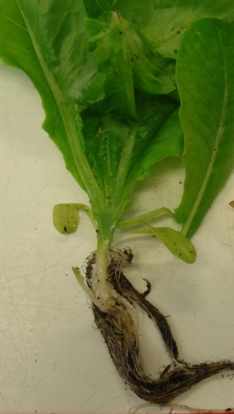
1: slightly stunting, growing reduction | 1: plant with brown vessels only below the cotyledon without yellowing and wilting  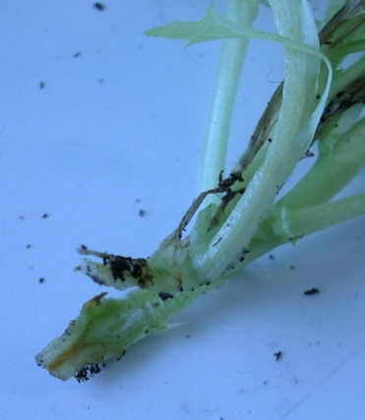
2: severely stunting | 2: plant with brown vessels above the cotyledon, without yellowing and wilting  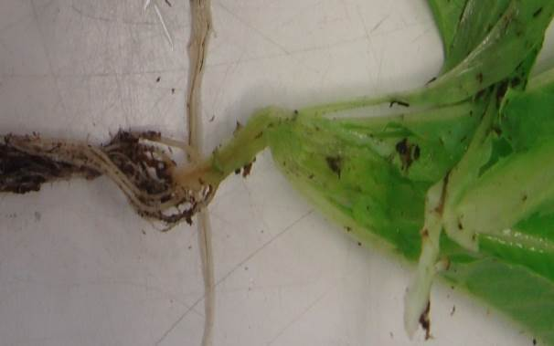
3: dead plant | 3: plant yellowing and wilting, brown vessels  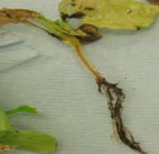
4: dead plant
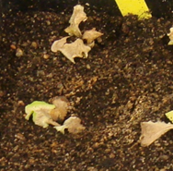

11.3 Validation of test | results should be compared with results of controls and are depending of the aggressiveness of the test and the distribution of the plants over the categories.  a disease index may be helpful (example for the method of inoculation by soaking seedlings: DI= (0A + 1B + 2C + 3D + 4E) / (A + B + C + D + E), where A to E are number of plants in each category).
12. Interpretation of data in terms of UPOV characteristic states | compare the distribution over the categories with the result of the controls.

Ad. 47: Resistance to Fusarium oxysporum f.sp. lactucae (Fol) Race 4

1. Pathogen | Fusarium oxysporum f.sp. lactucae
2. Quarantine status | NO : EPPO alert list
3. Host species | lettuce - Lactuca sativa L.
4. Source of inoculum | e.g. GEVES (FR)
5. Isolate | Fol: 4, e.g. isolate 04750888 reference strain validated in an interlaboratory test  Other validated isolates may be used, as long as producing the same results on the differential set.
6. Establishment isolate identity | The most recent table of differential set is available through ISF at https://worldseed.org/our-work/disease-resistance/differential-hosts/
7. Establishment pathogenicity | use lettuce susceptible standard
8. Multiplication inoculum
8.1 Multiplication medium | on liquid medium (e.g. Potatoes Dextrose Broth)
8.6 Harvest of inoculum | 15 days
9. Format of the test
9.1 Number of plants per genotype | at least 30 plants, in case of doubt 60 plants
9.2 Number of replicates | at least 2 replicates
9.3 Control varieties | absent or low resistance: Gisela
 | medium resistance: Ballerina and Patriot (Ballerina is the lowest level of medium resistance)
 | high resistance: Lomeria, Palmos
9.4 Test design | include control varieties
9.5 Test facility | greenhouse or climate room
9.6 Temperature | 23-26°C
9.7 Light | under natural day length
10. Inoculation

10.1 Preparation inoculum | spores are harvested
10.2 Quantification inoculum | adjust to 10⁶ sp/ml
10.3 Plant stage at inoculation | cotyledons to 2 or 3 leaves appearing
10.4 Inoculation method | soaking roots and hypocotyl for 5 to 15 min in the inoculum suspension
10.5 First observation | -
10.6 Second observation | -
10.7 Final observations | 20-25 days post inoculation
11. Observations
11.1 Method | visual and/or counting number of plants with symptom.
11.2 Observation scale

inoculation by soaking seedlings
0: plant without symptoms and healthy vessels
1: plant with brown vessels only below the cotyledon without yellowing and wilting
2: plant with brown vessels above the cotyledon, without yellowing and wilting
3: plant yellowing and wilting, brown vessels
4: dead plant

11.3 Validation of test | results should be compared with results of controls and are depending of the aggressiveness of the test and the distribution of the plants over the categories.

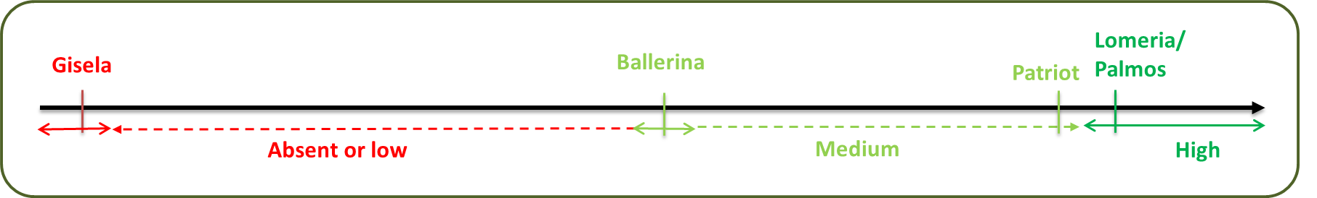

12. Interpretation of data in terms of UPOV characteristic states | compare the distribution over the categories with the result of the controls.
8.3 Lettuce types

See also 5.3 for a table to determine the type using several characteristics.

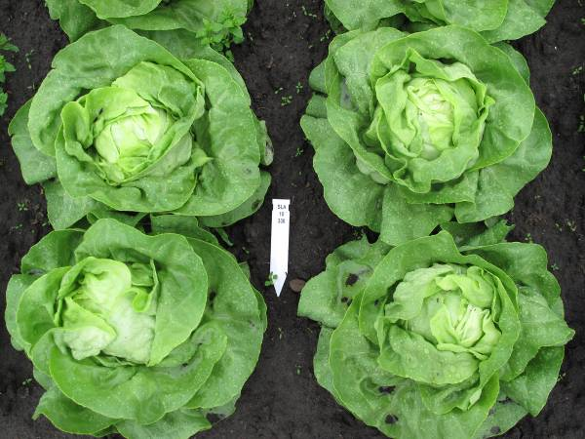 | 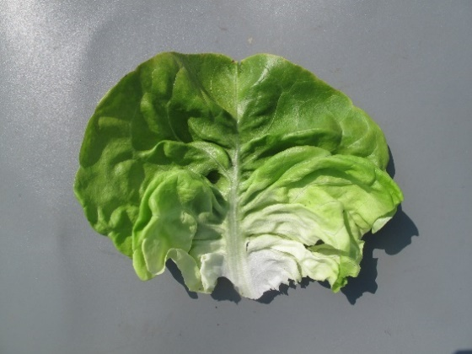 | Heading; thin to rather thick, tender leaves with a clear midrib; leaf shape circular to transverse broad elliptic; in general no incised margin; head shape ranging from broad elliptic to transvers elliptic.
Butterhead type

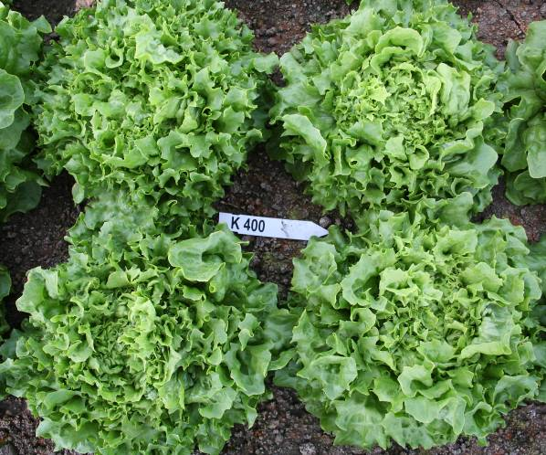 | 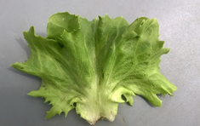 | Cross between Butterhead and Iceberg type for glasshouse growing.  Open heading; leaf structure like Butterhead, incisions of the margin as Iceberg.
Novita type

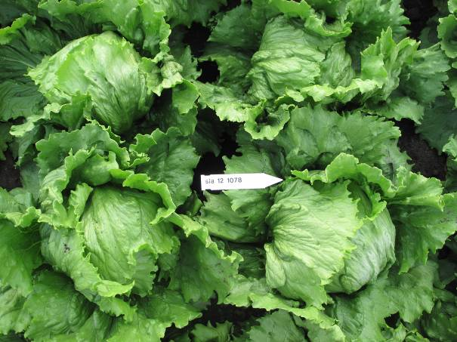 | 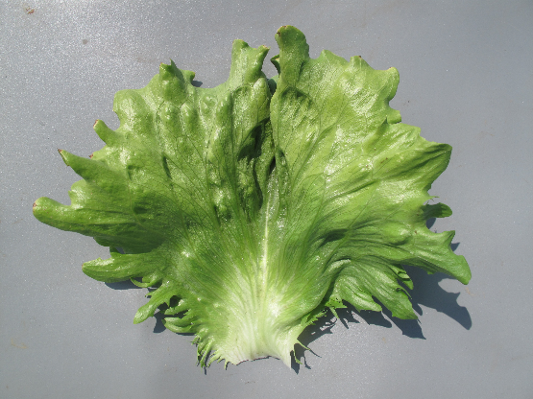 | Heading with strong or very strong overlapping of upper part of leaves; thick and crispy leaves, predominantly green and greyish green, leaf margin hardly to rather strongly incised, no clear midrib but with flabellate venation.
Iceberg type

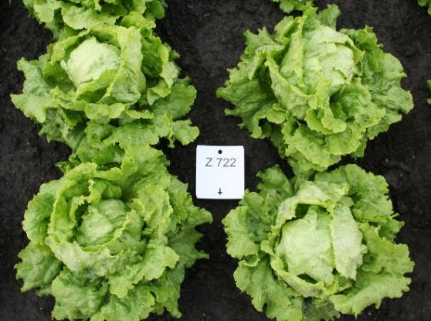 | 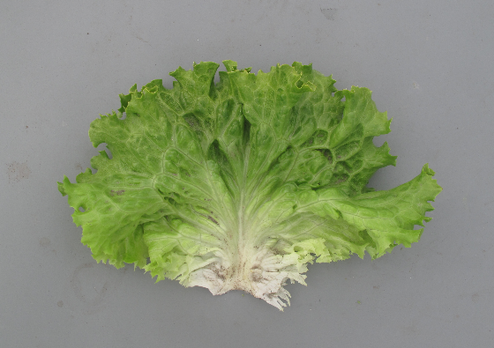 | Open to strong heading; generally medium thick, rather strongly blistered leaves, predominantly yellowish or medium green; leaf margin with weak to strong undulation.
Batavia type

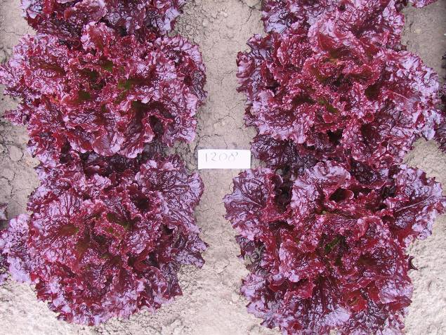 | 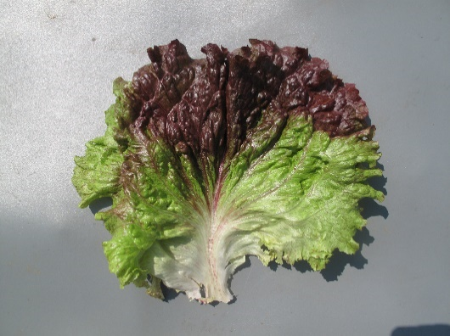 | Non-heading, loose, generally quite large plant; thin leaves. Compared to Lollo type in general less undulating margin and showing more leaf blade. Compared to Batavia type, leaves are thinner. Mainly used for babyleaf production.
Frisée d'Amérique type

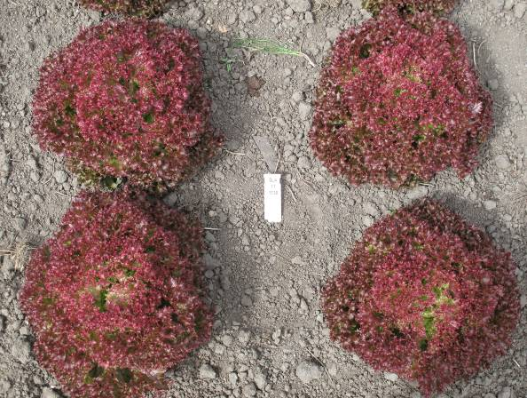 | 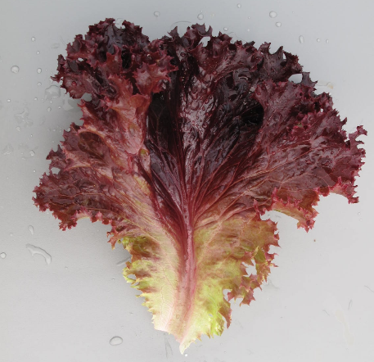 | Non-heading; thin leaves with strongly undulated leaf margin. The plant as a whole shows mainly the undulating leaf margins. In general strongly blistered leaves, blisters are rather small.
Lollo type

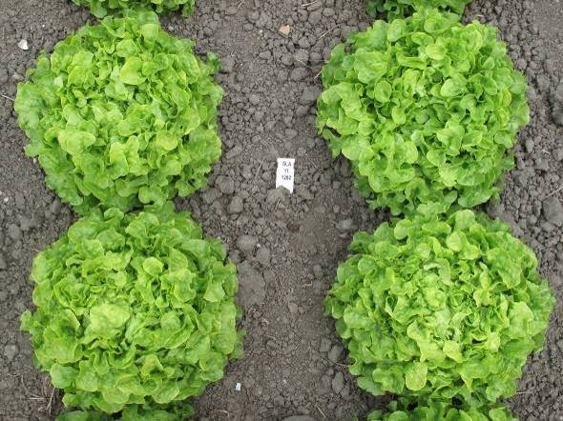 | 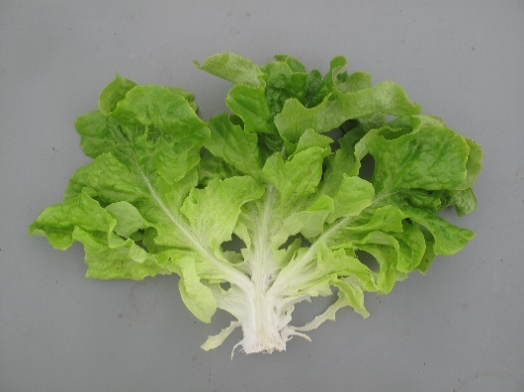 | Thin, divided leaves; divisions have an oakleaf or lobed shape with in general a rounded tip. Radichetta or Catalogna with acute tip of the division. Heart can be loose to dense.
Oakleaf type

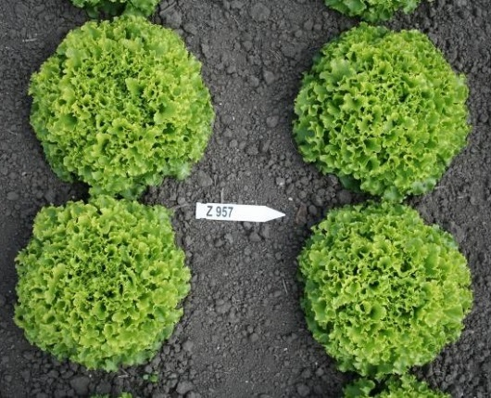 | 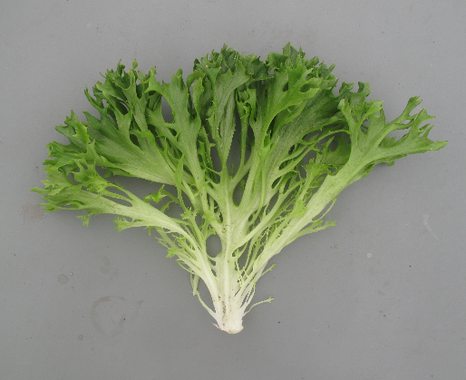 | Non-heading; thin, medium to very strong divided leaves. Tip of divisons can be undulated and incised. Plant may look as a Lollo type, but leaves are always divided.
Multi-divided type

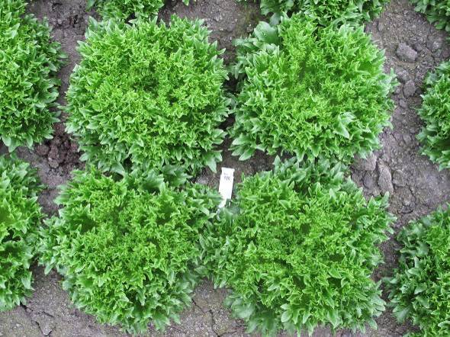 | 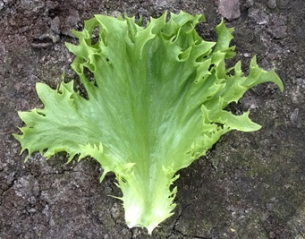 | Non-heading; thick, crispy leaves, sometimes weakly divided. Clearly incised leaf margin.
Frillice type

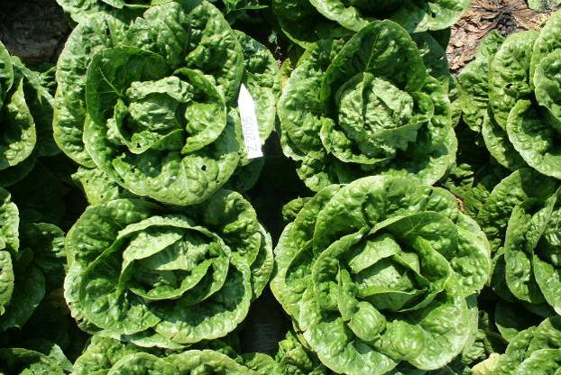 | 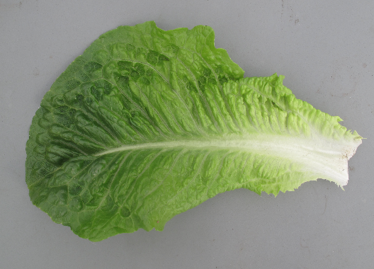 | Elongated and rather tough leaves with a clear midrib, head shape in longitudinal section elliptic, length of head >1.5 x diameter; heading can be very late.
Cos type

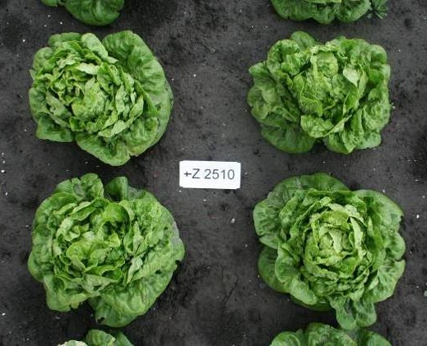 | 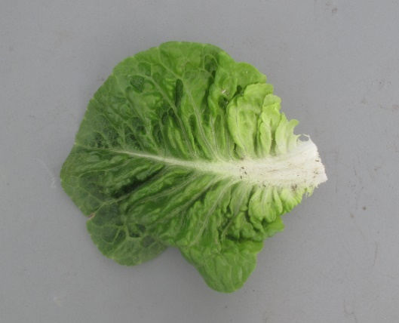 | Tough leaves with clear midrib, head shape short elliptic to slightly obovate. Some types only have a tightly filled heart, others are more similar to a short Cos type. Suitable for semi-arid conditions.
Gem type
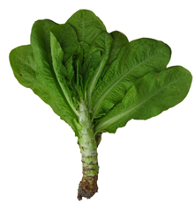 | 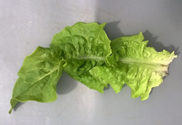 | Forms a fleshy stem before bolting, at least under (semi-)short day condtions; leaves are mainly tough and have a clear midrib. Leaves and/or stem are consumed.
Stem type

9. | Literature

Bowring, J.D.C., 1969: The identification of varieties of lettuce. National Institute of Agricultural Botany, XI. pp 499-520.

Casallo, A., Sobrino, E., 1965: Variedades de Hortalizas Cultivadas en España. Ministerio de Agricultura, Manuales Técnicos A29. Madrid, ES, pp 257-285.

Christensen, I., 1980: Sallatssorternas morfologi enligt UPOV. Swedish University of Agricultural Sciences, Research Information Centre. Alnarp Trädgaards 190, SE.

Crute, I.R., Johnson, A.G., 1976: The genetic relationship between races of Bremia lactucae and cultivars of Lactuca sativa. Annals applied Biology 83. UK. pp 125-137.

Crute, I.R., Johnson, A.G., 1976: Breeding for resistance to lettuce downy mildew, Bremia lactucae. Annals applied Biology 84. UK. pp 287-290.

Eenink A.H., Groenwold, R., Dieleman, F.L., 1982. Resistance of lettuce (Lactuca) to the leaf aphid Nasonovia ribis nigri. 1 Transfer of resistance from L. virosa to L. sativa by interspecific crosses and selection of resistant breeding lines. Euphytica 31. NL. pp 291–300.

Eenink A.H., Groenwold, R., Dieleman, F.L., 1982. Resistance of lettuce (Lactuca) to the leaf aphid Nasonovia ribis nigri. 2 Inheritance of the resistance. Euphytica 31. NL. pp 301–304.

Ettekoven, C. van, Arend, A.J.M. van der, 1999: Identification and denomination of “new” races of Bremia lactucae. Eucarpia Leafy Vegetables 1999 (Eds. Lebeda, A. and Kristkova, E.). Olomouc, CZ.

Farrara, B.F. et al., 1987: Genetic Analysis Factors for Resistance to Downy Mildew (Bremia Lactucae) in Species of Lettuce (Lactuca sativa and L. serriola). Plant Pathology 36. UK. pp 499-514.

Guenard, M., Cadot, V., Boulineau, and Fontanges, H. de, 1999: Collaboration between breeders and GEVES-SNES for the harmonisation and evaluation of disease resistance test: Bremia lactucae of lettuce. Eucarpia Leafy Vegetables 1999 (Eds. Lebeda, A. and Kristkova, E.). Olomouc, CZ.

Johnson, A.G., Crute, I.R., Gordon, P.L., 1977: The genetics of race specific resistance in lettuce (Lactuca sativa) to downy mildew (Bremia lactucae). Annals applied Biology 86. UK. pp 87-103.

Lebeda, A., Crute, I.R., Blok, I., Norwood, J.M., 1980: The identification of factors determining race specific resistance to Bremia lactucae in some Czechoslovakian Lettuce Cultivars. Z. Pflanzenzüchtg. 85. pp 71-77.

Lebeda, A., Kristkova, E., 1999: Eucarpia Leafy Vegetables ‘99, Proceedings of the Eucarpia Meeting on Leafy Vegetables Genetics and Breeding. Palacky University, Olomouc, CZ.

Lebeda, A., Petrzelova, I., 2010: Screening for resistance to lettuce downy mildew (Bremia lactucae). Mass screening techiques for selecting crops resistant to diseases. IAEA, Vienna, AT. pp 245-256.

Michelmore, R.W., Norwood, J.M., Ingram, D.S., Crute, I.R., Nicholson, P., 1984: The inheritance of virulence in Bremia lactucae to match resistance factors 3, 4, 5, 6, 8, 9, 10 and 11 in lettuce (Lactuca sativa). Plant Pathology 33. UK. pp 301-315.

Nicaise, V., German-Retana, S., Sanjuán, R., Dubrana, M., Mazier, M., Maisonneuve, B., Candresse, T., Caranta, C., LeGall O., 2003: The Eukaryotic Translation Initiation Factor 4E Controls Lettuce Susceptibility to the Potyvirus Lettuce mosaic virus. Plant Physiology, Villenave d’Ornon cedex, FR, Volume 132, Issue 3, pp 1272–1282.

Noguera Garcia, V., Alba Bartual, V., 1979: Caracterización de Variedades de Lechuga Cultivadas en España, Patronato Prov. de Capacitación Agr., ES.

Norwood, J.M., Michelmore, R.W., Crute, I.R, Ingram, D.S., 1983: The inheritance of specific virulence in Bremia lactucae (downy mildew) to match resistance factors 1, 2, 4, 6 and 11 in Lactuca sativa (lettuce). Plant Pathology 32. UK. pp 177-186.

Perrot, S., Buffard, M., Grimault, V., 2015: European harmonization of evaluation of resistance of lettuce to Bremia lactucae. Eucarpia Leafy Vegetables 2015. Murcia, SP.

Pink, D.A.C., Lot, H., Johnson, R., 1992: Novel pathotypes of lettuce mosaic virus - breakdown of durable resistance? Euphytica 63. NL. pp 169-174.

Revers F. et al., 1997: Biological and Molecular Variability of Lettuce Mosaic Virus Isolates. Molecular Plant Pathology 87-4. US. pp 397-403.

Rodenburg, C.M. et al., 1960: Varieties of lettuce. An international monograph. Instituut voor de Veredeling van Tuinbouwgewassen (IVT), Wageningen, NL, 228 pp. (Also in French: “Variétés de laitues”; and German: “Salatsorten”).

Scott, J.C., Gordon, T.R., 2010. Effect of temperature on severity of Fusarium wilt of lettuce caused by Fusarium oxysporum f. sp. lactucae. Plant Disease 94. US. pp 13-17.

Scott, J.C., Kirkpatrick, S.C., Gordon, T.R. 2010. Variation in susceptiblity of lettuce cultivars to fusarium wilt caused by Fusarium oxysporum f. sp. lactucae. Plant Pathology 59. UK. pp 139-146.

Smilde, D., Dijk-Veldhuizen, A., 2015: IBEB and ABEB propose a streamlined lettuce differential set for Bremia lactucae. Eucarpia Leafy Vegetables 2015. Murcia, SP.

Van der Arend et al., 2007: Identification and nomination of new races of Bremia lactucae in Europe by IBEB until 2006. Eucarpia Leafy Vegetables 2007 Conference Abstracts, 18-20 April 2007, University of Warwick, Poster presentations, pp. 27 v.v.

Zinkernagel, V., Gensler, H., Bamberg, D., 1989: Die Virulenzgene von Isolaten von Bremia lactucae Regel in der Bundesrepublik Deutschland. Gartenbauwissenschaft 54 (6). DE. pp 244-249.

10. | Technical Questionnaire

TECHNICAL QUESTIONNAIRE | Page {x} of {y} | Reference Number:

Application date:
(not to be filled in by the applicant)
TECHNICAL QUESTIONNAIRE
to be completed in connection with an application for plant breeders' rights

1. | Subject of the Technical Questionnaire
 | 1.1 | Botanical name | Lactuca sativa L.
 | 1.2 | Common name | Lettuce

2. | Applicant
 | Name
 | Address
 | Telephone No.
 | Fax No.
 | E-mail address
 | Breeder (if different from
 | applicant)

3. | Proposed denomination and breeder's reference
 | Proposed denomination
 | (if available)
 | Breeder's reference

TECHNICAL QUESTIONNAIRE |  |  | Page {x} of {y} | Reference Number:
#4. | Information on the breeding scheme and propagation of the variety
 | 4.1 | Breeding scheme

Variety resulting from:
4.1.1 Crossing
(a) controlled cross [ ]
(b) partially known cross [ ]
(c) unknown cross [ ]
4.1.2 Mutation [ ]
(please state parent variety)

4.1.3 Discovery and development [ ]
(please state where and when discovered and how developed)

4.1.4 Other [ ]
(please provide details)

TECHNICAL QUESTIONNAIRE | Page {x} of {y} | Reference Number:

 | 4.2 | Method of propagating the variety
4.2.1 | Seed-propagated varieties
(a) | Self-pollination | [ ]
(b) | Other (please provide details) | [ ]
4.2.2 | Other  (Please provide details) | [ ]

 | TECHNICAL QUESTIONNAIRE Page {x} of {y} Reference Number:
 | 5. Characteristics of the variety to be indicated (the number in brackets refers to the corresponding characteristic in Test Guidelines; please mark the note which best corresponds).
 |  | Characteristics | Example Varieties | Note
5.1  (1) |  | Seed: color
 |  | white | Verpia | 1 [ ]
 |  | yellow | Durango | 2 [ ]
 |  | brown | Oaklin | 3 [ ]
 |  | black | Kagraner Sommer 2 | 4 [ ]
5.2  (6) |  | Leaf: number of divisions
 |  | absent or very few | Fiorella, Lollo rossa | 1 [ ]
 |  | very few to few |  | 2 [ ]
 |  | few | Curletta, Rodagio | 3 [ ]
 |  | few to medium |  | 4 [ ]
 |  | medium | Ezabel, Jadigon | 5 [ ]
 |  | medium to many |  | 6 [ ]
 |  | many | Expedition, Multired 54 | 7 [ ]
 |  | many to very many |  | 8 [ ]
 |  | very many | Excite, Ezfrill, Telex | 9 [ ]
5.3  (11) |  | Leaf: anthocyanin coloration
 |  | absent or very weak | Clarion | 1 [ ]
 |  | very weak to weak |  | 2 [ ]
 |  | weak | Du bon jardinier | 3 [ ]
 |  | weak to medium |  | 4 [ ]
 |  | medium | Lollo rossa, Luana | 5 [ ]
 |  | medium to strong |  | 6 [ ]
 |  | strong | Merveille des quatre saisons | 7 [ ]
 |  | strong to very strong |  | 8 [ ]
 |  | very strong | Iride, Revolution | 9 [ ]
5.4  (12) |  | Leaf: hue of anthocyanin coloration
 |  | reddish | Lollo rossa | 1 [ ]
 |  | purplish | Iride | 2 [ ]
 |  | brownish | Luana, Maravilla de Verano | 3 [ ]
 |  | Characteristics | Example Varieties | Note
5.5  (13) |  | Leaf: area covered by anthocyanin coloration
 |  | very small | Steirer Krauthauptel | 1 [ ]
 |  | very small to small |  | 2 [ ]
 |  | small | Diablo | 3 [ ]
 |  | small to medium |  | 4 [ ]
 |  | medium | Luana | 5 [ ]
 |  | medium to large |  | 6 [ ]
 |  | large | Merveille des quatre saisons | 7 [ ]
 |  | large to very large |  | 8 [ ]
 |  | very large | Bijou, Revolution | 9 [ ]
5.6  (14) |  | Leaf: color
 |  | green | Verpia | 1 [ ]
 |  | yellowish green | Dorée de printemps | 2 [ ]
 |  | greyish green | Celtuce, Du bon jardinier | 3 [ ]
5.7  (15) |  | Leaf: intensity of green color
 |  | very light |  | 1 [ ]
 |  | very light to light |  | 2 [ ]
 |  | light | Blonde maraîchère, Lollo Bionda | 3 [ ]
 |  | light to medium |  | 4 [ ]
 |  | medium | Aquarel, Clarion | 5 [ ]
 |  | medium to dark |  | 6 [ ]
 |  | dark | Expedition, Verpia | 7 [ ]
 |  | dark to very dark |  | 8 [ ]
 |  | very dark | Pascal, Verdetrix | 9 [ ]
5.8  (34) |  | Only varieties with Plant: degree of overlapping of upper part of leaves: medium or strong: Time of harvest maturity
 |  | very early | Gotte jaune d'or | 1 [ ]
 |  | very early to early |  | 2 [ ]
 |  | early | Pantlika, Sucrine | 3 [ ]
 |  | early to medium |  | 4 [ ]
 |  | medium | Clarion | 5 [ ]
 |  | medium to late |  | 6 [ ]
 |  | late | Blonde maraîchère, Calmar | 7 [ ]
 |  | late to very late |  | 8 [ ]
 |  | very late | El Toro, Pinokkio | 9 [ ]

TECHNICAL QUESTIONNAIRE | Page {x} of {y} | Reference Number:

 | Characteristics | Example Varieties | Note
5.9  (35) | Time of beginning of bolting
 | very early | Blonde à couper améliorée | 1 [ ]
 | very early to early |  | 2 [ ]
 | early | Gotte à graine blanche | 3 [ ]
 | early to medium |  | 4 [ ]
 | medium | Pantlika | 5 [ ]
 | medium to late |  | 6 [ ]
 | late | Hilde II | 7 [ ]
 | late to very late |  | 8 [ ]
 | very late | Erika, Roxette | 9 [ ]
5.10  (38) | Resistance to Bremia lactucae (Bl) Isolate Bl: 16EU
 | absent | Green Towers | 1 [ ]
 | present | Argelès | 9 [ ]
 | not tested |  | [ ]
5.11  (39) | Resistance to Bremia lactucae (Bl) Isolate Bl: 17EU
 | absent | Green Towers | 1 [ ]
 | present | Argelès | 9 [ ]
 | not tested |  | [ ]
5.12  (40) | Resistance to Bremia lactucae (Bl) Isolate Bl: 20EU
 | absent | Green Towers | 1 [ ]
 | present | FrRsal-1 | 9 [ ]
 | not tested |  | [ ]
5.13  (41) | Resistance to Bremia lactucae (Bl) Isolate Bl: 21EU
 | absent | Green Towers | 1 [ ]
 | present | Argelès, Colorado | 9 [ ]
 | not tested |  | [ ]
5.14  (42) | Resistance to Bremia lactucae (Bl) Isolate Bl: 22EU
 | absent | Green Towers | 1 [ ]
 | present | FrRsal-1 | 9 [ ]
 | not tested |  | [ ]
5.15  (43) | Resistance to Bremia lactucae (Bl) Isolate Bl: 23EU
 | absent | Green Towers | 1 [ ]
 | present | Colorado | 9 [ ]
 | not tested |  | [ ]

TECHNICAL QUESTIONNAIRE | Page {x} of {y} | Reference Number:

 | Characteristics | Example Varieties | Note
5.16  (44) | Resistance to Bremia lactucae (Bl) Isolate Bl: 24EU
 | absent | Argelès, Colorado | 1 [ ]
 | present | Dandie, NunDm15, UCDm14 | 9 [ ]
 | not tested |  | [ ]
5.17  (45) | Resistance to Bremia lactucae (Bl) Isolate Bl: 25EU
 | absent | Colorado | 1 [ ]
 | present | Argelès | 9 [ ]
 | not tested |  | [ ]
5.18  (46) | Resistance to Bremia lactucae (Bl) Isolate Bl: 26EU
 | absent | Colorado | 1 [ ]
 | present | Balesta, Bedford | 9 [ ]
 | not tested |  | [ ]
5.19  (47) | Resistance to Bremia lactucae (Bl) Isolate Bl: 27EU
 | absent | Balesta, Colorado | 1 [ ]
 | present | FrRsal-1 | 9 [ ]
 | not tested |  | [ ]
5.10  (38) | Resistance to Bremia lactucae (Bl) Isolate Bl: 29EU
 | absent | Argelès | 1 [ ]
 | present | Balesta | 9 [ ]
 | not tested |  | [ ]
5.11  (39) | Resistance to Bremia lactucae (Bl) Isolate Bl: 30EU
 | absent | Argelès, Colorado | 1 [ ]
 | present | Balesta | 9 [ ]
 | not tested |  | [ ]
5.12  (40) | Resistance to Bremia lactucae (Bl) Isolate Bl: 31EU
 | absent | Colorado, RYZ910457 | 1 [ ]
 | present | Argelès, Balesta | 9 [ ]
 | not tested |  | [ ]
5.13  (41) | Resistance to Bremia lactucae (Bl) Isolate Bl: 33EU
 | absent | Kibrille, RYZ2164 | 1 [ ]
 | present | RYZ910457 | 9 [ ]
 | not tested |  | [ ]

TECHNICAL QUESTIONNAIRE | Page {x} of {y} | Reference Number:

 | Characteristics | Example Varieties | Note
5.14  (42) | Resistance to Bremia lactucae (Bl) Isolate Bl: 35EU
 | absent | Design, Kibrille | 1 [ ]
 | present | Bartoli | 9 [ ]
 | not tested |  | [ ]
5.15  (43) | Resistance to Bremia lactucae (Bl) Isolate Bl: 36EU
 | absent | Bartoli, RYZ2164 | 1 [ ]
 | present | Design, Kibrille | 9 [ ]
 | not tested |  | [ ]
5.16  (44) | Resistance to Lettuce mosaic virus (LMV) Pathotype II
 | absent | Bijou, Hilde II, Sprinter, Sucrine | 1 [ ]
 | present | Capitan, Corsica | 9 [ ]
 | not tested |  | [ ]
5.17  (45) | Resistance to Nasonovia ribisnigri (Nr) Biotype Nr: 0
 | absent | Abel, Green Towers, Nadine | 1 [ ]
 | present | Barcelona, Bedford, Dynamite, Silvinas | 9 [ ]
 | not tested |  | [ ]
5.18  (46) | Resistance to Fusarium oxysporum f.sp. lactucae (Fol) Race 1
 | absent or low | Cobham Green, Patriot | 1 [ ]
 | medium | Affic, Fuzila, Natexis | 2 [ ]
 | high | Costa Rica No. 4, Romasol | 3 [ ]
 | not tested |  | [ ]
5.19  (47) | Resistance to Fusarium oxysporum f.sp. lactucae (Fol) Race 4
 | absent or low | Costa Rica No. 4, Gisela | 1 [ ]
 | medium | Ballerina, Patriot | 2 [ ]
 | high | Lomeria, Palmos | 3 [ ]
 | not tested |  | [ ]

TECHNICAL QUESTIONNAIRE | Page {x} of {y} | Reference Number:

6. | Similar varieties and differences from these varieties
Please use the following table and box for comments to provide information on how your candidate variety differs from the variety (or varieties) which, to the best of your knowledge, is (or are) most similar. This information may help the examination authority to conduct its examination of distinctness in a more efficient way.

Denomination(s) of variety(ies) similar to your candidate variety | Characteristic(s) in which your candidate variety differs from the similar variety(ies) | Describe the expression of the characteristic(s) for the similar variety(ies) | Describe the expression of the characteristic(s) for your candidate variety

Example | Plant: diameter | medium | medium to large

 | Comments:

TECHNICAL QUESTIONNAIRE | Page {x} of {y} | Reference Number:

#7. | Additional information which may help in the examination of the variety
7.1 | In addition to the information provided in sections 5 and 6, are there any additional characteristics which may help to distinguish the variety?
 | Yes | [ ] | No | [ ]
 | (If yes, please provide details)
7.2 | Are there any special conditions for growing the variety or conducting the examination?
 | Yes | [ ] | No | [ ]
 | (If yes, please provide details)
7.3 | Other information  Type (see 5.3 and 8.3 in the Test Guidelines for Lettuce (document TG/13/11 Rev.) for explanations):  Type Example varieties  Butterhead type Clarion, Maikönig, Sartre [ ]  Novita type Norvick [ ]  Iceberg type Great Lakes 659, Roxette, Saladin, Vanguard 75 [ ]  Batavia type Aquarel, Curtis, Funnice, Felucca, Grand Rapids, Masaida, Visyon [ ]  Frisée d'Amérique type Bijou, Blonde à couper améliorée [ ]  Lollo type Lollo rossa, Revolution [ ]  Oakleaf type Catalogna, Kipling, Muraï, Salad Bowl [ ]  Multi-divided type Curletta, Duplex, Jadigon, Rodagio [ ]  Frillice type Frilett [ ]  Cos type Actarus,Blonde maraîchère, Pinokkio [ ]  Gem type Craquerelle du Midi, Sucrine, Xanadu [ ]  Stem type Celtuce, Guasihong [ ]

TECHNICAL QUESTIONNAIRE | Page {x} of {y} | Reference Number:

8. | Authorization for release
 | (a) | Does the variety require prior authorization for release under legislation concerning the protection of the environment, human and animal health?
 |  | Yes | [ ] | No | [ ]
 | (b) | Has such authorization been obtained?
 |  | Yes | [ ] | No | [ ]
 | If the answer to (b) is yes, please attach a copy of the authorization.

9. Information on plant material to be examined or submitted for examination

9.1 The expression of a characteristic or several characteristics of a variety may be affected by factors, such as pests and disease, chemical treatment (e.g. growth retardants or pesticides), effects of tissue culture, different rootstocks, scions taken from different growth phases of a tree, etc.
9.2 The plant material should not have undergone any treatment which would affect the expression of the characteristics of the variety, unless the competent authorities allow or request such treatment. If the plant material has undergone such treatment, full details of the treatment must be given. In this respect, please indicate below, to the best of your knowledge, if the plant material to be examined has been subjected to:

 | (a) | Microorganisms (e.g. virus, bacteria, phytoplasma) | Yes [ ] | No [ ]
 | (b) | Chemical treatment (e.g. growth retardant, pesticide) | Yes [ ] | No [ ]
 | (c) | Tissue culture | Yes [ ] | No [ ]
 | (d) | Other factors | Yes [ ] | No [ ]
 | Please provide details for where you have indicated “yes”.

10. | I hereby declare that, to the best of my knowledge, the information provided in this form is correct:
 | Applicant’s name
 | Signature |  | Date

[End of document]

∗ These names were correct at the time of the introduction of these Test Guidelines but may be revised or updated. [Readers are advised to consult the UPOV Code, which can be found on the UPOV Website (www.upov.int), for the latest information.]
held by electronic means, from April 22 to 25, 2024.
matref@geves.fr
resistentie@naktuinbouw.nl
matref@geves.fr
resistentie@naktuinbouw.nl
Naktuinbouw: resistentie@naktuinbouw.nl
resistentie@naktuinbouw.nl
genebank@nias.affrc.go.jp
scs.sa@crea.gov.it
resistentie@naktuinbouw.nl
matref@geves.fr
matref@geves.fr
See ISF EG DRT Fol: 4 resistance in lettuce https://worldseed.org/document/isf-final-report-fol-race-4-lettuce/

