 |  | E  TC/49/39  ORIGINAL: English  DATE: February 5, 2013
INTERNATIONAL UNION FOR THE PROTECTION OF NEW VARIETIES OF PLANTS
Geneva
Technical Committee
Forty-Ninth Session
Geneva, March 18 to 20, 2013

partial revision of the test guidelines for Spinach (document tg/55/7 rev.)
Document prepared by the Office of the Union

1. The Technical Working Party for Vegetables (TWV) at its forty-sixth session, held near the city of Venlo, Netherlands, from June 11 to 15, 2012, agreed to propose to revise the Test Guidelines for Spinach (document TG/55/7 Rev.) as follows:

- to add a new characteristic “Leaf: anthocyanin coloration of petioles and veins” after Characteristic 1, which would also be included as a grouping characteristic in Chapter 5.3. An explanation for the new characteristic would be provided in Chapter 8.

- for Characteristic 17 “Resistance to Peronospora farinosa f.sp. spinaciae”
- to add an asterisk for Race Pfs: 5, Race Pfs: 6 and Race Pfs: 7;
- to add Race Pfs: 12 and Race Pfs: 13, including example varieties
- to add columns for Race Pfs: 12 and Race Pfs: 13 in the table of differential varieties to identify races in Ad. 17 “Resistance to Peronospora farinosa f.sp. spinaciae.”

2. The Annex to this document contains the proposed partial revision of the Test Guidelines for Spinach (document TG/55/7 Rev.), as set out in paragraph 1 of this document.

3. The partial revision of document TG/55/7 Rev. would be adopted as document TG/55/7 Rev.2.

[Annex follows]

Proposed new characteristic “Leaf: anthocyanin coloration of petioles and veins” after characteristic 1

 |  | English | français | Deutsch | español | Example Varieties  Exemples  Beispielssorten  Variedades ejemplo | Note/  Nota
NEW  (*)  (+) | VG | Leaf: anthocyanin coloration of petioles and veins | Feuille : pigmentation anthocyanique du pétiole et des veines | Blatt: Anthocyanfärbung des Blattstiels und der Adern | Hoja: pigmentación antociánica del pecíolo y de los nervios
QL | (a) | absent | absentes | fehlend | ausentes | Resistoflay, Nores | 1
 |  | present | présentes | vorhanden | presentes | Red Cardinal, Reddy | 9

Ad. NEW : Leaf: anthocyanin coloration of petioles and veins

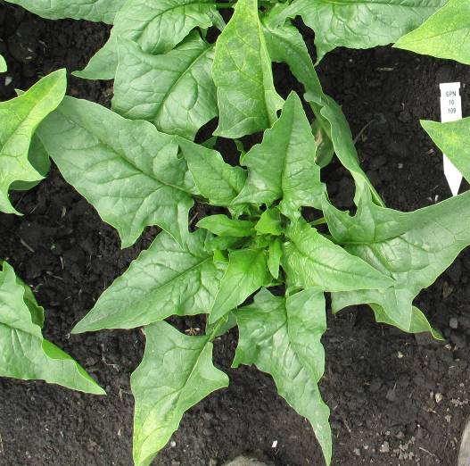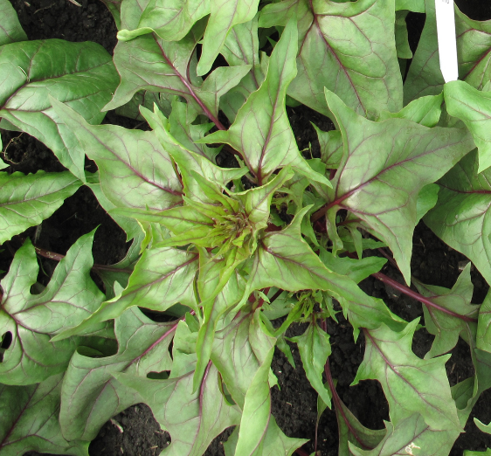

1 | 9
absent | present

Proposal to amend characteristic and addendum 17 “Resistance to Peronospora farinosa f. sp. spinaciae”

Proposed amendments are indicated by:

highlighting: proposed addition

 |  | English | français | Deutsch | español | Example Varieties  Exemples  Beispielssorten  Variedades ejemplo | Note/  Nota
17.  (+) | VG | Resistance to Peronospora farinosa f. sp. spinaciae | Résistance à Peronospora farinosa f. sp. spinaciae | Resistenz gegen Peronospora farinosa f. sp. spinaciae | Resistencia a Peronospora farinosa f. sp. spinaciae
 |  | -------------------------- | -------------------------- | -------------------------- | -------------------------- | ------------------------------ | ---------
17.1 |  | Race Pfs: 1 | Race Pfs: 1 | Pathotyp Pfs: 1 | Raza Pfs: 1
QL |  | absent | absente | fehlend | ausente | Viroflay, Winterreuzen | 1
 |  | present | présente | vorhanden | presente | Califlay, Resistoflay | 9
 |  | -------------------------- | -------------------------- | -------------------------- | -------------------------- | ------------------------------ | ---------
17.2 |  | Race Pfs: 2 | Race Pfs: 2 | Pathotyp Pfs: 2 | Raza Pfs: 2
QL |  | absent | absente | fehlend | ausente | Califlay | 1
 |  | present | présente | vorhanden | presente | Resistoflay | 9
 |  | -------------------------- | -------------------------- | -------------------------- | -------------------------- | ------------------------------ | ---------
17.3 |  | Race Pfs: 3 | Race Pfs: 3 | Pathotyp Pfs: 3 | Raza Pfs: 3
QL |  | absent | absente | fehlend | ausente | Resistoflay | 1
 |  | present | présente | vorhanden | presente | Califlay, Clermont | 9
 |  | -------------------------- | -------------------------- | -------------------------- | -------------------------- | ------------------------------ | ---------
17.4 |  | Race Pfs: 4 | Race Pfs: 4 | Pathotyp Pfs: 4 | Raza Pfs: 4
QL |  | absent | absente | fehlend | ausente | Califlay | 1
 |  | present | présente | vorhanden | presente | Clermont | 9
 |  | -------------------------- | -------------------------- | -------------------------- | -------------------------- | ------------------------------ | ---------
17.5  (*) |  | Race Pfs: 5 | Race Pfs: 5 | Pathotyp Pfs: 5 | Raza Pfs: 5
QL |  | absent | absente | fehlend | ausente | Clermont | 1
 |  | present | présente | vorhanden | presente | Califlay, Campania | 9
 |  | -------------------------- | -------------------------- | -------------------------- | -------------------------- | ------------------------------ | ---------
17.6  (*) |  | Race Pfs: 6 | Race Pfs: 6 | Pathotyp Pfs: 6 | Raza Pfs: 6
QL |  | absent | absente | fehlend | ausente | Califlay, Campania | 1
 |  | present | présente | vorhanden | presente | Boeing | 9
 |  | -------------------------- | -------------------------- | -------------------------- | -------------------------- | ------------------------------ | ---------
17.7  (*) |  | Race Pfs: 7 | Race Pfs: 7 | Pathotyp Pfs: 7 | Raza Pfs: 7
QL |  | absent | absente | fehlend | ausente | Califlay | 1
 |  | present | présente | vorhanden | presente | Campania | 9
 |  | -------------------------- | -------------------------- | -------------------------- | -------------------------- | ------------------------------ | ---------
17.8 |  | Race Pfs: 8 | Race Pfs: 8 | Pathotyp Pfs: 8 | Raza Pfs: 8
QL |  | absent | absente | fehlend | ausente | Boeing, Campania | 1
 |  | present | présente | vorhanden | presente | Lazio, Lion | 9
 |  | -------------------------- | -------------------------- | -------------------------- | -------------------------- | ------------------------------ | ---------
17.9 |  | Race Pfs: 10 | Race Pfs: 10 | Pathotyp Pfs:10 | Raza Pfs:10
QL |  | absent | absente | fehlend | ausente | Boeing, Campania, Lion | 1
 |  | present | présente | vorhanden | presente | Lazio | 9
 |  | -------------------------- | -------------------------- | -------------------------- | -------------------------- | ------------------------------ | ---------
17.10 |  | Race Pfs: 11 | Race Pfs: 11 | Pathotyp Pfs: 11 | Raza Pfs: 11
QL |  | absent | absente | fehlend | ausente | Lazio | 1
 |  | present | présente | vorhanden | presente | Boeing, Califlay, Campania,  Lion | 9
 |  | -------------------------- | -------------------------- | -------------------------- | -------------------------- | ------------------------------ | ---------
17.11 |  | Race Pfs: 12 | Race Pfs: 12 | Pathotyp Pfs: 12 | Raza Pfs: 12
QL |  | absent | absente | fehlend | ausente | Boeing, Campania | 1
 |  | present | présente | vorhanden | presente | Finch, Pigeon, Red Kitten, Zebu | 9
 |  | -------------------------- | -------------------------- | -------------------------- | -------------------------- | ------------------------------ | ---------
17.12 |  | Race Pfs: 13 | Race Pfs: 13 | Pathotyp Pfs: 13 | Raza Pfs: 13
QL |  | absent | absente | fehlend | ausente | Campania | 1
 |  | present | présente | vorhanden | presente | Boeing, Lion | 9

Proposed amendment to the table of differential varieties to identify races in Ad. 17 “Resistance to Peronospora farinosa f. sp. spinaciae”

Proposed amendments are indicated in yellow

Ad 17: Resistance to Peronospora farinosa f. sp. spinaciae

[...]

Differential varieties to identify races

Races Pfs: 1-8 and 10-13 of Peronospora farinosa f. sp. spinaciae are defined with a standard set of “differential varieties” according to the following table:

Differential variety | Pfs: 1 | Pfs: 2 | Pfs: 3 | Pfs: 4 | Pfs: 5 | Pfs: 6 | Pfs: 7 | Pfs: 8 | Pfs: 10 | Pfs: 11 | Pfs: 12 | Pfs: 13
Viroflay | S | S | S | S | S | S | S | S | S | S | S | S
Resistoflay | R | R | S | S | S | S | S | S | S | S | S | S
Califlay | R | S | R | S | R | S | S | R | S | R | R | S
Clermont | R | R | R | R | S | S | S | S | S | S | S | S
Campania | R | R | R | R | R | S | R | S | S | R | S | S
Boeing | R | R | R | R | R | R | R | S | S | R | S | R
Lion | R | R | R | R | R | R | R | R | S | R | R | R
Lazio | R | R | R | R | R | R | R | R | R | S | S | S

Legend: R= resistance present; S = resistance absent, susceptible

[End of Annex and of document]

